

**NEW ERA UNIVERSITY COLLEGE**

**Faculty of Computer Science & Information Computing Technology**

**Department of Information Computing Technology**

**DIPLOMA IN COMPUTER SCIENCE & E-COMMERCE**

**SEP 2023**

**TIST223 DATABASE CONCEPTS**

**GROUP ASSIGNMENT Part 1 – PET SHOP**

|  |  |
| --- | --- |
| **Student ID & Name:** | 2350080-DCS / WONG JIE YING  2320130-DEC /ANGEL YONG ZU ER  2320023-DEC / LEONG ZHI XIN  2130237-DEC /LEE CHOO LIANG |
| **Lecturer:** | MR ALEX LAW TENG YI |
| **Date of Submission:** | 15/01/2024 |

**Table Contact**

**1. Introduction** 17

**2. Diagram** 18

**2.1 ER Diagram** 18

**2.2 Chen Notation Diagram** 19

**2.3 Data Flow Diagram Level 1** 20

**3. Data Definition Language (DDL) & Data Manipulation Language (DML)** 21

**3.1 Create Database** 21

**3.2 Create Table** 21

**3.3 Insert Value** 33

**3.3.1 Table Monthly Budget** 33

**3.3.2 Table Supplier** 34

**3.3.3 Table Pet Care Service** 35

**3.3.4 Table Pet Accessories** 36

**3.3.5 Table Pet Category** 36

**3.3.6 Table Vaccine** 37

**3.3.7 Table Inventory** 37

**3.3.8 Table Customer** 38

**3.3.9 Table Customer Pet** 39

**3.3.10 Table Adoption Record** 39

**3.3.11 Table Lost And Found Record** 40

**3.3.12 Table Pet Record** 40

**3.3.13 Table Membership** 41

**3.3.14 Table Pet Appointment Record** 42

**3.3.15 Table Purchase Order** 42

**3.3.16 Table Customer Invoice** 43

**3.3.17 Table Customer DO** 43

**3.3.18 Table Supplier Invoice** 44

**3.3.19 Table Supplier DO** 44

**3.3.20 Table Stock Received** 45

**3.3.21 Table Stock Card** 45

**3.3.22 Table Customer Interest** 46

**3.3.23 Table Customer Feedback** 46

**3.3.24 Table Employees** 47

**3.3.25 Table Employee Training** 47

**3.3.26 Table Pet Treatment Records** 48

**3.3.27 Table Vaccine Record** 49

**3.3.28 Table Shop Event** 49

**3.3.29 Table Sales History** 50

**3.3.30 Table Payment History** 50

**3.3.31 Table Monthly Net Report** 51

**3.4. ALTER** 52

**3.4.1 Table Monthly Budget** 52

**3.4.2 Table Supplier** 52

**3.4.3 Table Pet Care Service** 52

**3.4.4 Table Pet Accessories** 53

**3.4.5 Table Pet Category** 53

**3.4.6 Table Vaccine** 54

**3.4.7 Table Inventory** 54

**3.4.8 Table Customer** 54

**3.4.9 Table Customer Pet** 55

**3.4.10 Table Adoption Record** 55

**3.4.11 Table Lost And Found Record** 56

**3.4.12 Table Pet Record** 56

**3.4.13 Table Membership** 56

**3.4.14 Table Pet Appointment Record** 57

**3.4.15 Table Purchase Order** 57

**3.4.16 Table Customer Invoice** 57

**3.4.17 Table Customer DO** 58

**3.4.18 Table Supplier Invoice** 58

**3.4.19 Table Supplier DO** 58

**3.4.20 Table Stock Received** 59

**3.4.21 Table Stock Card** 59

**3.4.22 Table Customer Interest** 60

**3.4.23 Table Customer Feedback** 60

**3.4.24 Table Employees** 60

**3.4.25 Table Employee Training** 61

**3.4.26 Table Pet Treatment Records** 61

**3.4.27 Table Vaccine Record** 61

**3.4.28 Table Shop Event** 62

**3.4.29 Table Sales History** 62

**3.4.30 Table Payment History** 62

**3.4.31 Table Monthly Net Report** 63

**3.5. UPDATE** 63

**3.5.1 Table Monthly Budget** 63

**3.5.2 Table Supplier** 64

**3.5.3 Table Pet Care Service** 65

**3.5.4 Table Pet Accessories** 66

**3.5.5 Table Pet Category** 68

**3.5.6 Table Vaccine** 69

**3.5.7 Table Inventory** 71

**3.5.8 Table Customer** 72

**3.5.9 Table Customer Pet** 73

**3.5.10 Table Adoption Record** 74

**3.5.11 Table Lost And Found Record** 75

**3.5.12 Table Pet Record** 76

**3.5.13 Table Membership** 77

**3.5.14 Table Pet Appointment Record** 78

**3.5.15 Table Purchase Order** 79

**3.5.16 Table Customer Invoice** 80

**3.5.17 Table Customer DO** 81

**3.5.18 Table Supplier Invoice** 82

**3.5.19 Table Supplier DO** 82

**3.5.20 Table Stock Received** 83

**3.5.21 Table Stock Card** 84

**3.5.22 Table Customer Interest** 85

**3.5.23 Table Customer Feedback** 86

**3.5.24 Table Employees** 87

**3.5.25 Table Employee Training** 88

**3.5.26 Table Pet Treatment Records** 90

**3.5.27 Table Vaccine Record** 91

**3.5.28 Table Shop Event** 92

**3.5.29 Table Sales History** 93

**3.5.30 Table Payment History** 95

**3.5.31 Table Monthly Net Report** 96

**3.6. DROP** 97

**3.6.1 Table Monthly Budget** 97

**3.6.2 Table Supplier** 97

**3.6.3 Table Pet Care Service** 98

**3.6.4 Table Pet Accessories** 98

**3.6.5 Table Pet Category** 99

**3.6.6 Table Vaccine** 99

**3.6.7 Table Inventory** 100

**3.6.8 Table Customer** 100

**3.6.9 Table Customer Pet** 101

**3.6.10 Table Adoption Record** 101

**3.6.11 Table Lost And Found Record** 102

**3.6.12 Table Pet Record** 102

**3.6.13 Table Membership** 102

**3.6.14 Table Pet Appointment Record** 103

**3.6.15 Table Purchase Order** 103

**3.6.16 Table Customer Invoice** 104

**3.6.17 Table Customer DO** 104

**3.6.18 Table Supplier Invoice** 105

**3.6.19 Table Supplier DO** 105

**3.6.20 Table Stock Received** 106

**3.6.21 Table Stock Card** 106

**3.6.22 Table Customer Interest** 107

**3.6.23 Table Customer Feedback** 107

**3.6.24 Table Employees** 107

**3.6.25 Table Employee Training** 108

**3.6.26 Table Pet Treatment Records** 108

**3.6.27 Table Vaccine Record** 109

**3.6.28 Table Shop Event** 109

**3.6.29 Table Sales History** 109

**3.6.30 Table Payment History** 110

**3.6.31 Table Monthly Net Report** 110

**4. Queries** 111

**4.1 Table Monthly Budget** 111

**4.1.1 UNION** 111

**4.1.2 GROUP BY** 111

**4.1.3 HAVING** 112

**4.1.4 EXISTS** 112

**4.1.5 ANY, ALL** 112

**4.1.6 CASE** 113

**4.1.7 NULL FUNCTIONS** 113

**4.2 Table Supplier** 114

**4.2.1 UNION** 114

**4.2.2 GROUP BY** 114

**4.2.3 HAVING** 115

**4.2.4 EXISTS** 116

**4.2.5 ANY, ALL** 116

**4.2.6 CASE** 116

**4.2.7 NULL FUNCTIONS** 117

**4.3 Table Pet Care Service** 118

**4.3.1 UNION** 118

**4.3.2 GROUP BY** 119

**4.3.3 HAVING** 119

**4.3.4 EXISTS** 120

**4.3.5 ANY, ALL** 120

**4.3.6 CASE** 120

**4.3.7 NULL FUNCTIONS** 121

**4.4 Table Pet Accessories** 122

**4.4.1 UNION with NULL FUNCTIONS** 122

**4.4.2 GROUP BY** 123

**4.4.3 HAVING** 123

**4.4.4 EXISTS** 124

**4.4.5 ANY, ALL** 124

**4.4.6 CASE** 125

**4.5 Table Pet Category** 125

**4.5.1 UNION with NULL FUNCTIONS** 125

**4.5.2 GROUP BY** 126

**4.5.3 HAVING** 127

**4.5.4 EXISTS** 127

**4.5.5 ANY, ALL** 128

**4.5.6 CASE** 128

**4.6 Table Vaccine** 129

**4.6.1 UNION with NULL FUNCTIONS** 129

**4.6.2 GROUP BY** 130

**4.6.3 HAVING** 131

**4.6.4 EXISTS** 131

**4.6.5 ANY, ALL** 132

**4.6.6 CASE** 132

**4.7 Table Inventory** 133

**4.7.1 UNION** 133

**4.7.2 GROUP BY** 134

**4.7.3 HAVING** 134

**4.7.4 EXISTS** 135

**4.7.5 ANY, ALL** 136

**4.7.6 CASE** 136

**4.7.7 NULL FUNCTIONS** 137

**4.8 Table Customer** 137

**4.8.1 SELECT & WHERE** 137

**4.8.2 AND, OR, NOT** 138

**4.8.3 ORDER BY** 138

**4.8.4 NULL & NOT NULL VALUES** 139

**4.9 Table Customer Pet** 140

**4.9.1 SELECT & WHERE** 140

**4.9.2 AND, OR, NOT** 140

**4.9.3 ORDER BY** 141

**4.9.4 NULL & NOT NULL VALUES** 141

**4.10 Table Adoption Record** 142

**4.10.1 SELECT & WHERE** 142

**4.10.2 AND, OR, NOT** 142

**4.10.3 ORDER BY** 143

**4.10.4 NULL & NOT NULL VALUES** 143

**4.11 Table Lost And Found Record** 143

**4.11.1 SELECT & WHERE** 144

**4.11.2 AND, OR, NOT** 144

**4.11.3 ORDER BY** 144

**4.11.4 NULL & NOT NULL VALUES** 145

**4.12 Table Pet Record** 145

**4.12.1 SELECT & WHERE** 146

**4.12.2 AND, OR, NOT** 146

**4.12.3 ORDER BY** 147

**4.12.4 NULL & NOT NULL VALUES** 148

**4.13 Table Membership** 148

**4.13.1 SELECT & WHERE** 148

**4.13.2 AND, OR, NOT** 149

**4.13.3 ORDER BY** 149

**4.13.4 NULL & NOT NULL VALUES** 149

**4.14 Table Pet Appointment Record** 149

**4.14.1 SELECT & WHERE** 149

**4.14.2 AND, OR, NOT** 150

**4.14.3 ORDER BY** 150

**4.14.4 NULL & NOT NULL VALUES** 151

**4.15 Table Purchase Order** 151

**4.15.1 SELECT & WHERE** 151

**4.15.2 AND, OR, NOT** 152

**4.15.3 ORDER BY** 152

**4.15.4 NULL & NOT NULL VALUES** 152

**4.16 Table Customer Invoice** 153

**4.16.1 ALIASES** 153

**4.16.2 INNER JOIN** 153

**4.16.3 LEFT JOIN** 154

**4.16.4 RIGHT JOIN** 154

**4.16.5 CROSS JOIN** 155

**4.16.6 SELF JOIN** 156

**4.17 Table Customer DO** 157

**4.17.1 ALIASES** 157

**4.17.2 INNER JOIN** 158

**4.17.3 LEFT JOIN** 158

**4.17.4 RIGHT JOIN** 159

**4.17.5 CROSS JOIN** 159

**4.17.6 SELF JOIN** 160

**4.18 Table Supplier Invoice** 161

**4.18.1 ALIASES** 161

**4.18.2 INNER JOIN** 161

**4.18.3 LEFT JOIN** 162

**4.18.4 RIGHT JOIN** 163

**4.18.5 CROSS JOIN** 163

**4.18.6 SELF JOIN** 164

**4.19 Table Supplier DO** 165

**4.19.1 ALIASES** 165

**4.19.2 INNER JOIN** 166

**4.19.3 LEFT JOIN** 166

**4.19.4 RIGHT JOIN** 167

**4.19.5 CROSS JOIN** 168

**4.19.6 SELF JOIN** 168

**4.20 Table Stock Received** 169

**4.20.1 ALIASES** 169

**4.20.2 INNER JOIN** 170

**4.20.3 LEFT JOIN** 170

**4.20.4 RIGHT JOIN** 171

**4.20.5 CROSS JOIN** 172

**4.20.6 SELF JOIN** 172

**4.21 Table Stock Card** 173

**4.21.1 ALIASES** 173

**4.21.2 INNER JOIN** 173

**4.21.3 LEFT JOIN** 174

**4.21.4 RIGHT JOIN** 174

**4.21.5 CROSS JOIN** 175

**4.21.6 SELF JOIN** 176

**4.22 Table Customer Interest** 177

**4.22.1 ALIASES** 177

**4.22.2 INNER JOIN** 177

**4.22.3 LEFT JOIN** 178

**4.22.4 RIGHT JOIN** 179

**4.22.5 CROSS JOIN** 179

**4.22.6 SELF JOIN** 180

**4.23 Table Customer Feedback** 181

**4.23.1 ALIASES** 181

**4.23.2 INNER JOIN** 181

**4.23.3 LEFT JOIN** 182

**4.23.4 RIGHT JOIN** 182

**4.23.5 CROSS JOIN** 183

**4.23.6 SELF JOIN** 184

**4.24 Table Employees** 185

**4.24.1 MySQL Limit** 185

**4.24.2 MySQL MIN and MAX** 185

**4.24.3 MySQL COUNT, AVG, SUM** 185

**4.24.4 MySQL LIKE** 186

**4.24.5 MySQL Wildcards** 186

**4.24.6 MySQL IN** 186

**4.24.7 MySQL BETWEEN** 186

**4.25 Table Employee Training** 187

**4.25.1 MySQL LIMIT** 187

**4.25.2 MySQL MIN and MAX** 187

**4.25.3 MySQL COUNT, AVG, SUM** 187

**4.25.4 MySQL LIKE** 187

**4.25.5 MySQL Wildcards** 188

**4.25.6 MySQL IN** 188

**4.25.7 MySQL BETWEEN** 188

**4.26 Table Pet Treatment Records** 188

**4.26.1 MySQL LIMIT** 188

**4.26.2 MySQL MIN and MAX** 189

**4.26.3 MySQL COUNT, AVG, SUM** 189

**4.26.4 MySQL LIKE** 189

**4.26.5 MySQL Wildcards** 189

**4.26.6 MySQL IN** 190

**4.26.7 MySQL BETWEEN** 190

**4.27 Table Vaccine Record** 190

**4.27.1 MySQL LIMIT** 190

**4.27.2 MySQL MIN and MAX** 191

**4.27.3 MySQL COUNT, AVG, SUM** 191

**4.27.4 MySQL LIKE** 191

**4.27.5 MySQL Wildcards** 191

**4.27.6 MySQL IN** 192

**4.27.7 MySQL BETWEEN** 192

**4.28 Table Shop Event** 192

**4.28.1 MySQL LIMIT** 192

**4.28.2 MySQL MIN and MAX** 193

**4.28.3 MySQL COUNT, AVG, SUM** 193

**4.28.4 MySQL LIKE** 193

**4.28.5 MySQL Wildcards** 193

**4.28.6 MySQL IN** 194

**4.28.7 MySQL BETWEEN** 194

**4.29 Table Sales History** 194

**4.29.1 MySQL LIMIT** 194

**4.29.2 MySQL MIN and MAX** 194

**4.29.3 MySQL COUNT, AVG, SUM** 195

**4.29.4 MySQL LIKE** 195

**4.29.5 MySQL Wildcards** 195

**4.29.6 MySQL IN** 195

**4.29.7 MySQL BETWEEN** 196

**4.30 Table Payment History** 196

**4.30.1 MySQL LIMIT** 196

**4.30.2 MySQL MIN and MAX** 196

**4.30.3 MySQL COUNT, AVG, SUM** 196

**4.30.4 MySQL LIKE** 197

**4.30.5 MySQL Wildcards** 197

**4.30.6 MySQL IN** 197

**4.30.7 MySQL BETWEEN** 197

**4.31 Table Monthly Net Report** 198

**4.31.1 MySQL LIMIT** 198

**4.31.2 MySQL MIN and MAX** 198

**4.31.3 MySQL COUNT, AVG, SUM** 198

**4.31.4 MySQL LIKE** 198

**4.31.5 MySQL Wildcards** 199

**4.31.6 MySQL IN** 199

**4.31.7 MySQL BETWEEN** 199

**5. Normalization** 200

**5.1 Table Monthly Budget** 200

**5.2 Table Supplier** 200

**5.3 Table Pet Care Service** 200

**5.4 Table Pet Accessories** 200

**5.5 Table Pet Category** 200

**5.6 Table Vaccine** 200

**5.7 Table Inventory** 201

**5.8 Table Customer** 201

**5.9 Table Customer Pet** 201

**5.10 Table Adoption Record** 201

**5.11 Table Lost And Found Record** 201

**5.12 Table Pet Record** 202

**5.13 Table Membership** 202

**5.14 Table Pet Appointment Record** 202

**5.15 Table Purchase Order** 202

**5.16 Table Customer Invoice** 202

**5.17 Table Customer DO** 203

**5.18 Table Supplier Invoice** 203

**5.19 Table Supplier DO** 203

**5.20 Table Stock Received** 203

**5.21 Table Stock Card** 204

**5.22 Table Customer Interest** 204

**5.23 Table Customer Feedback** 204

**5.24 Table Employees** 204

**5.25 Table Employee Training** 204

**5.26 Table Pet Treatment Records** 204

**5.27 Table Vaccine Record** 205

**5.28 Table Shop Event** 205

**5.29 Table Sales History** 205

**5.30 Table Payment History** 205

**5.31 Table Monthly Net Report** 205

**6. References** 206

# 

# **1. Introduction**

We created a database about pet stores. This database records all activities in the pet store. The records include customer purchase records, store purchase records, pet details, income and expenses, as well as activities held by the pet store, basic information of employees, employees' salaries, etc. All information about the pet shop is recorded in detail in the database.

This report mainly presents the situation of the database, but also presents some results and changes that occurred when we used other functions.

# **2. Diagram**

## **2.1 ER Diagram**

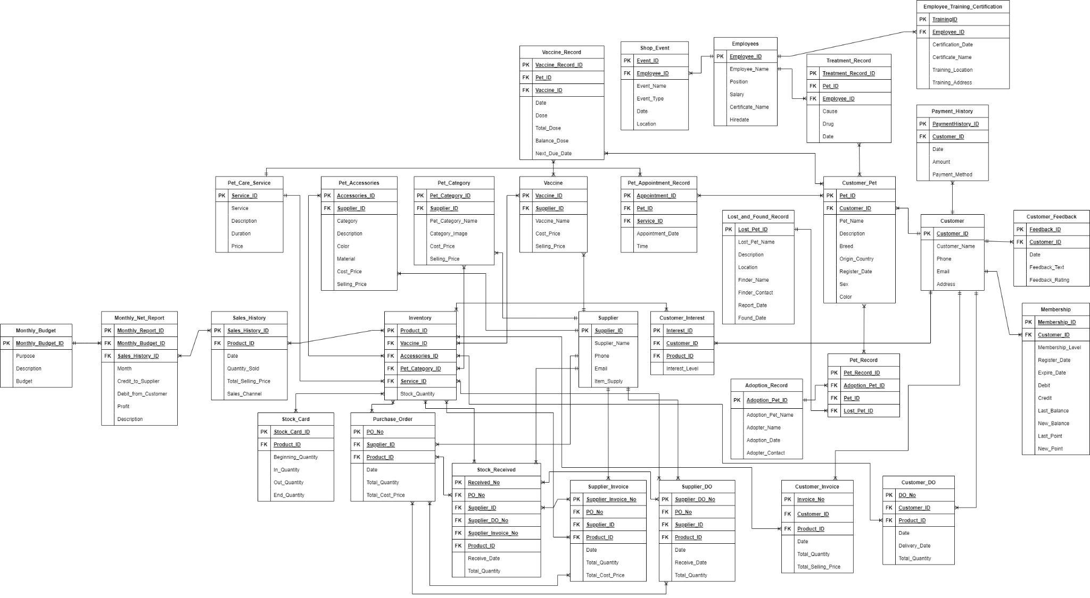

## **2.2 Chen Notation Diagram**

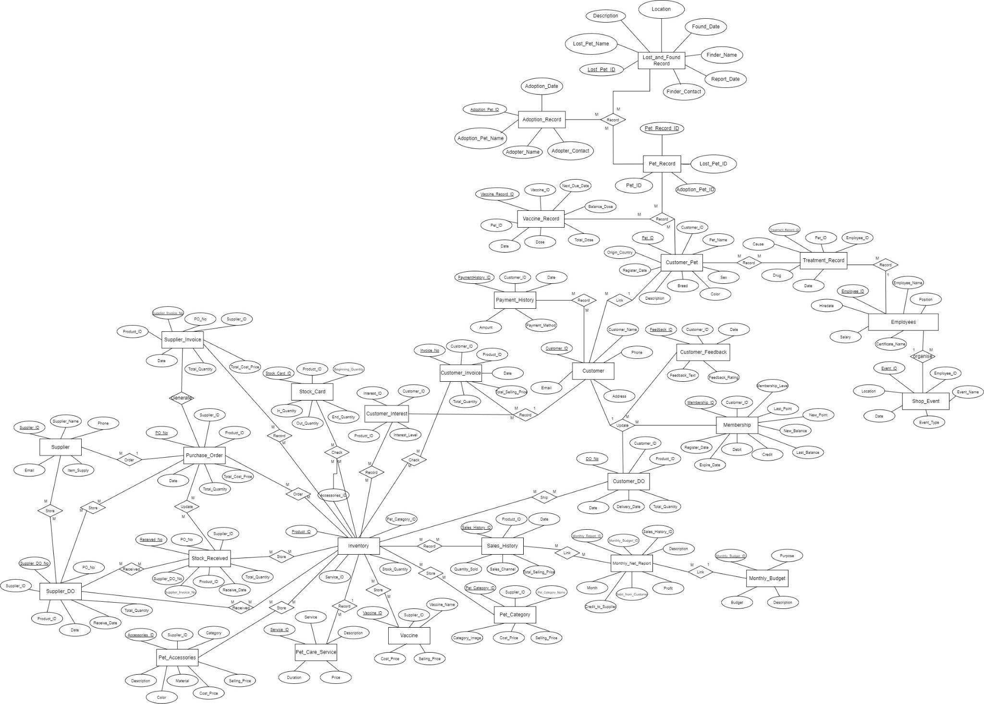

## **2.3 Data Flow Diagram Level 1**

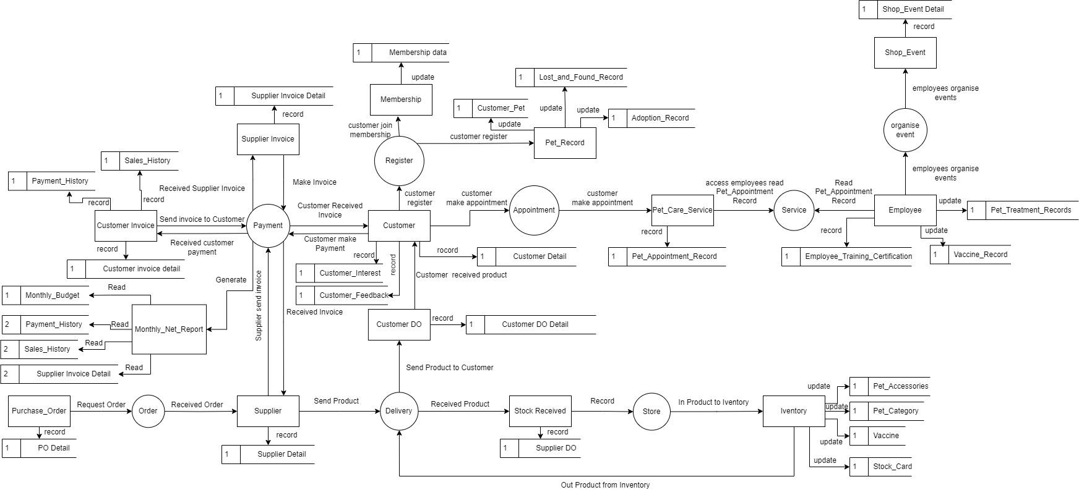

# **3. Data Definition Language (DDL) & Data Manipulation Language (DML)**

## **3.1 Create Database**

CREATE DATABASE Pet_Shop;

***Output***

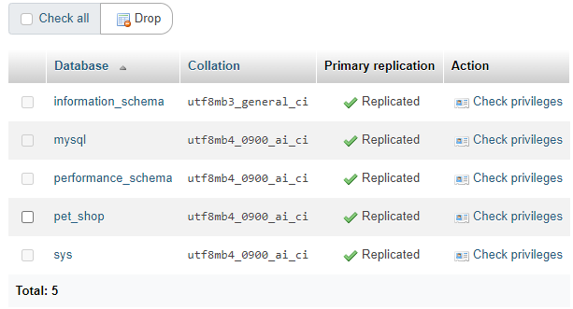

## **3.2 Create Table**

USE Pet_Shop;

CREATE TABLE Monthly_Budget (

Monthly_Budget_ID VARCHAR(10) NOT NULL,

Purpose VARCHAR(50),

Description TEXT,

Budget DECIMAL(10,2),

PRIMARY KEY (Monthly_Budget_ID)

);

CREATE TABLE Supplier (

Supplier_ID VARCHAR(10) NOT NULL,

Supplier_Name VARCHAR (200),

Phone VARCHAR (20),

Email VARCHAR (200),

Item_Supply VARCHAR (50),

PRIMARY KEY (Supplier_ID)

);

CREATE TABLE Pet_Care_Service (

Service_ID VARCHAR(10) NOT NULL,

Service VARCHAR (50),

Description TEXT,

Duration VARCHAR (20),

Price DECIMAL (10,2),

PRIMARY KEY (Service_ID)

);

CREATE TABLE Pet_Accessories (

Accessories_ID VARCHAR (10) NOT NULL,

Category VARCHAR (20),

Description TEXT,

Color VARCHAR (20),

Material VARCHAR (20),

Supplier_ID VARCHAR (10),

Cost_Price DECIMAL (10,2),

Selling_Price DECIMAL (10,2),

PRIMARY KEY (Accessories_ID),

FOREIGN KEY (Supplier_ID) REFERENCES Supplier (Supplier_ID)

);

CREATE TABLE Pet_Category (

Pet_Category_ID VARCHAR(10) NOT NULL,

Pet_Category_Name VARCHAR (50),

Category_Image BLOB,

Supplier_ID VARCHAR (10),

Cost_Price DECIMAL (10,2),

Selling_Price DECIMAL (10,2),

PRIMARY KEY (Pet_Category_ID),

FOREIGN KEY (Supplier_ID) REFERENCES Supplier (Supplier_ID)

);

CREATE TABLE Vaccine (

Vaccine_ID VARCHAR(10) NOT NULL,

Vaccine_Name VARCHAR (50),

Supplier_ID VARCHAR (10),

Cost_Price DECIMAL (10,2),

Selling_Price DECIMAL (10,2),

PRIMARY KEY (Vaccine_ID),

FOREIGN KEY (Supplier_ID) REFERENCES Supplier (Supplier_ID)

);

CREATE TABLE Inventory (

Product_ID VARCHAR(10) NOT NULL,

Service_ID VARCHAR (10),

Accessories_ID VARCHAR (10),

Pet_Category_ID VARCHAR (10),

Vaccine_ID VARCHAR (10),

Stock_Quantity INT (10),

PRIMARY KEY (Product_ID),

FOREIGN KEY (Service_ID) REFERENCES Pet_Care_Service (Service_ID),

FOREIGN KEY (Accessories_ID) REFERENCES Pet_Accessories (Accessories_ID),

FOREIGN KEY (Pet_Category_ID) REFERENCES Pet_Category (Pet_Category_ID),

FOREIGN KEY (Vaccine_ID) REFERENCES Vaccine (Vaccine_ID)

);

CREATE TABLE Customer (

Customer_ID VARCHAR(10) NOT NULL,

Customer_Name VARCHAR (50),

Phone VARCHAR (20),

Email VARCHAR (200),

Address VARCHAR (200),

PRIMARY KEY (Customer_ID)

);

CREATE TABLE Customer_Pet (

Pet_ID VARCHAR(10) NOT NULL,

Pet_Name VARCHAR (50),

Customer_ID VARCHAR (10),

Description TEXT,

Breed VARCHAR (50),

Origin_Country VARCHAR (50),

Sex VARCHAR (10),

Color VARCHAR (20),

Register_Date DATE,

PRIMARY KEY (Pet_ID),

FOREIGN KEY (Customer_ID) REFERENCES Customer (Customer_ID)

);

CREATE TABLE Adoption_Record (

Adoption_Pet_ID VARCHAR(10) NOT NULL,

Adoption_Pet_Name VARCHAR (50),

Adopter_Name VARCHAR (50),

Adoption_Date DATE,

Adopter_Contact VARCHAR (20),

PRIMARY KEY (Adoption_Pet_ID)

);

CREATE TABLE Lost_and_Found_Record (

Lost_Pet_ID VARCHAR(10) NOT NULL,

Lost_Pet_Name VARCHAR(50),

Description TEXT,

Location VARCHAR (50),

Finder_Name VARCHAR (50),

Finder_Contact VARCHAR (20),

Report_Date DATE,

Found_Date DATE,

PRIMARY KEY (Lost_Pet_ID)

);

CREATE TABLE Pet_Record (

Pet_Record_ID VARCHAR(10) NOT NULL,

Pet_ID VARCHAR (10),

Adoption_Pet_ID VARCHAR (10),

Lost_Pet_ID VARCHAR (10),

PRIMARY KEY (Pet_Record_ID),

FOREIGN KEY (Pet_ID) REFERENCES Customer_Pet (Pet_ID),

FOREIGN KEY (Adoption_Pet_ID) REFERENCES Adoption_Record (Adoption_Pet_ID),

FOREIGN KEY (Lost_Pet_ID) REFERENCES Lost_and_Found_Record (Lost_Pet_ID)

);

CREATE TABLE Membership (

Membership_ID VARCHAR(10) NOT NULL,

Customer_ID VARCHAR (10),

Membership_Level VARCHAR (10),

Register_Date DATE,

Expire_Date DATE,

Debit DECIMAL (10,2),

Credit DECIMAL (10,2),

Last_Balance DECIMAL (10,2),

New_Balance DECIMAL (10,2),

Last_Point DECIMAL (10,2),

New_Point DECIMAL (10,2),

PRIMARY KEY (Membership_ID),

FOREIGN KEY (Customer_ID) REFERENCES Customer (Customer_ID)

);

CREATE TABLE Pet_Appointment_Record (

Appointment_ID VARCHAR(10) NOT NULL,

Appointment_Date DATE,

Time TIME,

Pet_ID VARCHAR (10),

Service_ID VARCHAR (10),

PRIMARY KEY (Appointment_ID),

FOREIGN KEY (Pet_ID) REFERENCES Customer_Pet (Pet_ID),

FOREIGN KEY (Service_ID) REFERENCES Pet_Care_Service (Service_ID)

);

CREATE TABLE Purchase_Order (

PO_No VARCHAR(10) NOT NULL,

Date DATE,

Supplier_ID VARCHAR (10),

Product_ID VARCHAR (10),

Total_Quantity INT (10),

Total_Cost_Price DECIMAL (10,2),

PRIMARY KEY (PO_No),

FOREIGN KEY (Supplier_ID) REFERENCES Supplier (Supplier_ID),

FOREIGN KEY (Product_ID) REFERENCES Inventory (Product_ID)

);

CREATE TABLE Customer_Invoice (

Invoice_No VARCHAR(10) NOT NULL,

Date DATE,

Customer_ID VARCHAR (10),

Product_ID VARCHAR (10),

Total_Quantity INT (10),

Total_Selling_Price DECIMAL (10,2),

PRIMARY KEY (Invoice_No),

FOREIGN KEY (Customer_ID) REFERENCES Customer (Customer_ID),

FOREIGN KEY (Product_ID) REFERENCES Inventory (Product_ID)

);

CREATE TABLE Customer_DO (

DO_No VARCHAR(10) NOT NULL,

Date DATE,

Delivery_Date DATE,

Customer_ID VARCHAR (10),

Product_ID VARCHAR (10),

Total_Quantity INT (10),

PRIMARY KEY (DO_No),

FOREIGN KEY (Customer_ID) REFERENCES Customer (Customer_ID),

FOREIGN KEY (Product_ID) REFERENCES Inventory (Product_ID)

);

CREATE TABLE Supplier_Invoice (

Supplier_Invoice_No VARCHAR(10) NOT NULL,

Date DATE,

Supplier_ID VARCHAR (10),

PO_No VARCHAR (10),

Product_ID VARCHAR (10),

Total_Quantity INT (10),

Total_Cost_Price DECIMAL(10,2),

PRIMARY KEY (Supplier_Invoice_No),

FOREIGN KEY (Supplier_ID) REFERENCES Supplier (Supplier_ID),

FOREIGN KEY (PO_No) REFERENCES Purchase_Order (PO_No),

FOREIGN KEY (Product_ID) REFERENCES Inventory (Product_ID)

);

CREATE TABLE Supplier_DO (

Supplier_DO_No VARCHAR(10) NOT NULL,

Date DATE,

Receive_Date DATE,

Supplier_ID VARCHAR (10),

PO_No VARCHAR (10),

Product_ID VARCHAR (10),

Total_Quantity INT (10),

PRIMARY KEY (Supplier_DO_No),

FOREIGN KEY (Supplier_ID) REFERENCES Supplier (Supplier_ID),

FOREIGN KEY (PO_No) REFERENCES Purchase_Order (PO_No),

FOREIGN KEY (Product_ID) REFERENCES Inventory (Product_ID)

);

CREATE TABLE Stock_Received (

Received_No VARCHAR(10) NOT NULL,

Receive_Date DATE,

Supplier_Invoice_No VARCHAR (10),

Supplier_DO_No VARCHAR (10),

Supplier_ID VARCHAR (10),

PO_No VARCHAR (10),

Product_ID VARCHAR (10),

Total_Quantity INT (10),

PRIMARY KEY (Received_No),

FOREIGN KEY (Supplier_Invoice_No) REFERENCES Supplier_Invoice (Supplier_Invoice_No),

FOREIGN KEY (Supplier_DO_No) REFERENCES Supplier_DO (Supplier_DO_No),

FOREIGN KEY (Supplier_ID) REFERENCES Supplier (Supplier_ID),

FOREIGN KEY (PO_No) REFERENCES Purchase_Order (PO_No),

FOREIGN KEY (Product_ID) REFERENCES Inventory (Product_ID)

);CREATE TABLE Stock_Card (

Stock_Card_ID VARCHAR(10) NOT NULL,

Product_ID VARCHAR (10),

Beginning_Quantity INT (10),

In_Quantity INT (10),

Out_Quantity INT (10),

End_Quantity INT (10),

PRIMARY KEY (Stock_Card_ID),

FOREIGN KEY (Product_ID) REFERENCES Inventory (Product_ID)

);

CREATE TABLE Customer_Interest (

Interest_ID VARCHAR(10) NOT NULL,

Customer_ID VARCHAR (10),

Product_ID VARCHAR (10),

Interest_Level VARCHAR (20),

PRIMARY KEY (Interest_ID),

FOREIGN KEY (Customer_ID) REFERENCES Customer (Customer_ID),

FOREIGN KEY (Product_ID) REFERENCES Inventory (Product_ID)

);

CREATE TABLE Customer_Feedback (

Feedback_ID VARCHAR(10) NOT NULL,

Customer_ID VARCHAR (10),

Date DATE,

Feedback_Text VARCHAR (500),

Feedback_Rating INT (5),

PRIMARY KEY (Feedback_ID),

FOREIGN KEY (Customer_ID) REFERENCES Customer (Customer_ID)

);

CREATE TABLE Employees (

Employee_ID VARCHAR(10) NOT NULL,

Employee_Name VARCHAR(50),

Position VARCHAR(50),

Salary DECIMAL(10,2),

Certificate_Name VARCHAR(200),

Hiredate DATE,

PRIMARY KEY (Employee_ID)

);

CREATE TABLE Employee_Training_Certification (

TrainingID VARCHAR(10) NOT NULL,

Employee_ID VARCHAR (10),

Certification_Date DATE,

Certificate_Name VARCHAR(50),

Training_Location VARCHAR(50),

Training_Address VARCHAR(100),

PRIMARY KEY (TrainingID),

FOREIGN KEY (Employee_ID) REFERENCES Employees (Employee_ID)

);

CREATE TABLE Pet_Treatment_Records (

Treatment_Record_ID VARCHAR(10) NOT NULL,

Pet_ID VARCHAR (10),

Cause VARCHAR(200),

Drug VARCHAR(200),

Date DATE,

Employee_ID VARCHAR (10),

PRIMARY KEY (Treatment_Record_ID),

FOREIGN KEY (Pet_ID) REFERENCES Customer_Pet (Pet_ID),

FOREIGN KEY (Employee_ID) REFERENCES Employees (Employee_ID)

);

CREATE TABLE Vaccine_Record (

Vaccine_Record_ID VARCHAR(10) NOT NULL,

Pet_ID VARCHAR (10),

Vaccine_ID VARCHAR (10),

Date DATE,

Dose INT(5),

Total_Dose INT(5),

Balance_Dose INT(5),

Next_Due_Date DATE,

PRIMARY KEY (Vaccine_Record_ID),

FOREIGN KEY (Pet_ID) REFERENCES Customer_Pet (Pet_ID),

FOREIGN KEY (Vaccine_ID) REFERENCES Vaccine (Vaccine_ID)

);

CREATE TABLE Shop_Event (

Event_ID VARCHAR(10) NOT NULL,

Event_Name VARCHAR(200),

Event_Type VARCHAR(200),

Date DATE,

Location VARCHAR(100),

Employee_ID VARCHAR (10),

PRIMARY KEY (Event_ID),

FOREIGN KEY (Employee_ID) REFERENCES Employees (Employee_ID)

);

CREATE TABLE Sales_History (

Sales_History_ID VARCHAR(10) NOT NULL,

Date DATE,

Product_ID VARCHAR (10),

Quantity_Sold INT(5),

Total_Selling_Price DECIMAL(10,2),

Sales_Channel VARCHAR(50),

PRIMARY KEY (Sales_History_ID),

FOREIGN KEY (Product_ID) REFERENCES Inventory (Product_ID)

);

CREATE TABLE Payment_History (

PaymentHistory_ID VARCHAR(10) NOT NULL,

Customer_ID VARCHAR (10),

Date DATE,

Amount DECIMAL(10,2),

Payment_Method VARCHAR(50),

PRIMARY KEY (PaymentHistory_ID),

FOREIGN KEY (Customer_ID) REFERENCES Customer (Customer_ID)

);

CREATE TABLE Monthly_Net_Report (

Monthly_Report_ID VARCHAR(10) NOT NULL,

Month DATE,

Credit_to_Supplier DECIMAL(10,2),

Debit_from_Customer DECIMAL(10,2),

Sales_History_ID VARCHAR (10),

Monthly_Budget_ID VARCHAR (10),

Profit DECIMAL(10, 2),

Description VARCHAR(300),

PRIMARY KEY (Monthly_Report_ID),

FOREIGN KEY (Sales_History_ID) REFERENCES Sales_History (Sales_History_ID),

FOREIGN KEY (Monthly_Budget_ID) REFERENCES Monthly_Budget (Monthly_Budget_ID)

);

***Output***

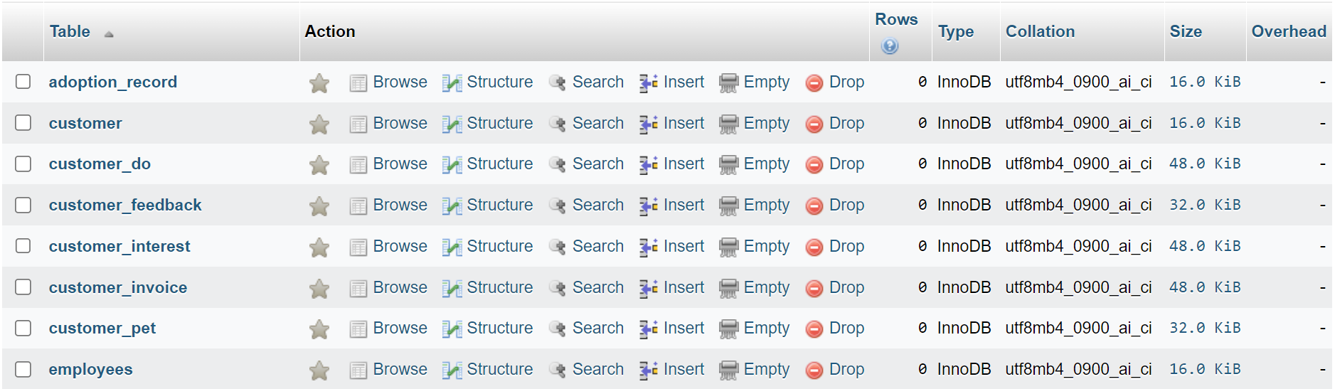

***^ Figure 1: shows output table from Adoption Record to table Employees***

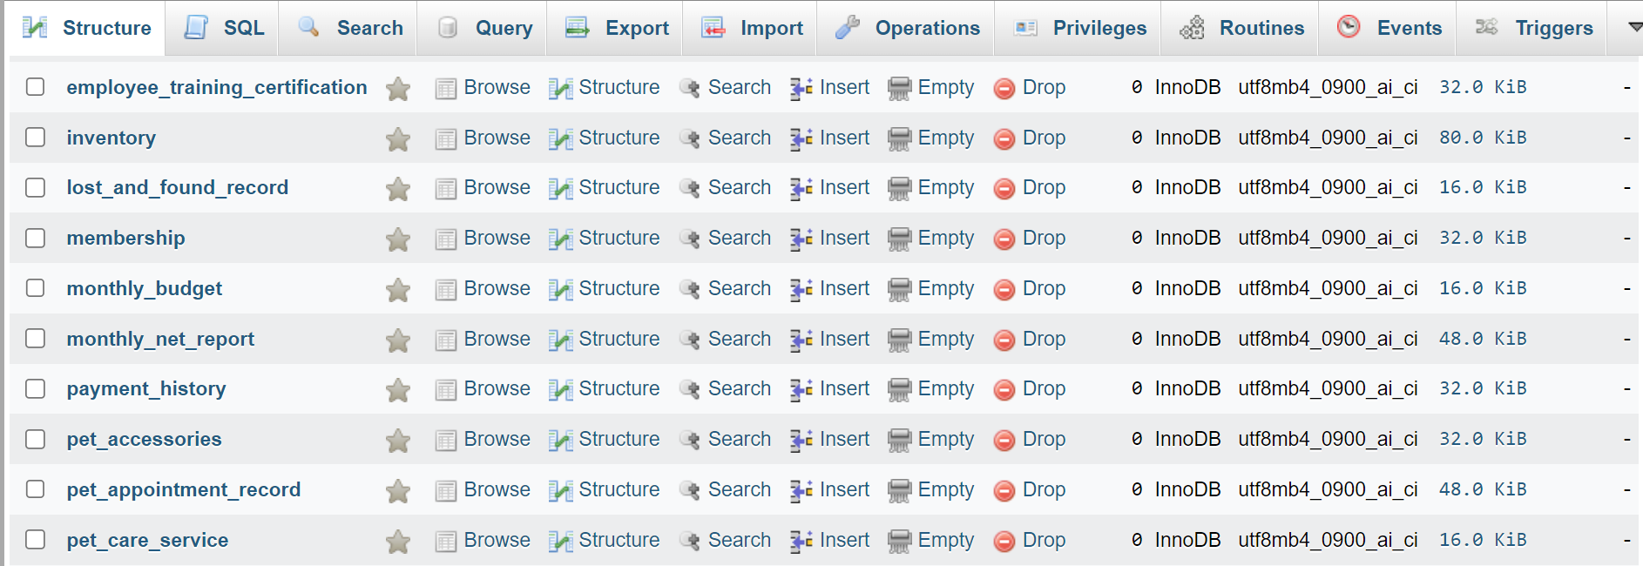

***^ Figure 2: shows output table from Employee Training Certification to table Pet care service***

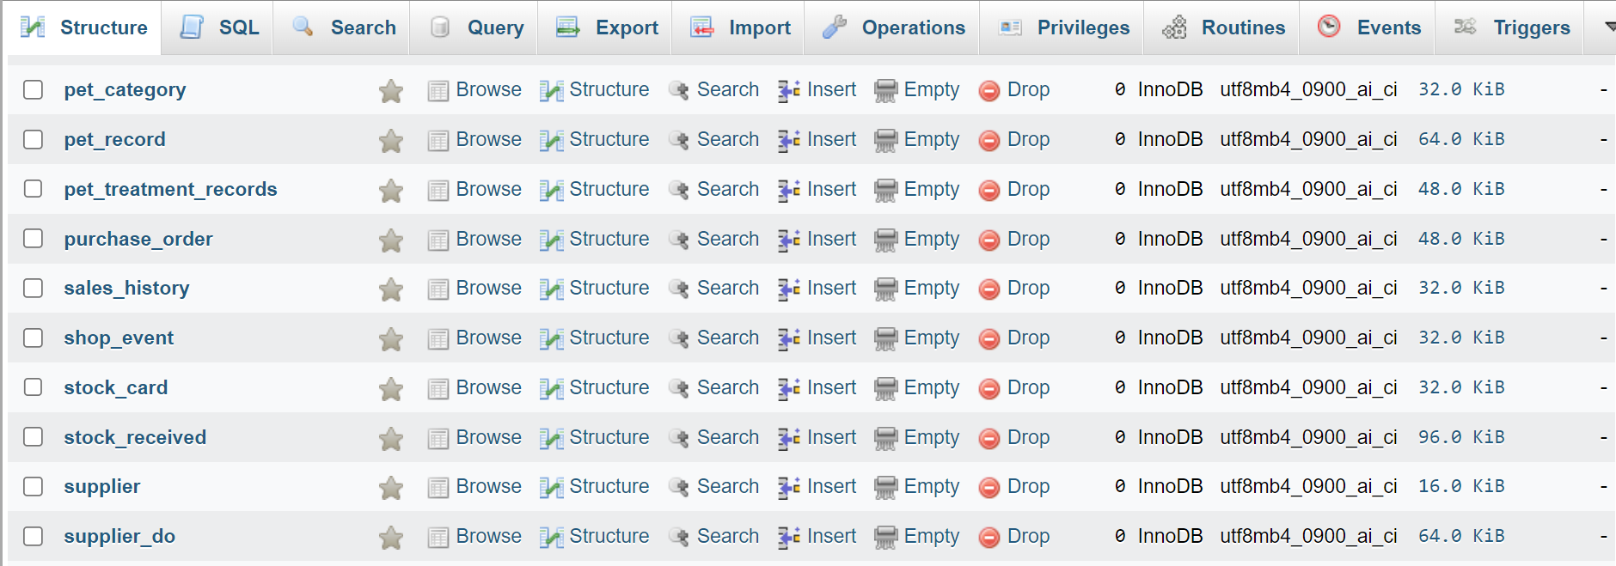

***^ Figure 3: shows output table from Pet Category to Table Supplier DO***

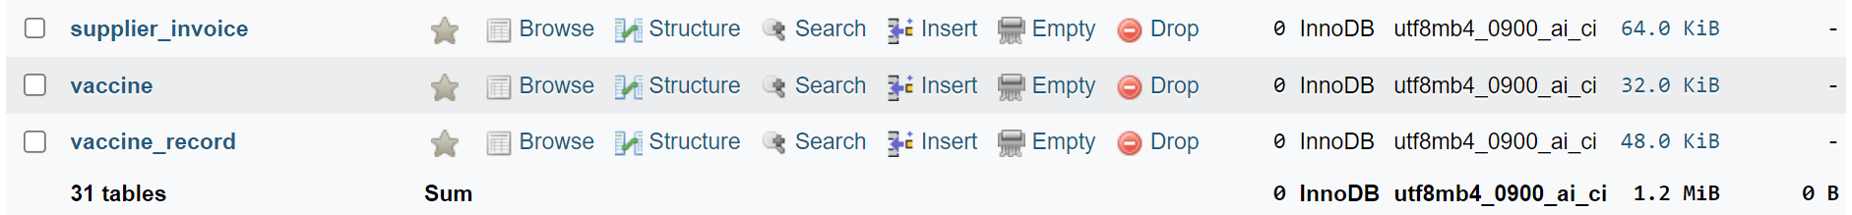

***^ Figure 4: shows output table from Supplier Invoice to Table Vaccine Record***

***\*Note: The output of the order table is organized alphabetically (A-Z), rather than following the order specified by the SQL code as mentioned above.***

## **3.3 Insert Value**

### **3.3.1 Table Monthly Budget**

INSERT INTO Monthly_Budget (Monthly_Budget_ID, Purpose, Description, Budget)

VALUES

("MB00001", "Employee Salaries", "Used to track payroll expenses paid to pet store employees", 100000.00),

("MB00002", "Inventory Purchases", "Used to record spending on pet food, supplies and products", 15000.00),

("MB00003", "Advertising and Promotion", "Spending on pet store promotions and promotions", 20000.00),

("MB00004", "Rent and Lease", "Used to pay rent or lease fees for the pet store location", 5000.00),

("MB00005", "Pet Care ", "Used to record expenses for providing pet care services", 25000.00);

***Output***

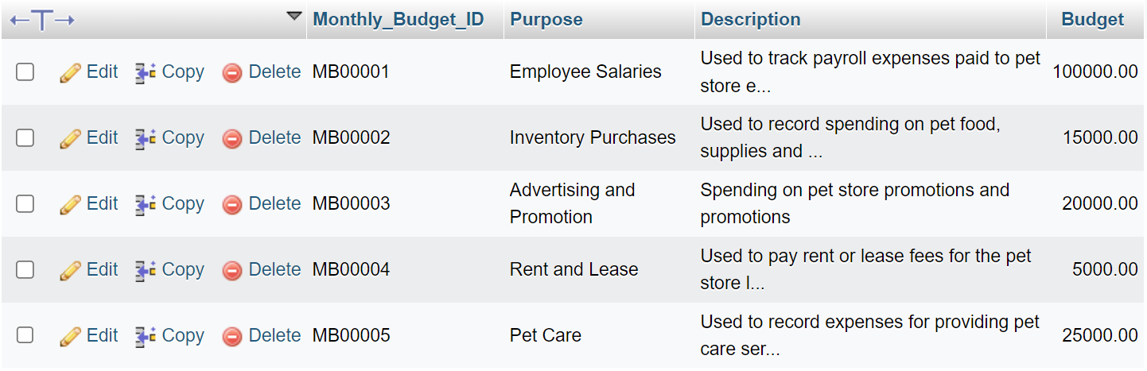

### **3.3.2 Table Supplier**

INSERT INTO Supplier (Supplier_ID, Supplier_Name, Phone, Email, Item_Supply)

VALUES

("SU00001", "Sin Yew Lai Trading Sdn Bhd", "010-228 0901", "syiewl68@gmail.com", "Bed, Leash,Bowl"),

("SU00002", "Jom Jom Pet", "011-332 6654", "JJ2002@gmail.com", "Collar"),

("SU00003", "Sea Park Pet Supplier", "012-541 3236", "seap68@gmail.com", "Clothes, Toys"),

("SU00004", "Pet Lovers Centred", "013-482 0565", "petlovers@gmail.com", "Scratcher"),

("SU00005", "Paws & Whiskers Supply Co.", "014-513 1213", "pawsnwhiskers22@gmail.com", "Beds, Toys, Grooming"),

("SU00006", "Happy Tails Pet Emporium", "012-215 3352", "happytailspets21@gmail.com", "Collars, Harnesses, Treats"),

("SU00007", "Medical Vaccine SdnBhd", "018-520 0662", "petmedic@gmail.com", "Vaccine"),

("SU00008", "Pet Vaccine Sdn Bhd", "012-682 6362", "petvaccine@gmail.comm", "Vaccine"),

("SU00009", "Lovely Pets Sdn Bhd", "015-421 2220", "happypet@gmail.com", "Dogs"),

("SU00010", "Cute Pets Sdn Bhd", "015-225 5600", "cutepet33@gmail.com", "Cats");

***Output***

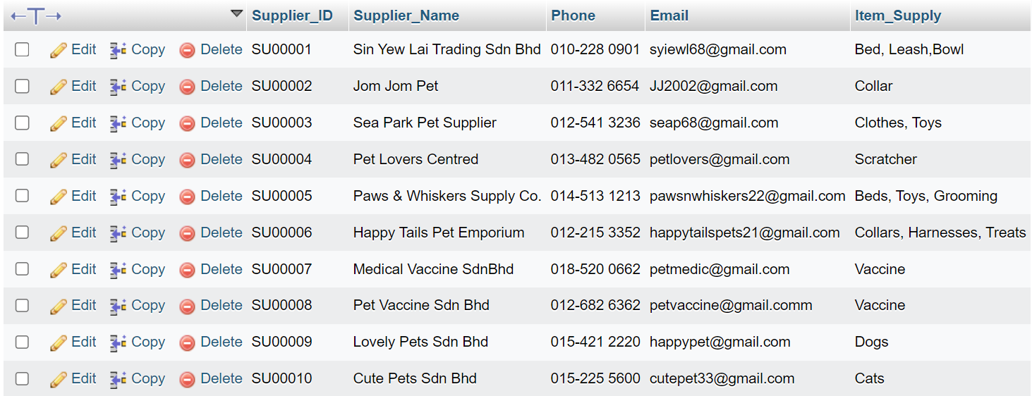

### **3.3.3 Table Pet Care Service**

INSERT INTO Pet_Care_Service (Service_ID, Service, Description, Duration, Price)

VALUES

("SE00001", "Grooming", "Grooming service for pets. Includes bath, haircut, and nail trimming", "1 hour", 45),

("SE00002", "Checkup", "Regular health checkup for pets, including a thorough examination", "45 mins", 35),

("SE00003", "Vaccination", "Pet vaccination service to ensure they stay healthy and protected", "1 hour", 50),

("SE00004", "Training", "Professional pet training to teach obedience and good behaviour", "1 hour", 55),

("SE00005", "Boarding", "Pet boarding service for overnight stays with full care and attention", "2 hours", 60);

***Output***

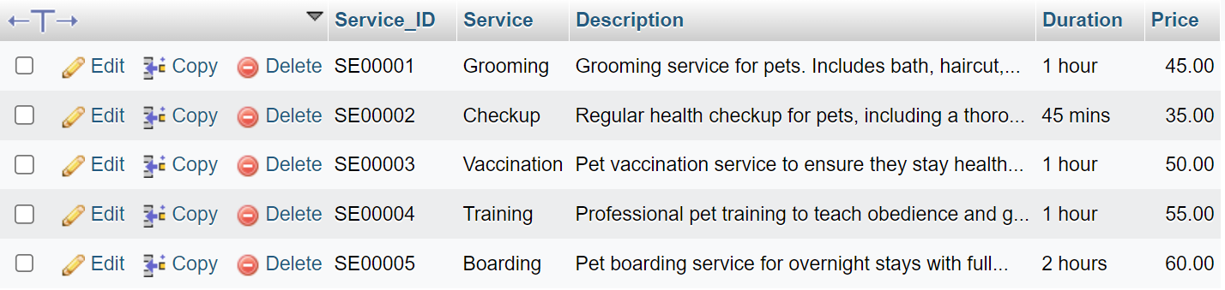

### **3.3.4 Table Pet Accessories**

INSERT INTO Pet_Accessories (Accessories_ID, Category, Description, Color, Material, Supplier_ID, Cost_Price, Selling_Price)

VALUES

("AC00001", "Bed", "A Cozy Pet Bed for Sweet Dreams", "Blue", "Cotton", "SU00001", 40, 80),

("AC00002", "Bed", "A Stylish Leather Collar", "Black", "Leather", "SU00002", 10, 20),

("AC00003", "Bed", "A Durable Nylon Leash", "Black", "Nylon", "SU00001", 10, 20),

("AC00004", "Bed", "Sporty Baseball Tank Top", "Grey", "Cotton", "SU00003", 15, 30),

("AC00005", "Bed", "Playful Plush Toys for Fun", "Yellow", "Plush", "SU00003", 15, 30);

***Output***

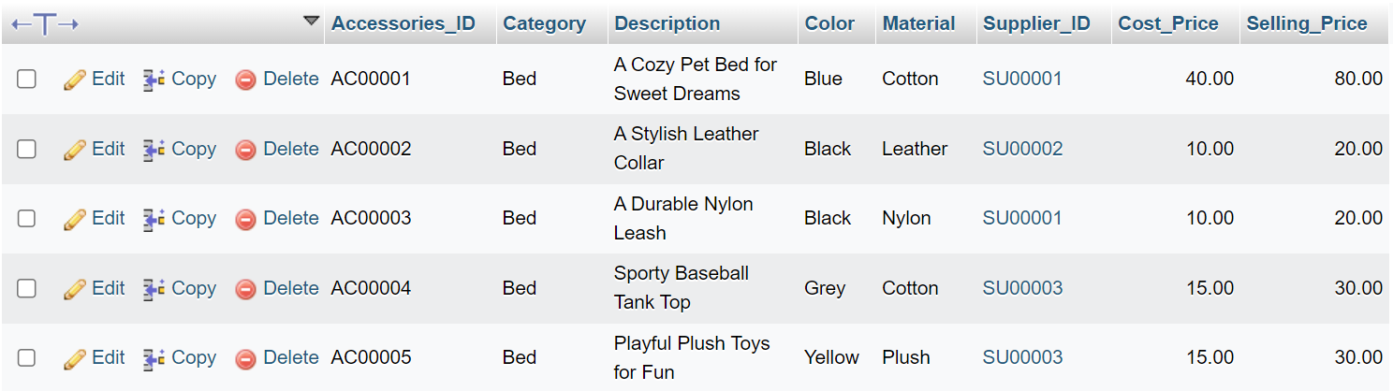

### **3.3.5 Table Pet Category**

INSERT INTO Pet_Category (Pet_Category_ID, Pet_Category_Name, Supplier_ID, Cost_Price, Selling_Price)

VALUES

("DOG00001", "Dog - Siberian Husky","SU00009", "150", 300),

("DOG00002", "Dog - Poodle", "SU00009", "200", 400),

("DOG00003", "Dog - French Bulldog", "SU00009", "400", 800),

("DOG00004", "Dog - Border Collie", "SU00009", "300", 600),

("DOG00005", "Dog - Golden Retriever", "SU00009", "250", 500);

***Output***

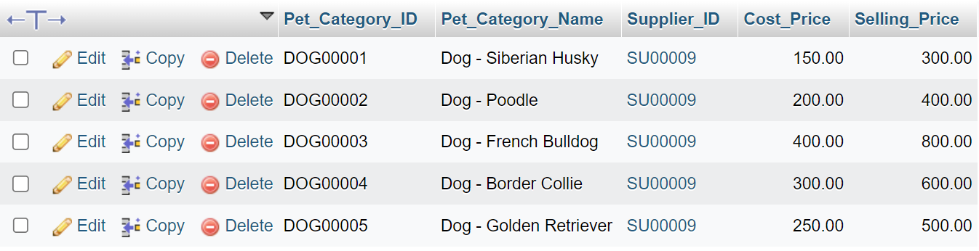

### **3.3.6 Table Vaccine**

INSERT INTO Vaccine (Vaccine_ID, Vaccine_Name, Supplier_ID, Cost_Price, Selling_Price)

VALUES

("VA00001", "Leptospirosis", "SU00007", 60, 120),

("VA00002", "Distemper", "SU00007", 60, 120),

("VA00003", "Canine influenza", "SU00007", 60, 120),

("VA00004", "Kennel cough", "SU00007", 60, 120),

("VA00005", "Feline calicivirus", "SU00007", 60, 120);

***Output***

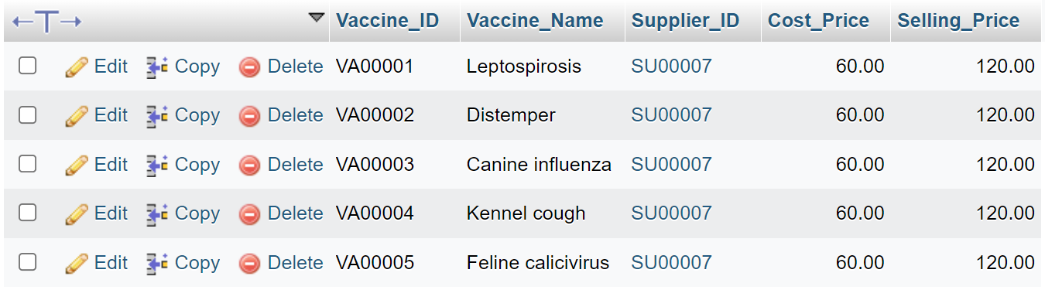

### **3.3.7 Table Inventory**

INSERT INTO Inventory (Product_ID, Service_ID, Accessories_ID, Pet_Category_ID, Vaccine_ID, Stock_Quantity)

VALUES

("PD00001", NULL, NULL, NULL, "VA00001", 30),

("PD00002", NULL, "AC00002", NULL, NULL, 30),

("PD00003", NULL, NULL, "DOG00003", NULL, 30),

("PD00004", "SE00004", NULL, NULL, NULL, 10000),

("PD00005", NULL, NULL, NULL, "VA00005", 30)

***Output***

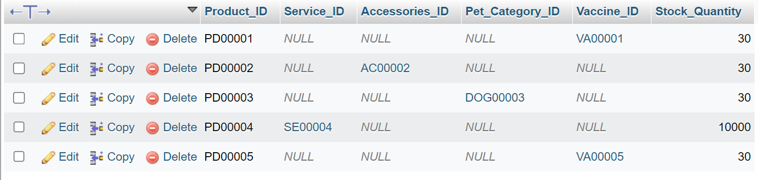

### **3.3.8 Table Customer**

INSERT INTO Customer (Customer_ID, Customer_Name, Phone, Email, Address)

VALUES

("CU00001", "Terry", "010 789 2531", "terry@gmail.com", "Jalan Durian 23, Taman Indah"),

("CU00002", "BuTong", "011 321 6513", "butong@gmail.com", "Jalan Sansan 77, Taman Mana"),

("CU00003", "Jaspi", "012 325 4064", "Jaspi@gmail.com", "Jalan SamLong 88, Taman Mua"),

("CU00004", "LianNi", "013 821 0653", "LianNi@gmail.com", "Jalan Yikyik 21, Taman Long"),

("CU00005", "Nick", "014 021 5248", "Nick@gmail.com", "Jalan Jing 45, Taman Yu");

***Output***

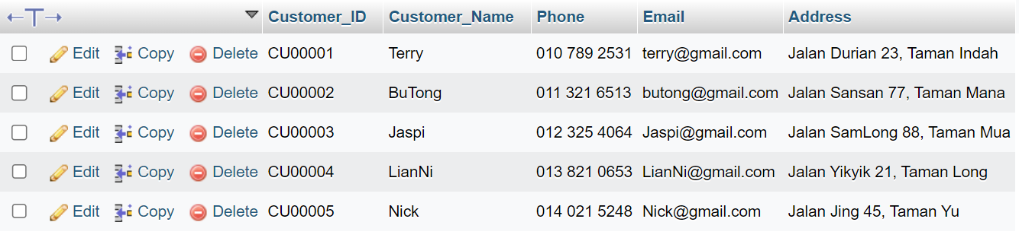

### **3.3.9 Table Customer Pet**

INSERT INTO Customer_Pet (Pet_ID, Pet_Name, Customer_ID, Description, Breed, Origin_Country, Sex, Color, Register_Date)

VALUES

("PID00001", "Lola", "CU00001", "Small, white-coated, affectionate dogs", "Maltese", "South Korea", "male", "white", "2023-01-08"),

("PID00002", "Max", "CU00002", "Lively, fluffy small dogs", "Pomeranian", "Taiwan", "male", "brown", "2023-01-08"),

("PID00003", "Fluffy", "CU00003", "Elegant, social cats with blue eyes", "Siamese", "Thailand", "female", "blue point", "2023-01-08"),

("PID00004", "Jeffrey", "CU00004", "Large, laid-back cats with blue eyes", "Ragdoll", "California", "male", "seal", "2023-01-08"),

("PID00005", "Isabella", "CU00005", "Friendly, keen-scented hounds", "Beagle", "United States", "female", "black", "2023-01-08");

***Output***

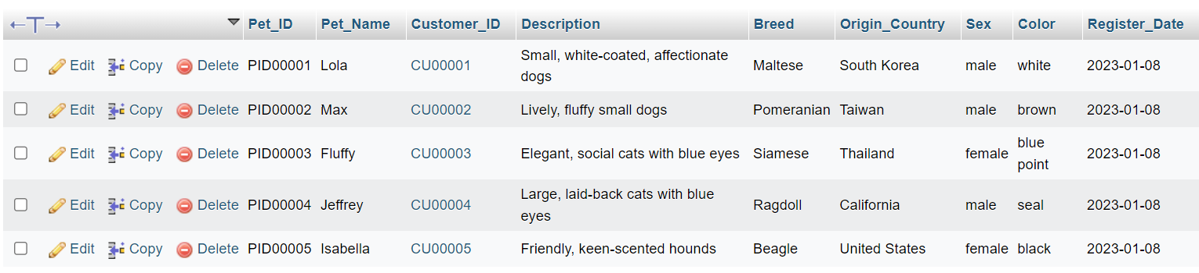

### **3.3.10 Table Adoption Record**

INSERT INTO Adoption_Record (Adoption_Pet_ID, Adoption_Pet_Name, Adopter_Name, Adoption_Date, Adopter_Contact)

VALUES

("AID00001", "Daisy", "Jimmy Wong", "2023-01-08", "012 339 8543"),

("AID00002", "Bear", "Shirley Yuen", "2023-01-08", "013 556 8064"),

("AID00003", "Buddy", "Justin Looi", "2023-01-08", "011 566 5470"),

("AID00004", "Duke", "Max Lee", "2023-01-08", "018 505 0186"),

("AID00005", "Charlie", "Carmen Kuo", "2023-01-08", "017 655 5621");

***Output***

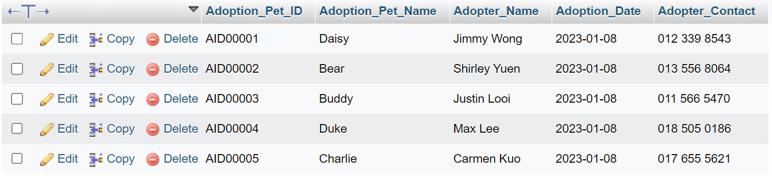

### **3.3.11 Table Lost And Found Record**

INSERT INTO Lost_and_Found_Record (Lost_Pet_ID, Lost_Pet_Name, Description, Location, Finder_Name, Finder_Contact, Report_Date, Found_Date)

VALUES

("LID00001", "Lucy", "A white Persian cat with blue eyes", "Setia Eco Park", "Allison Ho", "012 648 8148", "2023-01-10", "2023-03-10"),

("LID00002", "Anna", "Found a brown Labrador Retriever", "Cyberjaya Lake Gardens", "Kendra Sow", "013 432 6563", "2023-01-10", "2023-03-10"),

("LID00003", "Luna", "Spotted a Siamese cat with blue eyes", "Origami Park", "Summer Yuen", "014 546 8970", "2023-01-10", "2023-03-10"),

("LID00004", "Susan", "Found a lost Ragdoll cat", "Villea Port Dickson", "Benjamin Chin", "015 627 0264", "2023-01-10", "2023-03-10"),

("LID00005", "Jack", "Discovered a stray Beagle", "Bark Park", "Christine Tay", "016 188 3254", "2023-01-10", "2023-03-10");

***Output***

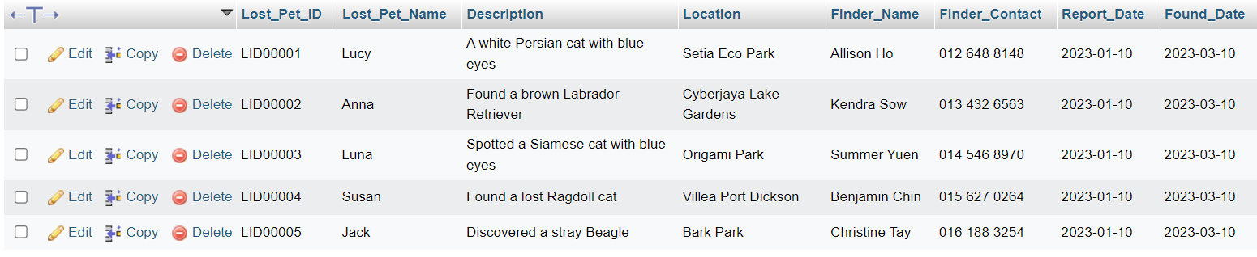

### **3.3.12 Table Pet Record**

INSERT INTO Pet_Record (Pet_Record_ID, Pet_ID, Adoption_Pet_ID, Lost_Pet_ID)

VALUES

("PR00001", "PID00001", "AID00001", "LID00001"),

("PR00002", "PID00002", "AID00002", "LID00002"),

("PR00003", "PID00003", "AID00003", "LID00003"),

("PR00004", "PID00004", "AID00004", "LID00004"),

("PR00005", "PID00005", "AID00005", "LID00005");

***Output***

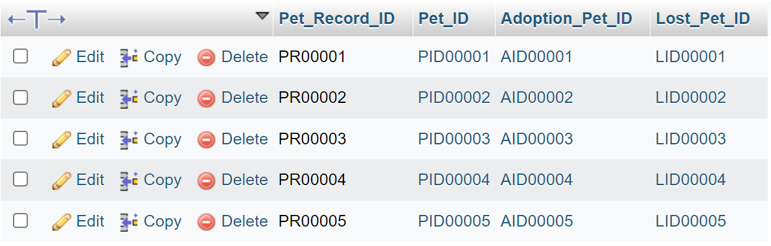

### **3.3.13 Table Membership**

INSERT INTO Membership (Membership_ID, Customer_ID, Membership_Level, Register_Date, Expire_Date, Debit, Credit, Last_Balance, New_Balance, Last_Point, New_Point)

VALUES

("ME00001", "CU00001", "VIP", "2023-01-10", "2024-01-10", 300, 30, 1000, 1270, 500, 530),

("ME00002", "CU00002", "VVIP", "2023-01-10", "2024-01-10", 500, 50, 500, 950, 300, 700),

("ME00003", "CU00003", "VVVIP", "2023-01-10", "2024-01-10", 1000, 60, 800, 1740, 400, 1380),

("ME00004", "CU00004", "VIP", "2023-01-10", "2024-01-10", 300, 100, 900, 1100, 50, 150),

("ME00005", "CU00005", "VVIP", "2023-01-10", "2024-01-10", 500, 70, 600, 1030, 600, 1340);

***Output***

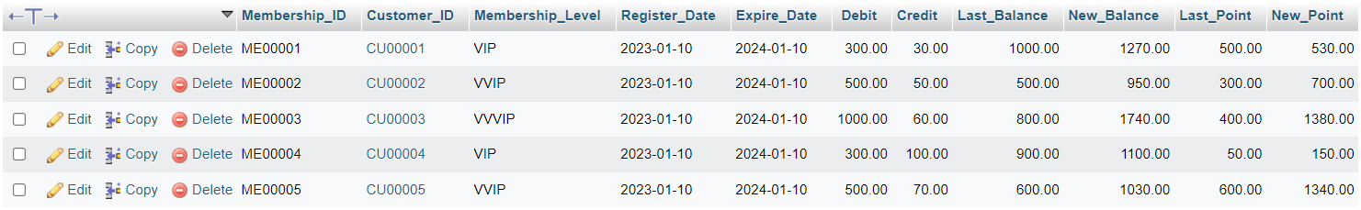

### **3.3.14 Table Pet Appointment Record**

INSERT INTO Pet_Appointment_Record (Appointment_ID, Appointment_Date, Time, Pet_ID, Service_ID)

VALUES

("AP00001", "2023-01-08", "10:00:00", "PID00001", "SE00001"),

("AP00002", "2023-01-08", "14:30:00", "PID00002", "SE00002"),

("AP00003", "2023-01-08", "15:45:00", "PID00003", "SE00003"),

("AP00004", "2023-01-08", "11:15:00", "PID00004", "SE00004"),

("AP00005", "2023-01-08", "13:00:00", "PID00005", "SE00005");

***Output***

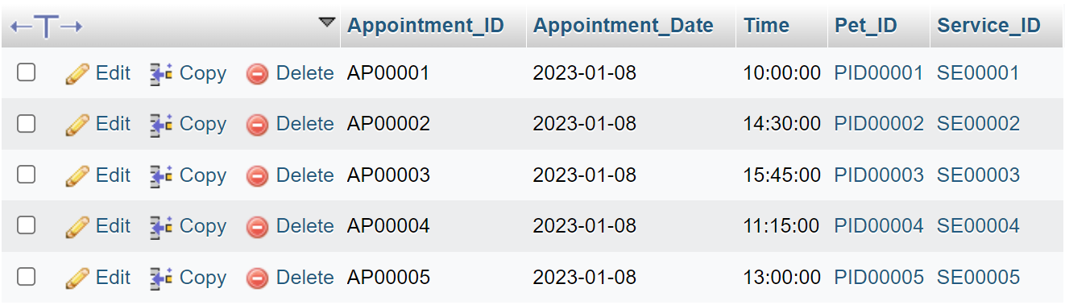

### **3.3.15 Table Purchase Order**

INSERT INTO Purchase_Order (PO_No, Date, Supplier_ID, Product_ID, Total_Quantity, Total_Cost_Price)

VALUES

("PO00001", "2023-02-08", "SU00001", "PD00001", 10, 400),

("PO00002", "2023-02-08", "SU00002", "PD00002", 30, 300),

("PO00003", "2023-02-08", "SU00003", "PD00003", 40, 400),

("PO00004", "2023-02-08", "SU00004", "PD00004", 20, 300),

("PO00005", "2023-02-08", "SU00001", "PD00005", 50, 500);

***Output***

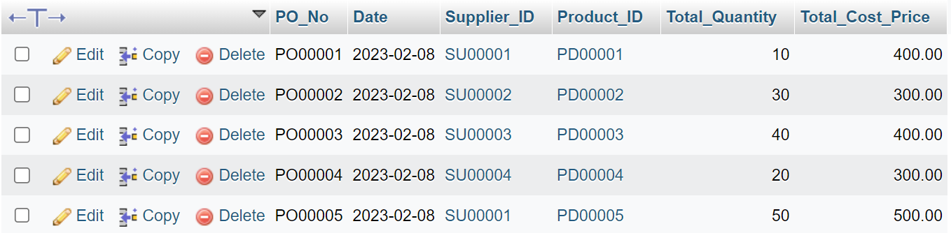

### **3.3.16 Table Customer Invoice**

INSERT INTO Customer_Invoice (Invoice_No, Date, Customer_ID, Product_ID, Total_Quantity, Total_Selling_Price)

VALUES

("IN00001", "2023-08-01", "CU00001", "PD00001", 1, 45),

("IN00002", "2023-08-01", "CU00002", "PD00002", 1, 35),

("IN00003", "2023-08-01", "CU00003", "PD00003", 3, 60),

("IN00004", "2023-08-01", "CU00004", "PD00004", 3, 90),

("IN00005", "2023-08-01", "CU00005", "PD00005", 1, 500);

***Output***

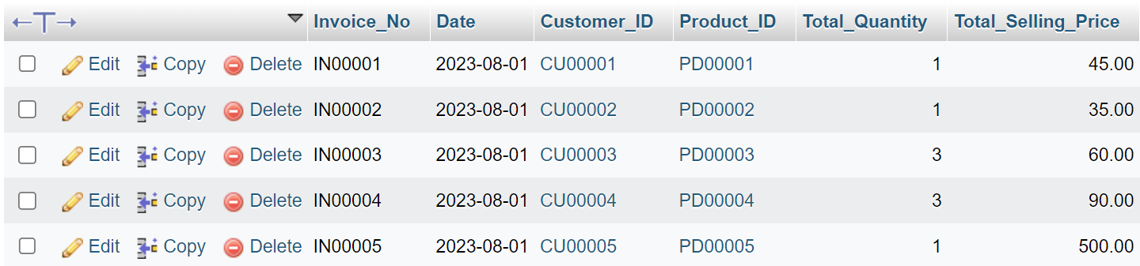

### **3.3.17 Table Customer DO**

INSERT INTO Customer_DO (DO_No, Date, Delivery_Date, Customer_ID, Product_ID, Total_Quantity)

VALUES

("DO00001", "2023-08-01", "2023-08-02", "CU00001", "PD00001", 1),

("DO00002", "2023-08-01", "2023-08-02", "CU00002", "PD00002", 5),

("DO00003", "2023-08-01", "2023-08-02", "CU00003", "PD00003", 3),

("DO00004", "2023-08-01", "2023-08-02", "CU00004", "PD00004", 4),

("DO00005", "2023-08-01", "2023-08-02", "CU00005", "PD00005", 2);

***Output***

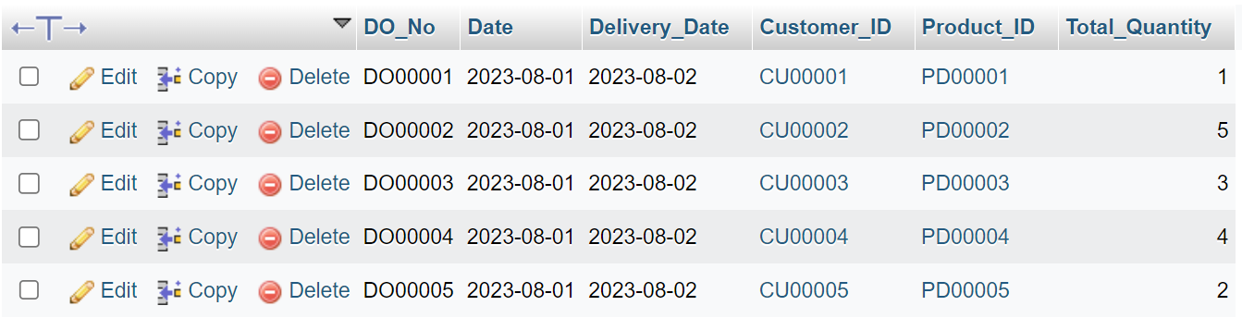

### **3.3.18 Table Supplier Invoice**

INSERT INTO Supplier_Invoice (Supplier_Invoice_No, Date, Supplier_ID, PO_No, Product_ID, Total_Quantity, Total_Cost_Price)

VALUES

("SIN00001", "2023-08-02", "SU00001", "PO00001", "PD00001", 10, 400),

("SIN00002", "2023-08-02", "SU00002", "PO00002", "PD00002", 30, 300),

("SIN00003", "2023-08-02", "SU00003", "PO00003", "PD00003", 40, 600),

("SIN00004", "2023-08-02", "SU00004", "PO00004", "PD00004", 20, 800),

("SIN00005", "2023-08-02", "SU00005", "PO00005", "PD00005", 50, 500);

***Output***

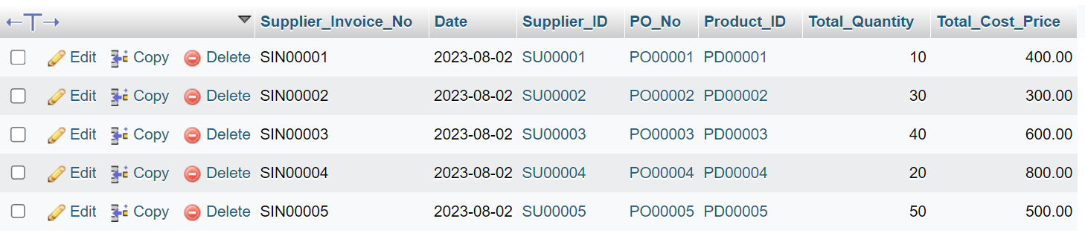

### **3.3.19 Table Supplier DO**

INSERT INTO Supplier_DO (Supplier_DO_No, Date, Receive_Date, Supplier_ID, PO_No, Product_ID, Total_Quantity)

VALUES

("SDO00001", "2023-08-03", "2023-08-03", "SU00001", "PO00001", "PD00001", 10),

("SDO00002", "2023-08-03", "2023-08-03", "SU00002", "PO00002", "PD00002", 30),

("SDO00003", "2023-08-03", "2023-08-03", "SU00003", "PO00003", "PD00003", 40),

("SDO00004", "2023-08-03", "2023-08-03", "SU00004", "PO00004", "PD00004", 20),

("SDO00005", "2023-08-03", "2023-08-03", "SU00005", "PO00005", "PD00005", 50);

***Output***

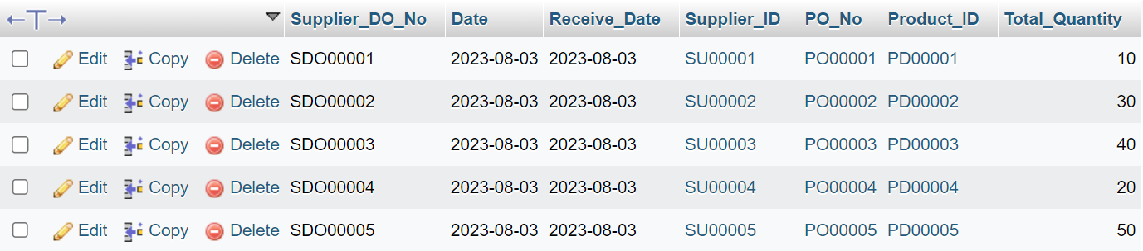

### **3.3.20 Table Stock Received**

INSERT INTO Stock_Received (Received_No, Receive_Date, Supplier_Invoice_No, Supplier_DO_No, Supplier_ID, PO_No, Product_ID, Total_Quantity)

VALUES

("RE00001", "2023-08-03", "SIN00001", "SDO00001", "SU00001", "PO00001", "PD00001", 10),

("RE00002", "2023-08-03", "SIN00002", "SDO00002", "SU00002", "PO00002", "PD00002", 30),

("RE00003", "2023-08-03", "SIN00003", "SDO00003", "SU00003", "PO00003", "PD00003", 40),

("RE00004", "2023-08-03", "SIN00004", "SDO00004", "SU00004", "PO00004", "PD00004", 20),

("RE00005", "2023-08-03", "SIN00005", "SDO00005", "SU00005", "PO00005", "PD00005", 50);

***Output***

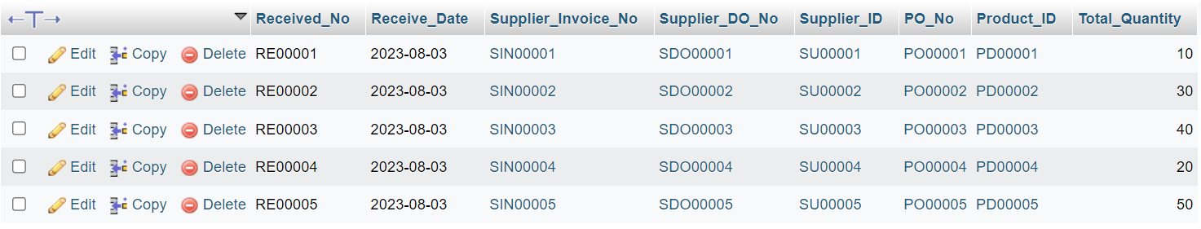

### **3.3.21 Table Stock Card**

INSERT INTO Stock_Card (Stock_Card_ID, Product_ID, Beginning_Quantity, In_Quantity, Out_Quantity, End_Quantity)

VALUES

("ST00001", "PD00001", 10, 10, 5, 15),

("ST00002", "PD00002", 30, 30, 10, 50),

("ST00003", "PD00003", 40, 40, 20, 60),

("ST00004", "PD00004", 20, 20, 10, 30),

("ST00005", "PD00005", 50, 50, 30, 70);

***Output***

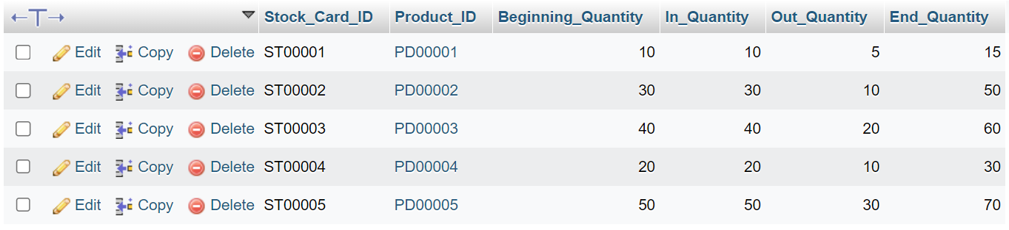

### **3.3.22 Table Customer Interest**

INSERT INTO Customer_Interest (Interest_ID, Customer_ID, Product_ID, Interest_Level)

VALUES

("CI00001", "CU00001", "PD00001", "High"),

("CI00002", "CU00002", "PD00002", "High"),

("CI00003", "CU00003", "PD00003", "Middle"),

("CI00004", "CU00004", "PD00004", "Moderate"),

("CI00005", "CU00005", "PD00005", "Moderate");

***Output***

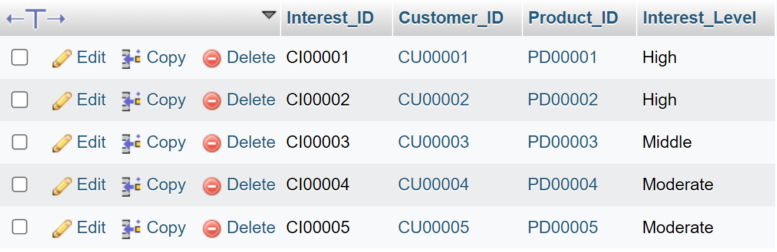

### **3.3.23 Table Customer Feedback**

INSERT INTO Customer_Feedback (Feedback_ID, Customer_ID, Date, Feedback_Text, Feedback_Rating)

VALUES

("FB00001", "CU00001", "2023-08-01", "wish there were more choices", 6),

("FB00002", "CU00002", "2023-08-02", "The clerk is very friendly", 7),

("FB00003", "CU00003", "2023-08-03", "Pets are cute", 7),

("FB00004", "CU00004", "2023-08-04", "Pets are cute", 8),

("FB00005", "CU00005", "2023-08-05", "The service was excellent", 10);

***Output***

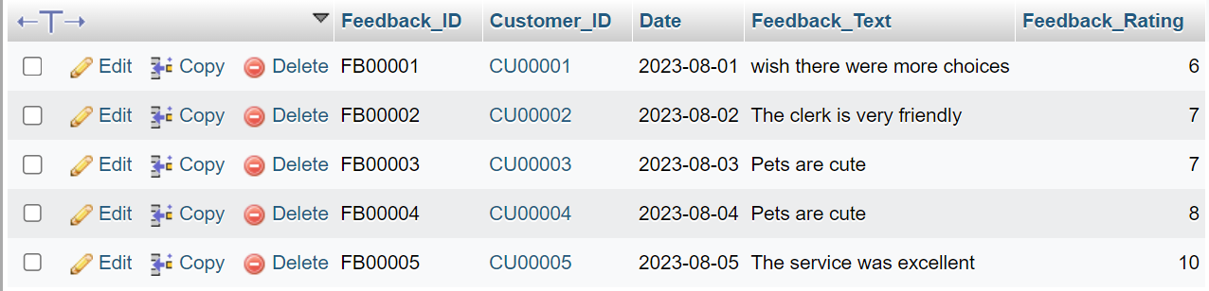

### **3.3.24 Table Employees**

INSERT INTO Employees (Employee_ID, Employee_Name, Position, Salary, Certificate_Name, Hiredate)

VALUES

("EM00001", "Jayden", "Admin Doctor", 3000, "Certification in Pet Product Knowledge", "2023-10-01"),

("EM00002", "Selina", "Admin Doctor", 3000, "Certification in Pet Nutrition", "2023-10-01"),

("EM00003", "Gabriel", "Driver", 2000, "E Lessen", "2023-10-01"),

("EM00004", "Angel", "Customer Service", 2500, "Certification in Pet Product Knowledge", "2023-10-01"),

("EM00005", "Beatrice", "Cashier", 2200, "Certification in Pet Nutrition", "2023-10-01");

***Output***

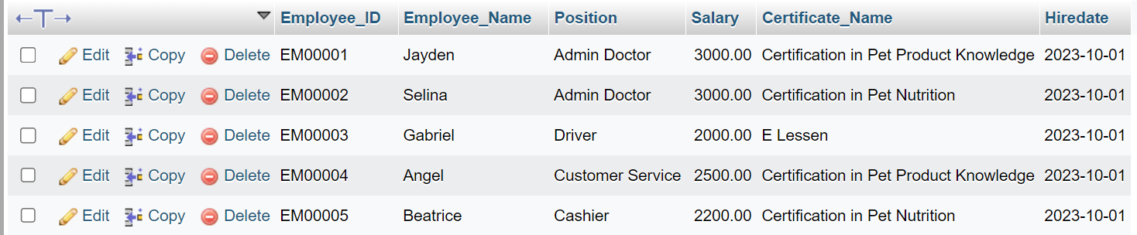

### **3.3.25 Table Employee Training**

INSERT INTO Employee_Training_Certification (Training_ID, Employee_ID, Certification_Date, Certificate_Name, Training_Location, Training_Address)

VALUES

("TR00001", "EM00001", "2023-10-01", "Certification in Pet Product Knowledge", "Animal Care School 1", "Animal Care School 1, 333 Cedar Blvd, Countryside"),

("TR00002", "EM00002", "2023-10-01", "Certification in Pet Nutrition", "Animal Care School 2", "Animal Care School 2, 444 Birch Street, Riverside"),

("TR00003", "EM00003", "2023-10-01", "E Lessen", "E Lesen Training Centre", "E Lesen Training Centre, 789 Pine Street, Villagetown"),

("TR00004", "EM00004", "2023-10-01", "Certification in Pet Product Knowledge", "Animal Care School 1", "Animal Care School 1, 333 Cedar Blvd, Countryside"),

("TR00005", "EM00005", "2023-10-01", "Certification in Pet Nutrition", "Animal Care School 2", "Animal Care School 2, 444 Birch Street, Riverside");

***Output***

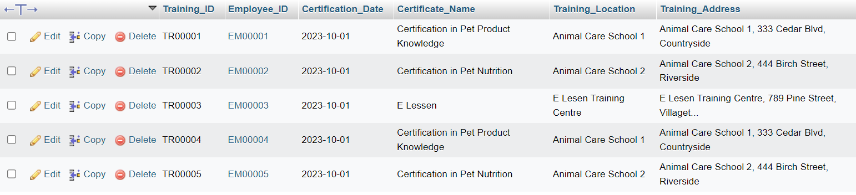

### **3.3.26 Table Pet Treatment Records**

INSERT INTO Pet_Treatment_Records (Treatment_Record_ID, Pet_ID, Cause, Drug, Date, Employee_ID)

VALUES

("PTR00001", "PID00001", "Allergy", "Diphenhydramine", "2023-08-01", "EM00001"),

("PTR00002", "PID00002", "Diarrhoea", "Berberine", "2023-08-01", "EM00002"),

("PTR00003", "PID00003", "Malnutrition", "Vitamin C,B,E", "2023-08-01", "EM00001"),

("PTR00004", "PID00004", "Indigestion", "Antibiotic", "2023-08-01", "EM00002"),

("PTR00005", "PID00005", "Allergy", "Diphenhydramine", "2023-08-01", "EM00001");

***Output***

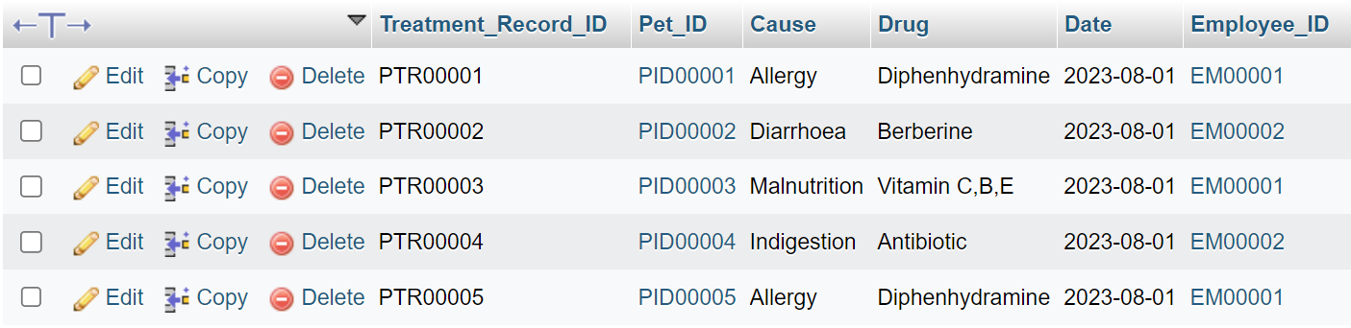

### **3.3.27 Table Vaccine Record**

INSERT INTO Vaccine_Record (Vaccine_Record_ID, Pet_ID, Vaccine_ID, Date, Dose, Total_Dose, Balance_Dose, Next_Due_Date)

VALUES

("VR00001", "PID00001", "VA00001", "2023-08-01", 1, 2, 1, "2023-10-01"),

("VR00002", "PID00002", "VA00002", "2023-08-01", 2, 3, 1, "2023-10-01"),

("VR00003", "PID00003", "VA00003", "2023-08-01", 1, 2, 1, "2023-10-01"),

("VR00004", "PID00004", "VA00004", "2023-08-01", 2,3, 1, "2023-10-01"),

("VR00005", "PID00005", "VA00004", "2023-08-01", 1, 2, 1, "2023-10-01");

***Output***

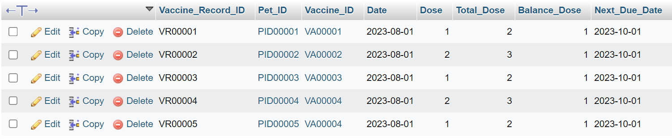

### **3.3.28 Table Shop Event**

INSERT INTO Shop_Event (Event_ID, Event_Name, Event_Type, Date, Location, Employee_ID)

VALUES

("EV00001", "Pet Care Workshop", "Exhibition", "2023-05-20", "In front of our own store", "EM00001"),

("EV00002", "Anniversary Celebration", "Celebration", "2023-05-25", "In front of our own store", "EM00002"),

("EV00003", "Pet Adoption Day", "Social and Gathering", "2023-06-06", "In front of our own store", "EM00003"),

("EV00004", "Health Check Day", "Training and Education", "2023-06-10", "In front of our own store", "EM00004"),

("EV00005", "Pet Social Gathering", "Social and Gathering", "2023-06-22", "In front of our own store", "EM00005");

***Output***

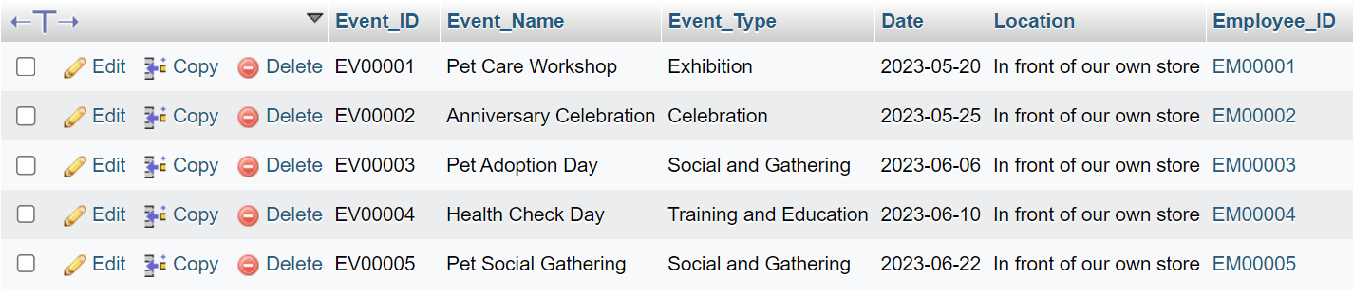

### **3.3.29 Table Sales History**

INSERT INTO Sales_History (Sales_History_ID, Date, Product_ID, Quantity_Sold, Total_Selling_Price, Sales_Channel)

VALUES

("SH00001", "2023-01-03", "PD00001", 5, 45, "In-Store"),

("SH00002", "2023-02-05", "PD00002", 10, 35, "In-Store"),

("SH00003", "2023-03-20", "PD00003", 20, 60, "Online Store"),

("SH00004", "2023-04-25", "PD00004", 15, 90, "Social Media Sales"),

("SH00005", "2023-05-10", "PD00005", 30, 500, "In-Person Sales Event");

***Output***

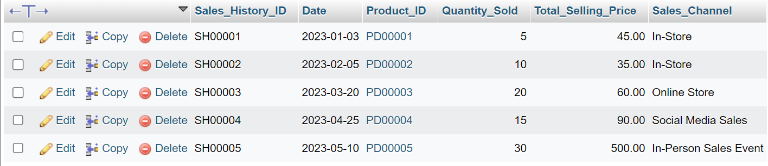

### **3.3.30 Table Payment History**

INSERT INTO Payment_History (PaymentHistory_ID, Customer_ID, Date, Amount, Payment_Method)

VALUES

("PH00001", "CU00001", "2023-05-20", 3000, "Cash"),

("PH00002", "CU00002", "2023-05-25", 5000, "Debit Card"),

("PH00003", "CU00003", "2023-06-06", 4000, "Electronic Transfer"),

("PH00004", "CU00004", "2023-06-10", 7000, "Credit Card"),

("PH00005", "CU00005", "2023-06-22", 7500, "Cash");

***Output***

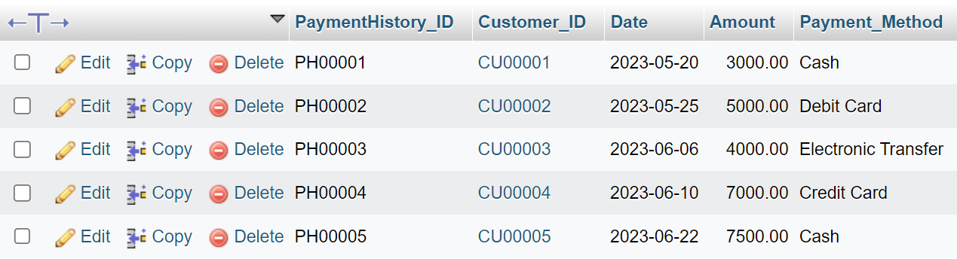

### **3.3.31 Table Monthly Net Report**

INSERT INTO Monthly_Net_Report (Monthly_Report_ID, Month, Credit_to_Supplier, Debit_from_Customer, Sales_History_ID, Monthly_Budget_ID, Profit, Description)

VALUES

("MR00001", "January", 3000, 8000, "SH00001", "MB00001", 5000, "Get RM 8000 From Customer, Minus Purchase RM 3000, Equal RM 5000. This Month Get RM 5000"),

("MR00002", "February", 5000, 9000, "SH00001", "MB00002", 4000, "Get RM 9000 From Customer, Minus Purchase RM 5000, Equal RM 4000. This Month Get RM 4000"),

("MR00003", "March", 3500, 7500, "SH00001", "MB00003", 4000, "Get RM 75000 From Customer, Minus Purchase RM 3500, Equal RM 4000. This Month Get RM 4000"),

("MR00004", "April", 2000, 10000, "SH00001", "MB00004", 8000, "Get RM 10000 From Customer, Minus Purchase RM 2000, Equal RM 8000. This Month Get RM 8000"),

("MR00005", "May", 5500, 20000, "SH00001", "MB00005", 14500, "Get RM 20000 From Customer, Minus Purchase RM 5500, Equal RM 14500. This Month Get RM 14500");

***Output***

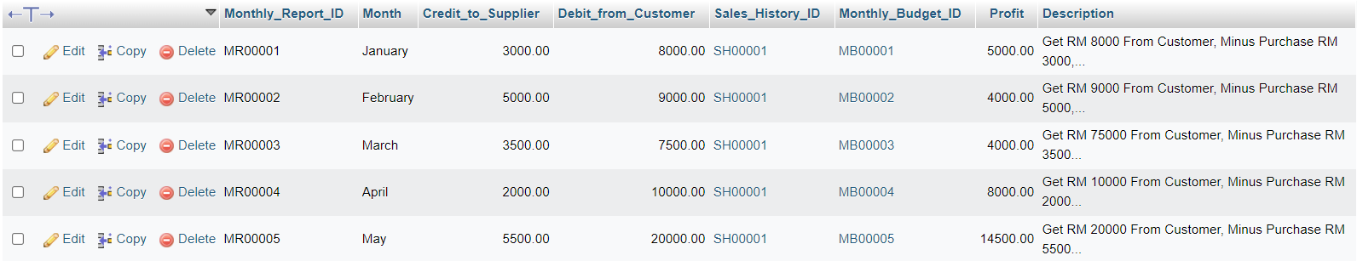

## **3.4. ALTER**

### **3.4.1 Table Monthly Budget**

ALTER TABLE monthly_budget ADD COLUMN Income DECIMAL (10,2);

ALTER TABLE monthly_budget ADD COLUMN Outcome DECIMAL (10,2);

ALTER TABLE monthly_budget ADD COLUMN Total_Outcome DECIMAL (10,2);

***Output***

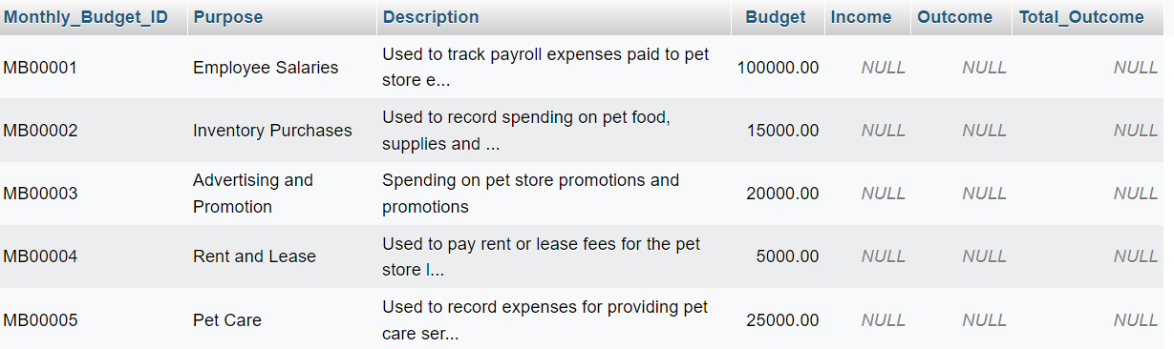

### **3.4.2 Table Supplier**

ALTER TABLE Supplier ADD COLUMN Contact_Person VARCHAR(100);

ALTER TABLE Supplier ADD COLUMN Address TEXT;

ALTER TABLE Supplier ADD COLUMN Balance_Owed DECIMAL (10,2);

***Output***

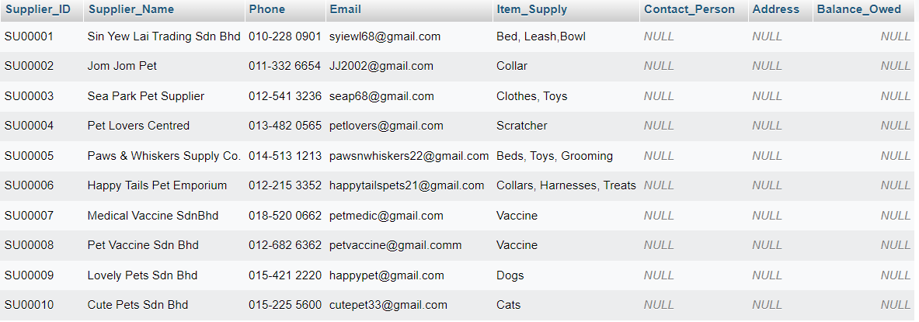

### **3.4.3 Table Pet Care Service**

ALTER TABLE Pet_Care_Service

ADD COLUMN Location VARCHAR(50),

ADD COLUMN Available_Days VARCHAR(50),

ADD COLUMN Discount_Percentage DECIMAL(5,2);

***Output***

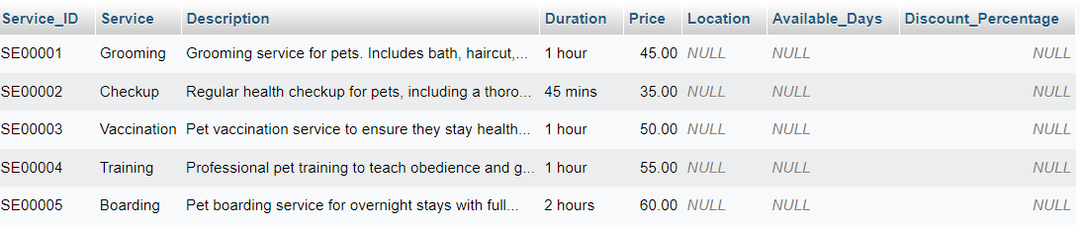

### **3.4.4 Table Pet Accessories**

ALTER TABLE Pet_Accessories

ADD COLUMN Size VARCHAR(10),

ADD COLUMN Stock_Quantity INT,

ADD COLUMN Discount_Percentage DECIMAL(10,2);

***Output***

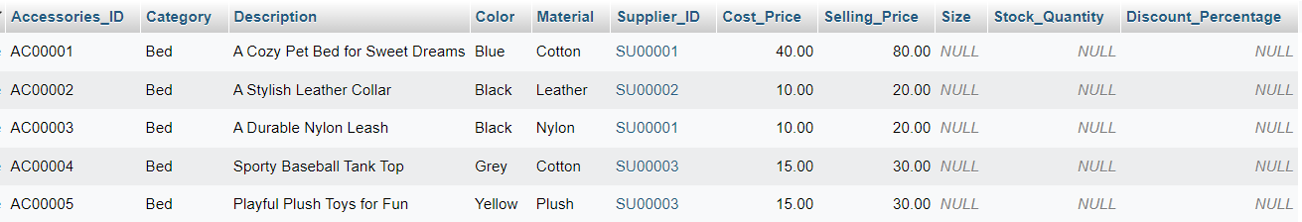

### **3.4.5 Table Pet Category**

ALTER TABLE Pet_Category

ADD COLUMN Age INT,

ADD COLUMN Weight DECIMAL(5,2),

ADD COLUMN Color VARCHAR(20);

***Output***

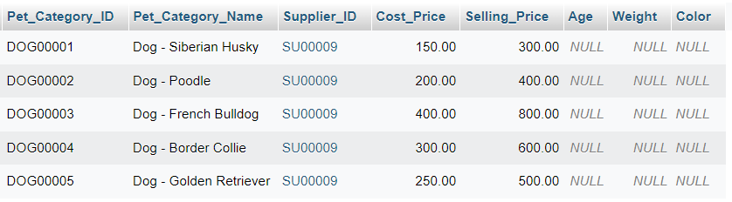

### **3.4.6 Table Vaccine**

ALTER TABLE Vaccine

ADD COLUMN Expiry_Date DATE,

ADD COLUMN Storage_Temperature VARCHAR(20),

ADD COLUMN Manufacturer VARCHAR(50);

***Output***

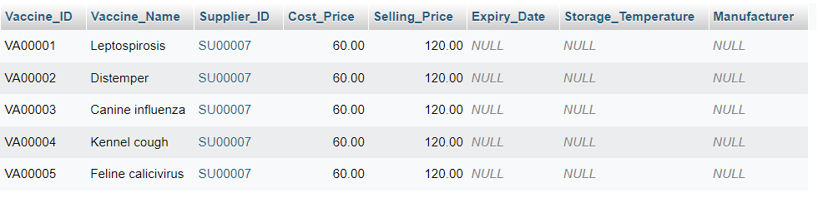

### **3.4.7 Table Inventory**

ALTER TABLE Inventory

ADD COLUMN Purchase_Date DATE,

ADD COLUMN Purchase_Cost DECIMAL(10,2),

ADD COLUMN Expiry_Date DATE;

***Output***

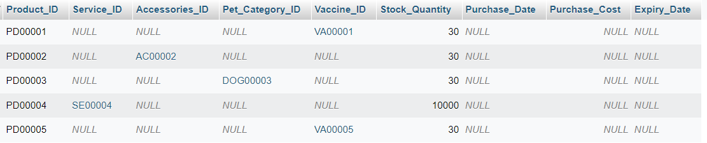

### **3.4.8 Table Customer**

ALTER TABLE Customer

ADD COLUMN Birthdate DATE,

ADD COLUMN MembershipLevel VARCHAR(20),

ADD COLUMN RegistrationDate DATE;

***Output***

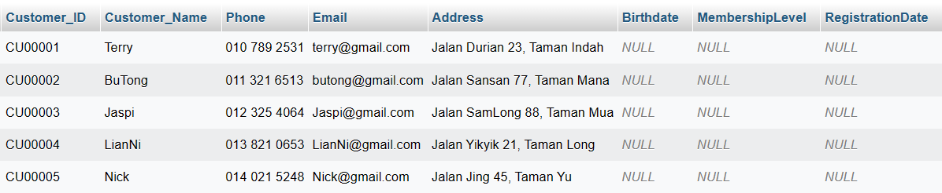

### **3.4.9 Table Customer Pet**

ALTER TABLE Customer_Pet

ADD COLUMN Vaccination_Status VARCHAR(20),

ADD COLUMN Last_Vaccination_Date DATE,

ADD COLUMN Next_Vaccination_Date DATE;

***Output***

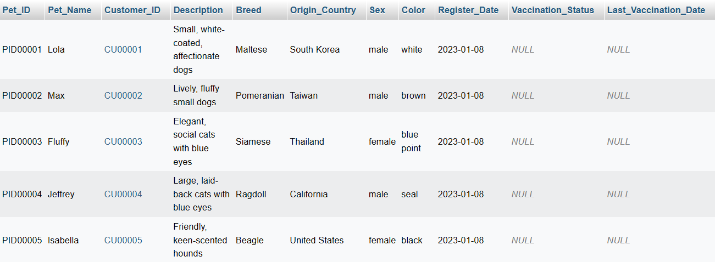

### **3.4.10 Table Adoption Record**

ALTER TABLE Adoption_Record

ADD COLUMN Adoption_Type VARCHAR(20),

ADD COLUMN Adoption_Fee DECIMAL(10, 2),

ADD COLUMN Adoption_Status VARCHAR(20);

***Output***

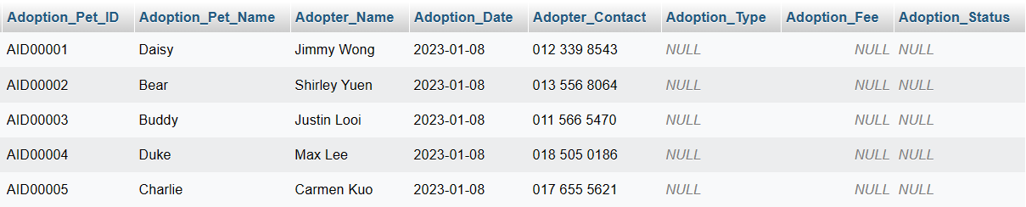

### **3.4.11 Table Lost And Found Record**

ALTER TABLE Lost_and_Found_Record

ADD COLUMN IsClaimed BOOLEAN,

ADD COLUMN Claimer_Name VARCHAR(50),

ADD COLUMN Claimer_Contact VARCHAR(20);

***Output***

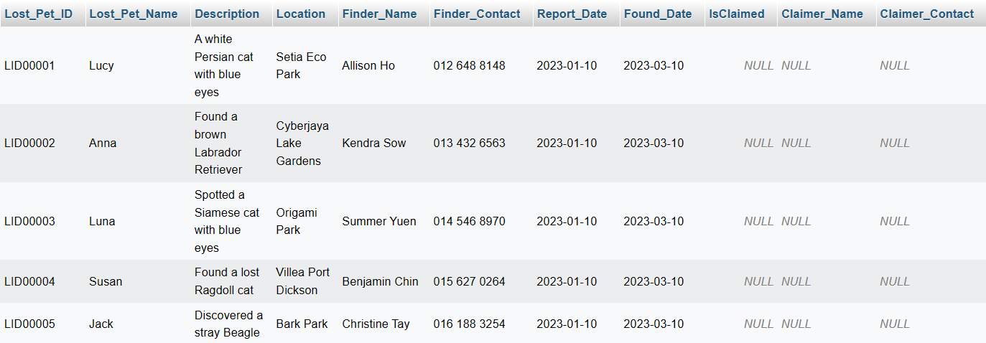

### **3.4.12 Table Pet Record**

ALTER TABLE Pet_Record

ADD COLUMN Vet_Appointment_Date DATE,

ADD COLUMN Grooming_Appointment_Date DATE,

ADD COLUMN Last_Feeding_Time TIME;

***Output***

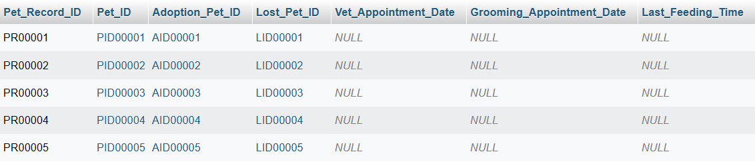

### **3.4.13 Table Membership**

ALTER TABLE Membership

ADD COLUMN Promo_Code VARCHAR(20),

ADD COLUMN Promo_Discount DECIMAL(5,2),

ADD COLUMN Promo_Expiry_Date DATE;

***Output***

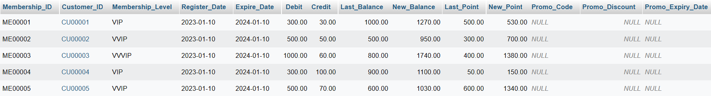

### **3.4.14 Table Pet Appointment Record**

ALTER TABLE Pet_Appointment_Record

ADD COLUMN Vet_Name VARCHAR(50),

ADD COLUMN Assistant_Name VARCHAR(50),

ADD COLUMN Additional_Notes TEXT;

***Output***

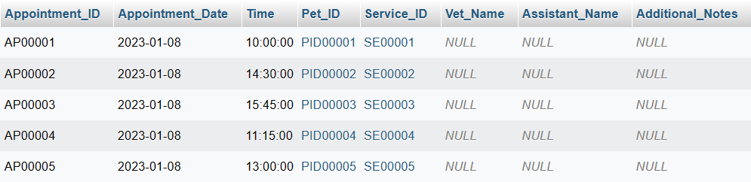

### **3.4.15 Table Purchase Order**

ALTER TABLE Purchase_Order

ADD COLUMN Delivery_Date DATE,

ADD COLUMN Delivery_Address VARCHAR(200),

ADD COLUMN Delivery_Status VARCHAR(20);

***Output***

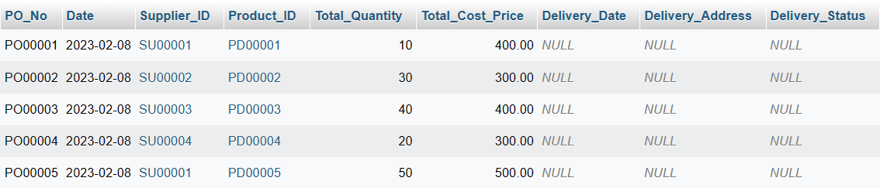

### **3.4.16 Table Customer Invoice**

ALTER TABLE Customer_Invoice

ADD COLUMN Payment_Method VARCHAR(20),

ADD COLUMN Payment_Status VARCHAR(20),

ADD COLUMN Due_Date DATE;

***Output***

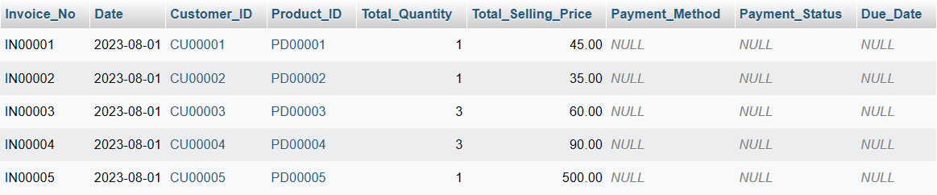

### **3.4.17 Table Customer DO**

ALTER TABLE Customer_DO

ADD COLUMN Delivery_Status VARCHAR(20),

ADD COLUMN Carrier_Name VARCHAR(50),

ADD COLUMN Tracking_Number VARCHAR(20);

***Output***

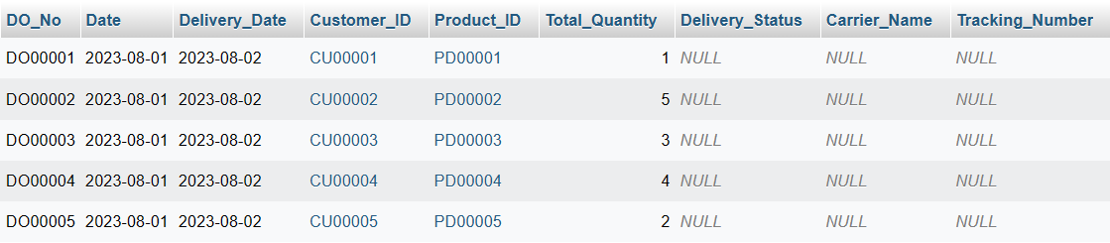

### **3.4.18 Table Supplier Invoice**

ALTER TABLE Supplier_Invoice

ADD COLUMN Payment_Method VARCHAR(20),

ADD COLUMN Payment_Status VARCHAR(20),

ADD COLUMN Due_Date DATE;

***Output***

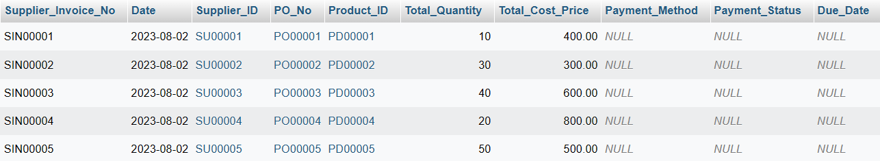

### **3.4.19 Table Supplier DO**

ALTER TABLE Supplier_DO

ADD COLUMN Delivery_Status VARCHAR(20),

ADD COLUMN Carrier_Name VARCHAR(50),

ADD COLUMN Tracking_Number VARCHAR(20);

***Output***

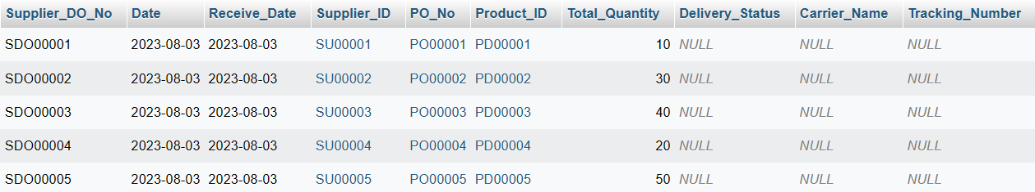

### **3.4.20 Table Stock Received**

ALTER TABLE Stock_Received

ADD COLUMN Inspection_Status VARCHAR(20),

ADD COLUMN Storage_Location VARCHAR(50),

ADD COLUMN Expiry_Date DATE;

***Output***

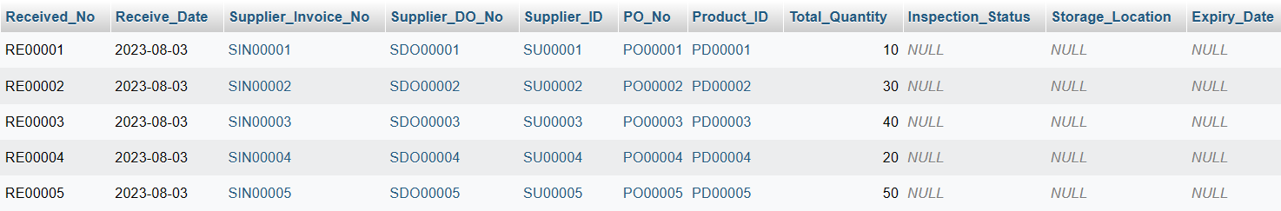

### **3.4.21 Table Stock Card**

ALTER TABLE Stock_Card

ADD COLUMN Transaction_Date DATE,

ADD COLUMN Transaction_Type VARCHAR(20),

ADD COLUMN Transaction_Description TEXT;

***Output***

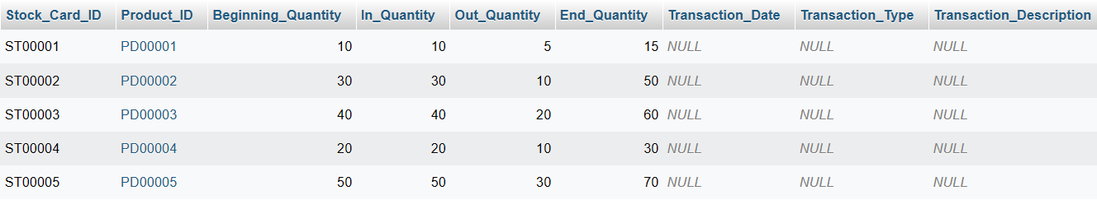

### **3.4.22 Table Customer Interest**

ALTER TABLE Customer_Interest

ADD COLUMN Interest_Date DATE,

ADD COLUMN Interest_Source VARCHAR(50),

ADD COLUMN Comments TEXT;

***Output***

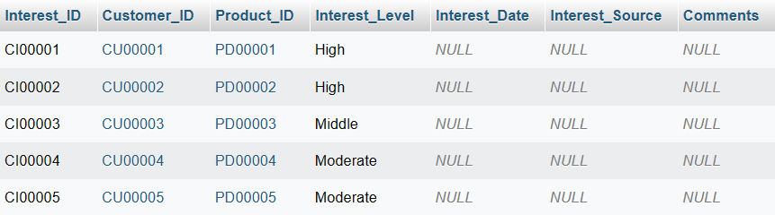

### **3.4.23 Table Customer Feedback**

ALTER TABLE Customer_Feedback

ADD COLUMN Feedback_Type VARCHAR(50),

ADD COLUMN Response_Text VARCHAR(500),

ADD COLUMN Response_Date DATE;

***Output***

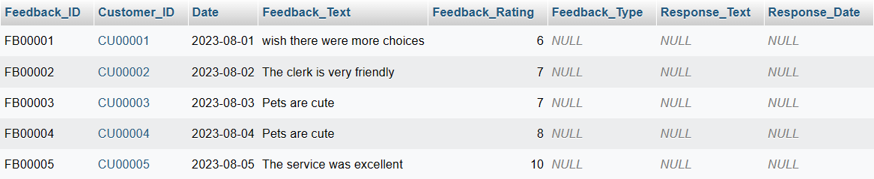

### **3.4.24 Table Employees**

ALTER TABLE Employees

ADD COLUMN Email VARCHAR(100),

ADD COLUMN Phone_Number VARCHAR(15),

ADD COLUMN Address VARCHAR(200);

***Output***

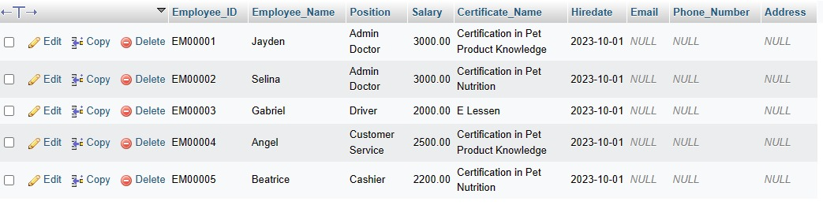

### **3.4.25 Table Employee Training**

ALTER TABLE Employee_Training_Certification

ADD COLUMN Trainer_Name VARCHAR(15),

ADD COLUMN Training_Duration INT,

ADD COLUMN Training_Fee DECIMAL(10,2);

***Output***

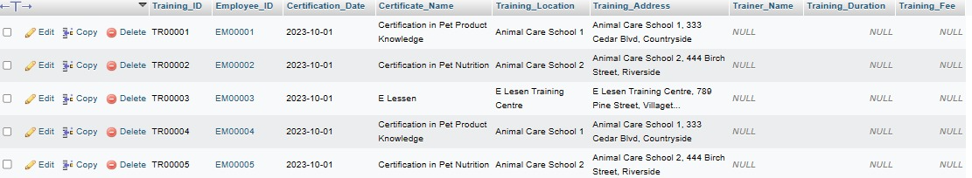

### **3.4.26 Table Pet Treatment Records**

ALTER TABLE Pet_Treatment_Records

ADD COLUMN Treatment_Type VARCHAR(50),

ADD COLUMN Treatment_Cost DECIMAL(10, 2),

ADD COLUMN Treatment_Status VARCHAR(20);

***Output***

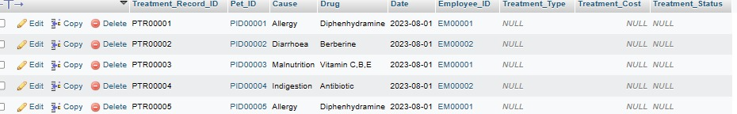

### **3.4.27 Table Vaccine Record**

ALTER TABLE Vaccine_Record

ADD COLUMN Vaccination_Clinic VARCHAR(100),

ADD COLUMN Vaccination_Doctor VARCHAR(50),

ADD COLUMN Vaccination_Cost DECIMAL(10, 2);

***Output***

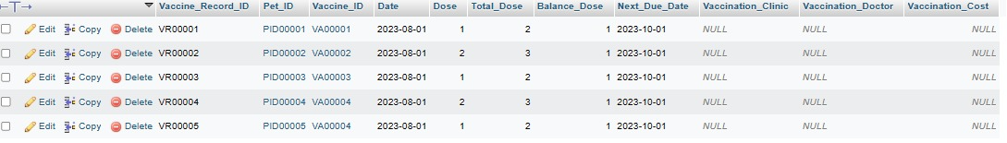

### **3.4.28 Table Shop Event**

ALTER TABLE Shop_Event

ADD COLUMN Organizer_Name VARCHAR(50),

ADD COLUMN Contact_Email VARCHAR(100),

ADD COLUMN Event_Description TEXT;

***Output***

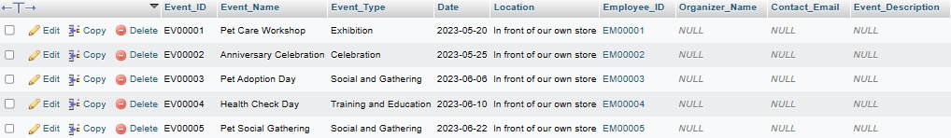

### **3.4.29 Table Sales History**

ALTER TABLE Sales_History

ADD COLUMN Discount DECIMAL(5, 2),

ADD COLUMN Customer_ID VARCHAR(10),

ADD COLUMN Payment_Method VARCHAR(50);

***Output***

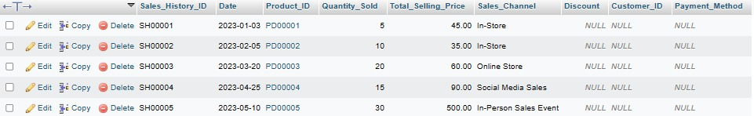

### **3.4.30 Table Payment History**

ALTER TABLE Payment_History

ADD COLUMN Invoice_Number VARCHAR(20),

ADD COLUMN Payment_Description TEXT,

ADD COLUMN Employee_ID VARCHAR(10);

***Output***

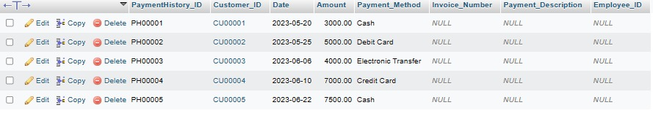

### **3.4.31 Table Monthly Net Report**

ALTER TABLE Monthly_Net_Report

ADD COLUMN Operating_Expenses DECIMAL(10, 2),

ADD COLUMN Tax_Expense DECIMAL(10, 2),

ADD COLUMN Net_Income DECIMAL(10, 2);

***Output***

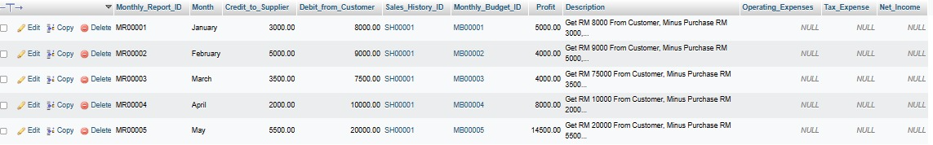

## **3.5. UPDATE**

### **3.5.1 Table Monthly Budget**

UPDATE Monthly_Budget

SET Income = 20000,

Outcome = 20000,

Total_Outcome = CASE

WHEN Monthly_Budget_ID = 'MB00001' THEN 20000

WHEN Monthly_Budget_ID = 'MB00002' THEN 20000

WHEN Monthly_Budget_ID = 'MB00003' THEN 20000

WHEN Monthly_Budget_ID = 'MB00004' THEN 20000

WHEN Monthly_Budget_ID = 'MB00005' THEN 20000

END;

***Output***

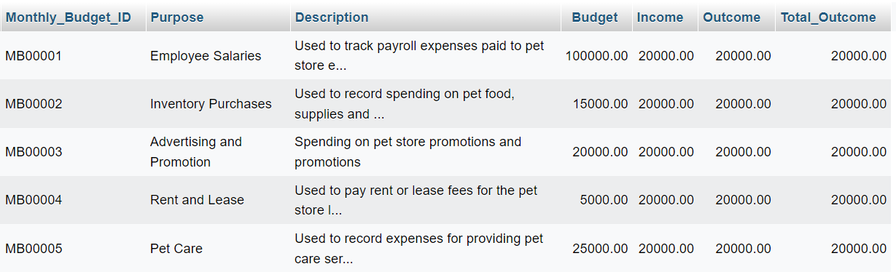

### **3.5.2 Table Supplier**

UPDATE Supplier

SET Contact_Person =

CASE Supplier_ID

WHEN 'SU00001' THEN 'John Tan'

WHEN 'SU00002' THEN 'Lisa Lee'

WHEN 'SU00003' THEN 'Michael Wong'

WHEN 'SU00004' THEN 'Samantha Chan'

WHEN 'SU00005' THEN 'Alex Lim'

WHEN 'SU00006' THEN 'Emily Ng'

WHEN 'SU00007' THEN 'David Tan'

WHEN 'SU00008' THEN 'Jessica Lim'

WHEN 'SU00009' THEN 'Gary Lee'

WHEN 'SU00010' THEN 'Sarah Tan'

END;

UPDATE Supplier

SET Phone = '011-454 6455'

WHERE Supplier_ID = 'SU00001';

UPDATE Supplier

SET Balance_Owed =

CASE Supplier_ID

WHEN 'SU00001' THEN 5000

WHEN 'SU00002' THEN 6000

WHEN 'SU00003' THEN 200

WHEN 'SU00004' THEN 600

WHEN 'SU00005' THEN 2000

WHEN 'SU00006' THEN 300

WHEN 'SU00007' THEN 10000

WHEN 'SU00008' THEN 15000

WHEN 'SU00009' THEN 1000

WHEN 'SU00010' THEN 8000

END;

***Output***

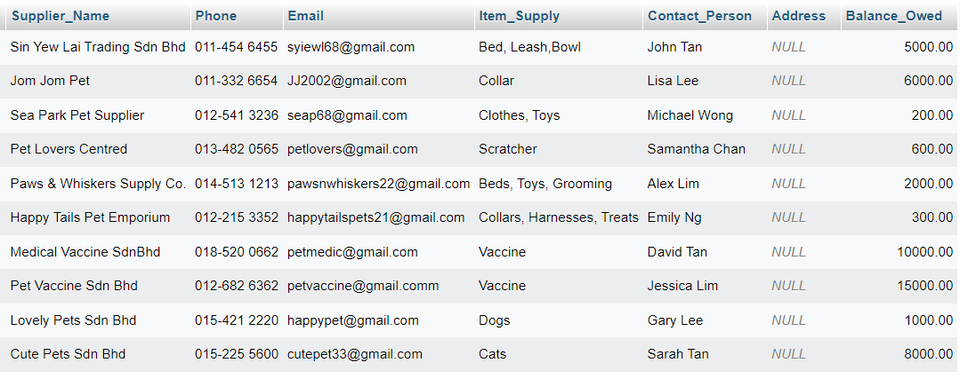

### **3.5.3 Table Pet Care Service**

UPDATE Pet_Care_Service

SET Location = '123 Main Street'

WHERE Service_ID = 'SE00001';

UPDATE Pet_Care_Service

SET Available_Days = 'Monday, Wednesday, Friday'

WHERE Service_ID = 'SE00002';

UPDATE Pet_Care_Service

SET Discount_Percentage = 10.5

WHERE Service_ID = 'SE00003';

UPDATE Pet_Care_Service

SET Location = '456 Oak Avenue',

Available_Days = 'Tuesday, Thursday',

Discount_Percentage = 15.0

WHERE Service_ID = 'SE00004';

UPDATE Pet_Care_Service

SET Location = '789 Pine Street',

Available_Days = 'Everyday',

Discount_Percentage = 20.25

WHERE Service_ID = 'SE00005';

***Output***

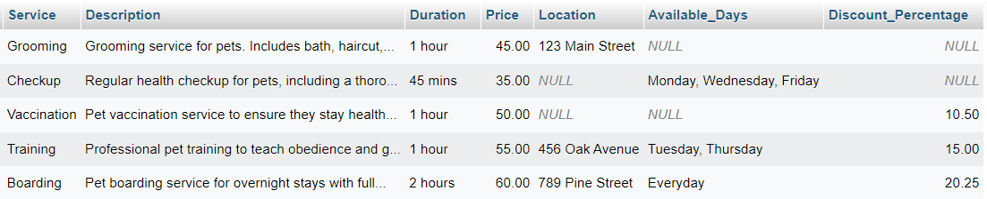

UPDATE Pet_Care_Service

SET Available_Days = NULL

WHERE Service_ID = 'SE00004' AND Available_Days = 'Tuesday, Thursday';

***Output***

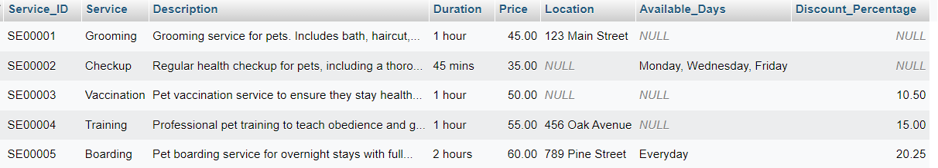

### **3.5.4 Table Pet Accessories**

UPDATE Pet_Accessories

SET Size =

CASE Accessories_ID

WHEN 'AC00001' THEN 'Medium'

WHEN 'AC00002' THEN 'Small'

WHEN 'AC00003' THEN 'Large'

WHEN 'AC00004' THEN 'Small'

WHEN 'AC00005' THEN 'Medium'

END;

UPDATE Pet_Accessories

SET Stock_Quantity =

CASE Accessories_ID

WHEN 'AC00001' THEN 50

WHEN 'AC00002' THEN 30

WHEN 'AC00003' THEN 25

WHEN 'AC00004' THEN 40

WHEN 'AC00005' THEN 20

END;

***Output***

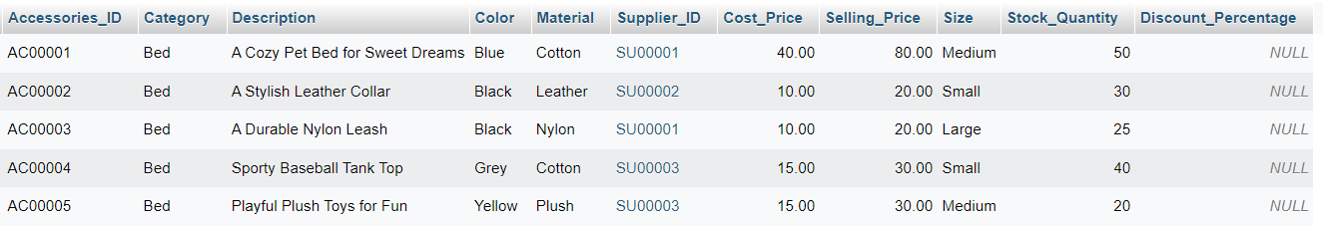

UPDATE Pet_Accessories

SET Stock_Quantity =

CASE Accessories_ID

WHEN 'AC00001' THEN 50

WHEN 'AC00002' THEN 30

WHEN 'AC00003' THEN 40

WHEN 'AC00004' THEN 25

WHEN 'AC00005' THEN 35

END;

***Output***

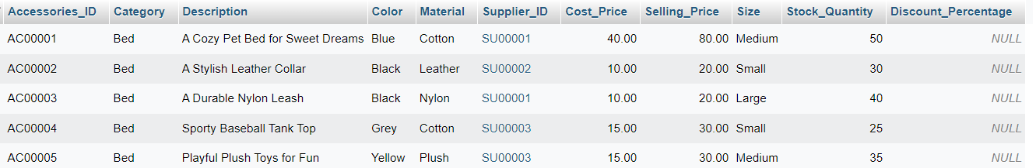

### **3.5.5 Table Pet Category**

UPDATE Pet_Category

SET

Age =

CASE Pet_Category_ID

WHEN 'DOG00001' THEN 3

WHEN 'DOG00002' THEN 2

WHEN 'DOG00003' THEN 4

WHEN 'DOG00004' THEN 2

WHEN 'DOG00005' THEN 5

END,

Weight =

CASE Pet_Category_ID

WHEN 'DOG00001' THEN 20.5

WHEN 'DOG00002' THEN 15.8

WHEN 'DOG00003' THEN 12.2

WHEN 'DOG00004' THEN 18.0

WHEN 'DOG00005' THEN 25.5

END,

Color =

CASE Pet_Category_ID

WHEN 'DOG00001' THEN 'Gray and White'

WHEN 'DOG00002' THEN 'Apricot'

WHEN 'DOG00003' THEN 'Fawn'

WHEN 'DOG00004' THEN 'Black and White'

WHEN 'DOG00005' THEN 'Golden'

END;

***Output***

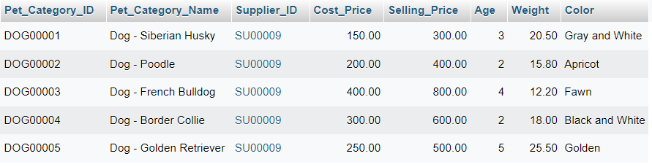

UPDATE Pet_Category

SET Age =

CASE

WHEN Age BETWEEN 1 AND 3 THEN Age + 1

ELSE Age

END;

UPDATE Pet_Category

SET

Color =

CASE Pet_Category_ID

WHEN 'DOG00001' THEN 'Blue'

WHEN 'DOG00002' THEN 'Red'

WHEN 'DOG00003' THEN 'Green'

WHEN 'DOG00004' THEN 'Yellow'

WHEN 'DOG00005' THEN 'Purple'

END;

***Output***

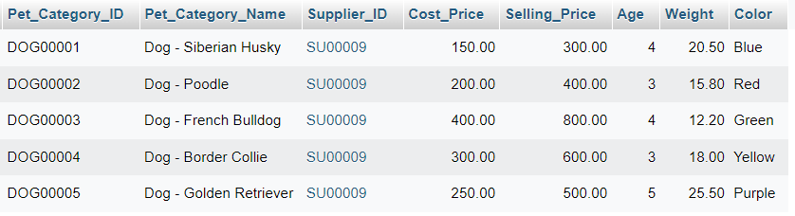

### **3.5.6 Table Vaccine**

UPDATE Vaccine

SET

Expiry_Date = '2023-12-31',

Storage_Temperature = '2-8°C',

Manufacturer = 'ABC Pharmaceuticals'

WHERE Vaccine_ID = 'VA00001';

UPDATE Vaccine

SET

Expiry_Date = '2023-12-31',

Storage_Temperature = '2-8°C',

Manufacturer = 'ABC Pharmaceuticals'

WHERE Vaccine_ID = 'VA00002';

UPDATE Vaccine

SET

Expiry_Date = '2023-12-31',

Storage_Temperature = '2-8°C',

Manufacturer = 'ABC Pharmaceuticals'

WHERE Vaccine_ID = 'VA00003';

UPDATE Vaccine

SET

Expiry_Date = '2023-12-31',

Storage_Temperature = '2-8°C',

Manufacturer = 'ABC Pharmaceuticals'

WHERE Vaccine_ID = 'VA00004';

UPDATE Vaccine

SET

Expiry_Date = '2023-12-31',

Storage_Temperature = '2-8°C',

Manufacturer = 'ABC Pharmaceuticals'

WHERE Vaccine_ID = 'VA00005';

***Output***

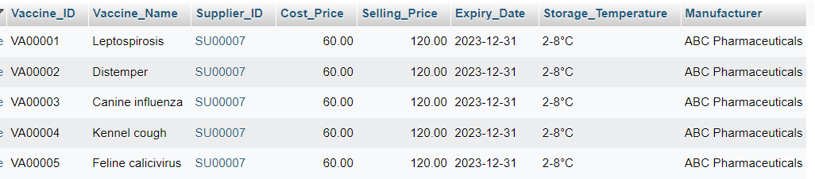

### **3.5.7 Table Inventory**

UPDATE Inventory

SET

Purchase_Date = '2022-01-11',

Purchase_Cost = 50.00,

Expiry_Date = '2023-01-11'

WHERE Product_ID = 'PD00001';

UPDATE Inventory

SET

Purchase_Date = '2022-01-12',

Purchase_Cost = 25.00,

Expiry_Date = '2023-01-12'

WHERE Product_ID = 'PD00002';

UPDATE Inventory

SET

Purchase_Date = '2022-01-13',

Purchase_Cost = 100.00,

Expiry_Date = '2023-01-13'

WHERE Product_ID = 'PD00003';

UPDATE Inventory

SET

Purchase_Date = '2022-01-14',

Purchase_Cost = 5000.00,

Expiry_Date = '2023-01-14'

WHERE Product_ID = 'PD00004';

UPDATE Inventory

SET

Purchase_Date = '2022-01-15',

Purchase_Cost = 30.00,

Expiry_Date = '2023-01-15'

WHERE Product_ID = 'PD00005';

***Output***

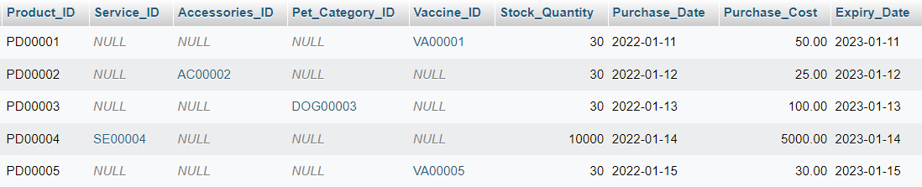

### **3.5.8 Table Customer**

UPDATE Customer

SET Birthdate = '1990-01-15', MembershipLevel = 'Silver', RegistrationDate = '2022-01-13'

WHERE Customer_ID = 'CU00001';

UPDATE Customer

SET Birthdate = '1985-05-22', MembershipLevel = 'Gold', RegistrationDate = '2022-01-13'

WHERE Customer_ID = 'CU00002';

UPDATE Customer

SET Birthdate = '1992-11-07', MembershipLevel = 'Bronze', RegistrationDate = '2022-01-13'

WHERE Customer_ID = 'CU00003';

UPDATE Customer

SET Birthdate = '1980-08-30', MembershipLevel = 'Platinum', RegistrationDate = '2022-01-13'

WHERE Customer_ID = 'CU00004';

UPDATE Customer

SET Birthdate = '1988-04-12', MembershipLevel = 'Silver', RegistrationDate = '2022-01-13'

WHERE Customer_ID = 'CU00005';

***Output***

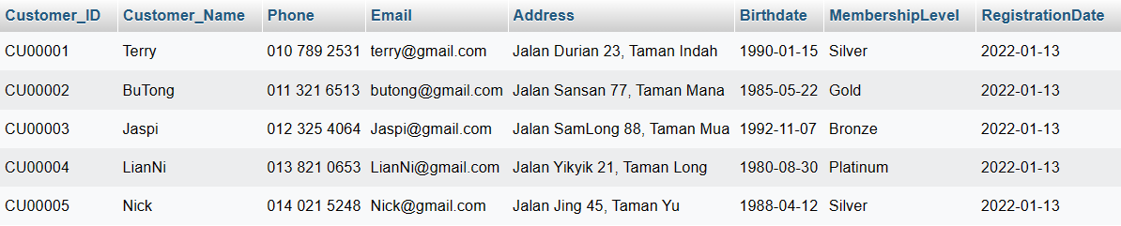

### **3.5.9 Table Customer Pet**

UPDATE Customer_Pet

SET Vaccination_Status = 'Up-to-date', Last_Vaccination_Date = '2023-01-15', Next_Vaccination_Date = '2023-07-15'

WHERE Pet_ID = 'PID00001';

UPDATE Customer_Pet

SET Vaccination_Status = 'Pending', Last_Vaccination_Date = NULL, Next_Vaccination_Date = '2023-07-22'

WHERE Pet_ID = 'PID00002';

UPDATE Customer_Pet

SET Vaccination_Status = 'Up-to-date', Last_Vaccination_Date = '2023-01-10', Next_Vaccination_Date = '2023-07-10'

WHERE Pet_ID = 'PID00003';

UPDATE Customer_Pet

SET Vaccination_Status = 'Up-to-date', Last_Vaccination_Date = '2023-01-12', Next_Vaccination_Date = '2023-07-12'

WHERE Pet_ID = 'PID00004';

UPDATE Customer_Pet

SET Vaccination_Status = 'Pending', Last_Vaccination_Date = NULL, Next_Vaccination_Date = '2023-07-18'

WHERE Pet_ID = 'PID00005';

***Output***

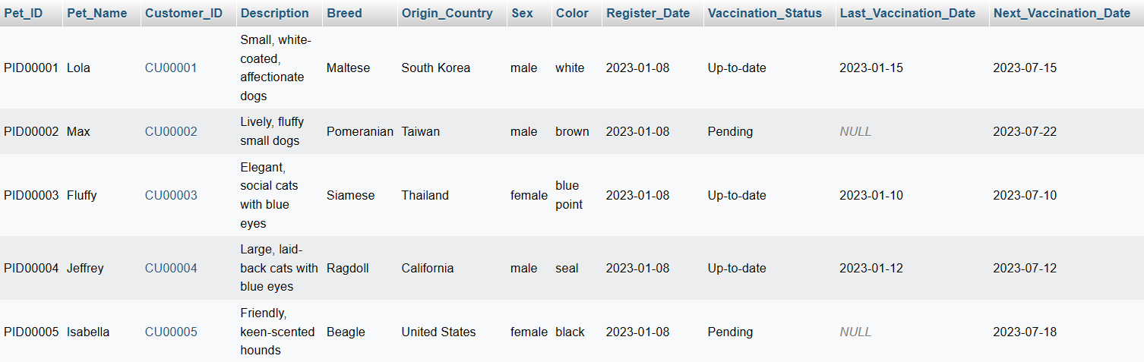

### **3.5.10 Table Adoption Record**

UPDATE Adoption_Record

SET Adoption_Type = 'Dog', Adoption_Fee = 150.00, Adoption_Status = 'Pending'

WHERE Adoption_Pet_ID = 'AID00001';

UPDATE Adoption_Record

SET Adoption_Type = 'Dog', Adoption_Fee = 200.00, Adoption_Status = 'Approved'

WHERE Adoption_Pet_ID = 'AID00002';

UPDATE Adoption_Record

SET Adoption_Type = 'Cat', Adoption_Fee = 100.00, Adoption_Status = 'Pending'

WHERE Adoption_Pet_ID = 'AID00003';

UPDATE Adoption_Record

SET Adoption_Type = 'Cat', Adoption_Fee = 180.00, Adoption_Status = 'Approved'

WHERE Adoption_Pet_ID = 'AID00004';

UPDATE Adoption_Record

SET Adoption_Type = 'Dog', Adoption_Fee = 120.00, Adoption_Status = 'Pending'

WHERE Adoption_Pet_ID = 'AID00005';

***Output***

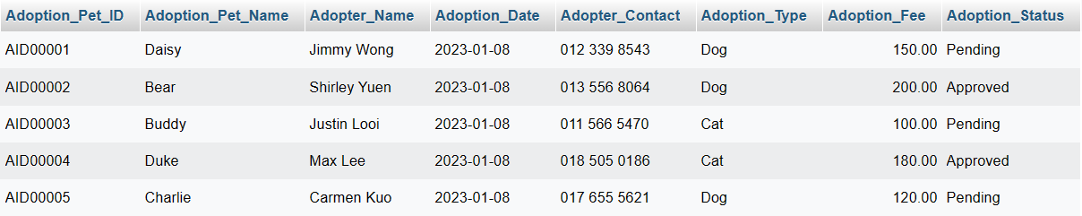

### **3.5.11 Table Lost And Found Record**

UPDATE Lost_and_Found_Record

SET IsClaimed = TRUE, Claimer_Name = 'John Doe', Claimer_Contact = '017 123 4567'

WHERE Lost_Pet_ID = 'LID00001';

UPDATE Lost_and_Found_Record

SET IsClaimed = FALSE, Claimer_Name = NULL, Claimer_Contact = NULL

WHERE Lost_Pet_ID = 'LID00002';

UPDATE Lost_and_Found_Record

SET IsClaimed = TRUE, Claimer_Name = 'Jane Smith', Claimer_Contact = '019 987 6543'

WHERE Lost_Pet_ID = 'LID00003';

UPDATE Lost_and_Found_Record

SET IsClaimed = FALSE, Claimer_Name = NULL, Claimer_Contact = NULL

WHERE Lost_Pet_ID = 'LID00004';

UPDATE Lost_and_Found_Record

SET IsClaimed = TRUE, Claimer_Name = 'Robert Johnson', Claimer_Contact = '016 456 7890'

WHERE Lost_Pet_ID = 'LID00005';

***Output***

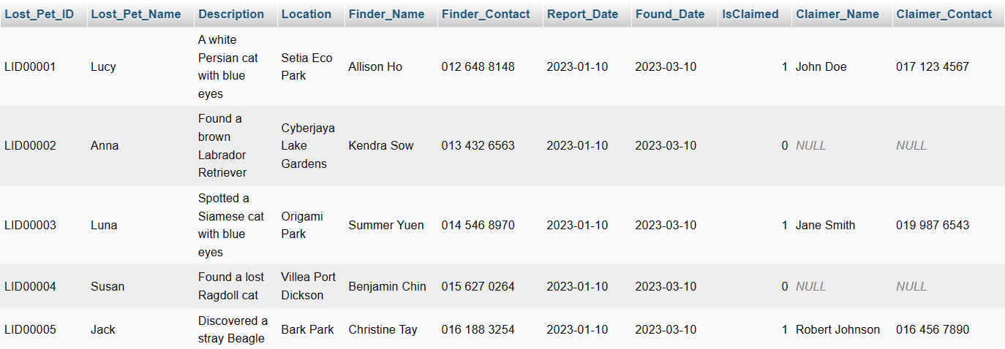

### **3.5.12 Table Pet Record**

UPDATE Pet_Record

SET Vet_Appointment_Date = '2023-02-15', Grooming_Appointment_Date = '2023-02-20', Last_Feeding_Time = '18:30:00'

WHERE Pet_Record_ID = 'PR00001';

UPDATE Pet_Record

SET Vet_Appointment_Date = '2023-03-10', Grooming_Appointment_Date = '2023-03-15', Last_Feeding_Time = '19:45:00'

WHERE Pet_Record_ID = 'PR00002';

UPDATE Pet_Record

SET Vet_Appointment_Date = '2023-02-28', Grooming_Appointment_Date = '2023-03-05', Last_Feeding_Time = '20:15:00'

WHERE Pet_Record_ID = 'PR00003';

UPDATE Pet_Record

SET Vet_Appointment_Date = '2023-03-12', Grooming_Appointment_Date = '2023-03-18', Last_Feeding_Time = '17:30:00'

WHERE Pet_Record_ID = 'PR00004';

UPDATE Pet_Record

SET Vet_Appointment_Date = '2023-03-05', Grooming_Appointment_Date = '2023-03-10', Last_Feeding_Time = '21:00:00'

WHERE Pet_Record_ID = 'PR00005';

***Output***

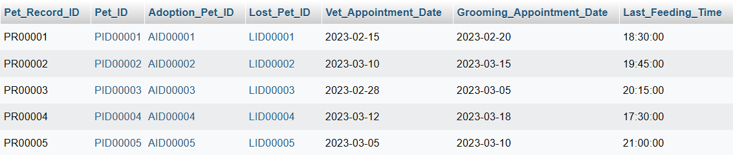

### **3.5.13 Table Membership**

UPDATE Membership

SET Promo_Code = 'SUMMER20', Promo_Discount = 20.00, Promo_Expiry_Date = '2023-06-30'

WHERE Membership_ID = 'ME00001';

UPDATE Membership

SET Promo_Code = NULL, Promo_Discount = NULL, Promo_Expiry_Date = NULL

WHERE Membership_ID = 'ME00002';

UPDATE Membership

SET Promo_Code = 'FALL25', Promo_Discount = 25.00, Promo_Expiry_Date = '2023-09-30'

WHERE Membership_ID = 'ME00003';

UPDATE Membership

SET Promo_Code = 'VIP10', Promo_Discount = 10.00, Promo_Expiry_Date = '2023-05-31'

WHERE Membership_ID = 'ME00004';

UPDATE Membership

SET Promo_Code = 'HOLIDAY15', Promo_Discount = 15.00, Promo_Expiry_Date = '2023-12-31'

WHERE Membership_ID = 'ME00005';

***Output***

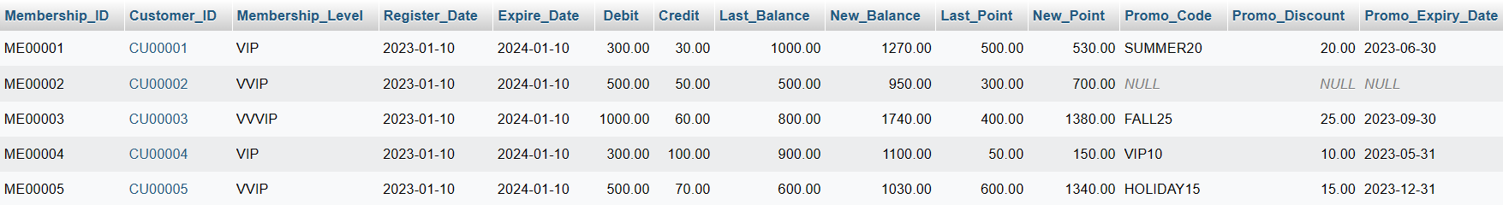

### **3.5.14 Table Pet Appointment Record**

UPDATE Pet_Appointment_Record

SET Vet_Name = 'Dr. Smith', Assistant_Name = 'Sarah Johnson', Additional_Notes = 'Routine checkup, vaccinations'

WHERE Appointment_ID = 'AP00001';

UPDATE Pet_Appointment_Record

SET Vet_Name = 'Dr. Davis', Assistant_Name = 'Emily White', Additional_Notes = 'Teeth cleaning'

WHERE Appointment_ID = 'AP00002';

UPDATE Pet_Appointment_Record

SET Vet_Name = 'Dr. Brown', Assistant_Name = 'Jessica Miller', Additional_Notes = 'Spaying surgery'

WHERE Appointment_ID = 'AP00003';

UPDATE Pet_Appointment_Record

SET Vet_Name = 'Dr. Wilson', Assistant_Name = 'Michael Turner', Additional_Notes = 'Annual health check'

WHERE Appointment_ID = 'AP00004';

UPDATE Pet_Appointment_Record

SET Vet_Name = 'Dr. Taylor', Assistant_Name = 'Alexis Martinez', Additional_Notes = 'Nail trimming'

WHERE Appointment_ID = 'AP00005';

***Output***

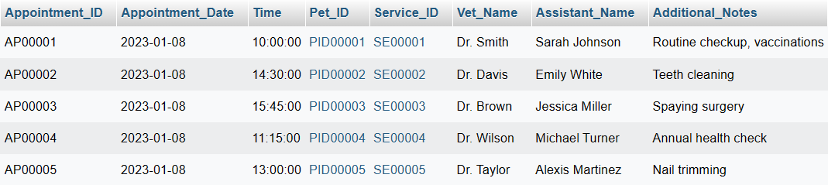

### **3.5.15 Table Purchase Order**

UPDATE Purchase_Order

SET Delivery_Date = '2023-02-15', Delivery_Address = '123 Main St, Cityville', Delivery_Status = 'Shipped'

WHERE PO_No = 'PO00001';

UPDATE Purchase_Order

SET Delivery_Date = '2023-02-18', Delivery_Address = '456 Oak St, Townsville', Delivery_Status = 'In Transit'

WHERE PO_No = 'PO00002';

UPDATE Purchase_Order

SET Delivery_Date = '2023-02-20', Delivery_Address = '789 Pine St, Villageton', Delivery_Status = 'Delivered'

WHERE PO_No = 'PO00003';

UPDATE Purchase_Order

SET Delivery_Date = '2023-02-22', Delivery_Address = '101 Cedar St, Hamletville', Delivery_Status = 'In Transit'

WHERE PO_No = 'PO00004';

UPDATE Purchase_Order

SET Delivery_Date = '2023-02-25', Delivery_Address = '202 Maple St, Suburbia', Delivery_Status = 'Shipped'

WHERE PO_No = 'PO00005';

***Output***

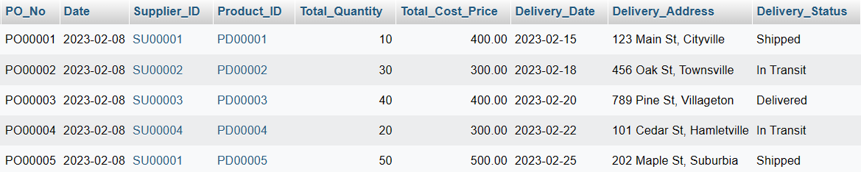

### **3.5.16 Table Customer Invoice**

UPDATE Customer_Invoice

SET Payment_Method = 'Credit Card', Payment_Status = 'Paid', Due_Date = '2023-08-15'

WHERE Invoice_No = 'IN00001';

UPDATE Customer_Invoice

SET Payment_Method = 'Cash', Payment_Status = 'Unpaid', Due_Date = '2023-08-15'

WHERE Invoice_No = 'IN00002';

UPDATE Customer_Invoice

SET Payment_Method = 'Bank Transfer', Payment_Status = 'Paid', Due_Date = '2023-08-15'

WHERE Invoice_No = 'IN00003';

UPDATE Customer_Invoice

SET Payment_Method = 'Cheque', Payment_Status = 'Unpaid', Due_Date = '2023-08-15'

WHERE Invoice_No = 'IN00004';

UPDATE Customer_Invoice

SET Payment_Method = 'Online Payment', Payment_Status = 'Paid', Due_Date = '2023-08-15'

WHERE Invoice_No = 'IN00005';

***Output***

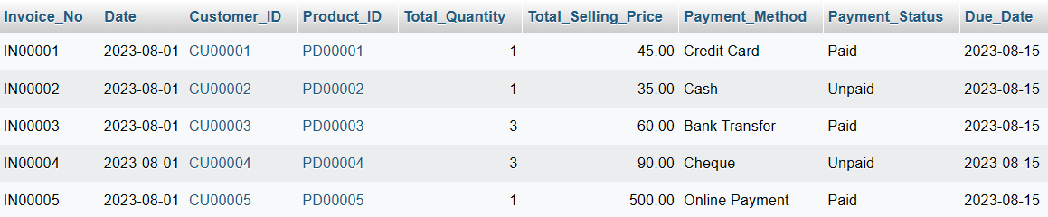

### **3.5.17 Table Customer DO**

UPDATE Customer_DO

SET Delivery_Status = 'Shipped', Carrier_Name = 'ABC Logistics', Tracking_Number = '123456789'

WHERE DO_No = 'DO00001';

UPDATE Customer_DO

SET Delivery_Status = 'In Transit', Carrier_Name = 'XYZ Couriers', Tracking_Number = '987654321'

WHERE DO_No = 'DO00002';

UPDATE Customer_DO

SET Delivery_Status = 'Delivered', Carrier_Name = 'Swift Shipping', Tracking_Number = '456789012'

WHERE DO_No = 'DO00003';

UPDATE Customer_DO

SET Delivery_Status = 'In Transit', Carrier_Name = 'Fast Movers', Tracking_Number = '789012345'

WHERE DO_No = 'DO00004';

UPDATE Customer_DO

SET Delivery_Status = 'Delivered', Carrier_Name = 'Speedy Deliveries', Tracking_Number = '345678901'

WHERE DO_No = 'DO00005';

***Output***

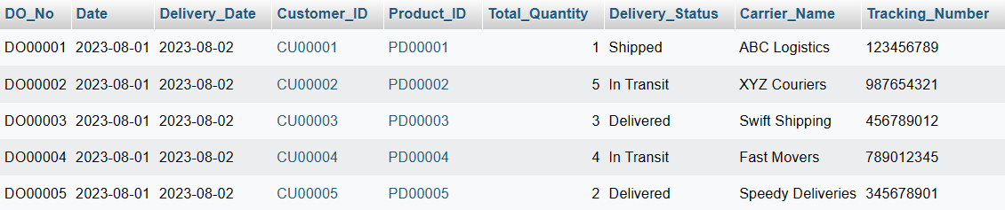

### **3.5.18 Table Supplier Invoice**

UPDATE Supplier_Invoice

SET Payment_Method = 'Bank Transfer', Payment_Status = 'Paid', Due_Date = '2023-08-15'

WHERE Supplier_Invoice_No = 'SIN00001';

UPDATE Supplier_Invoice

SET Payment_Method = 'Credit Card', Payment_Status = 'Unpaid', Due_Date = '2023-08-15'

WHERE Supplier_Invoice_No = 'SIN00002';

UPDATE Supplier_Invoice

SET Payment_Method = 'Cheque', Payment_Status = 'Paid', Due_Date = '2023-08-15'

WHERE Supplier_Invoice_No = 'SIN00003';

UPDATE Supplier_Invoice

SET Payment_Method = 'Bank Transfer', Payment_Status = 'Unpaid', Due_Date = '2023-08-15'

WHERE Supplier_Invoice_No = 'SIN00004';

UPDATE Supplier_Invoice

SET Payment_Method = 'Credit Card', Payment_Status = 'Paid', Due_Date = '2023-08-15'

WHERE Supplier_Invoice_No = 'SIN00005';

***Output***

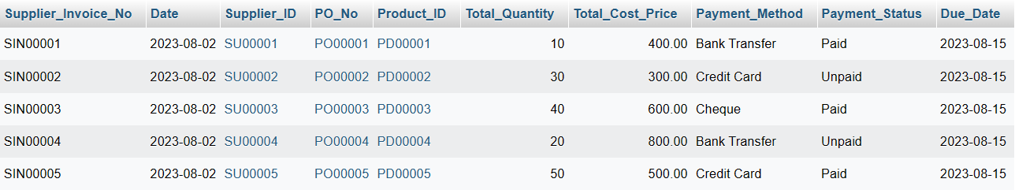

### **3.5.19 Table Supplier DO**

UPDATE Supplier_DO

SET Delivery_Status = 'Shipped', Carrier_Name = 'ABC Logistics', Tracking_Number = '123456789'

WHERE Supplier_DO_No = 'SDO00001';

UPDATE Supplier_DO

SET Delivery_Status = 'In Transit', Carrier_Name = 'XYZ Couriers', Tracking_Number = '987654321'

WHERE Supplier_DO_No = 'SDO00002';

UPDATE Supplier_DO

SET Delivery_Status = 'Delivered', Carrier_Name = 'Swift Shipping', Tracking_Number = '456789012'

WHERE Supplier_DO_No = 'SDO00003';

UPDATE Supplier_DO

SET Delivery_Status = 'In Transit', Carrier_Name = 'Fast Movers', Tracking_Number = '789012345'

WHERE Supplier_DO_No = 'SDO00004';

UPDATE Supplier_DO

SET Delivery_Status = 'Delivered', Carrier_Name = 'Speedy Deliveries', Tracking_Number = '345678901'

WHERE Supplier_DO_No = 'SDO00005';

***Output***

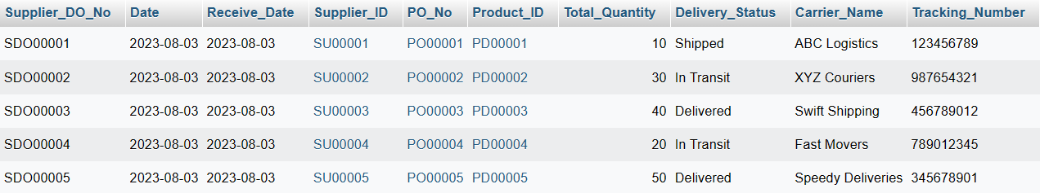

### **3.5.20 Table Stock Received**

UPDATE Stock_Received

SET Inspection_Status = 'Passed', Storage_Location = 'Warehouse A', Expiry_Date = '2023-12-31'

WHERE Received_No = 'RE00001';

UPDATE Stock_Received

SET Inspection_Status = 'Pending', Storage_Location = 'Warehouse B', Expiry_Date = '2023-12-31'

WHERE Received_No = 'RE00002';

UPDATE Stock_Received

SET Inspection_Status = 'Failed', Storage_Location = 'Warehouse C', Expiry_Date = '2023-12-31'

WHERE Received_No = 'RE00003';

UPDATE Stock_Received

SET Inspection_Status = 'Pending', Storage_Location = 'Warehouse D', Expiry_Date = '2023-12-31'

WHERE Received_No = 'RE00004';

UPDATE Stock_Received

SET Inspection_Status = 'Passed', Storage_Location = 'Warehouse E', Expiry_Date = '2023-12-31'

WHERE Received_No = 'RE00005';

***Output***

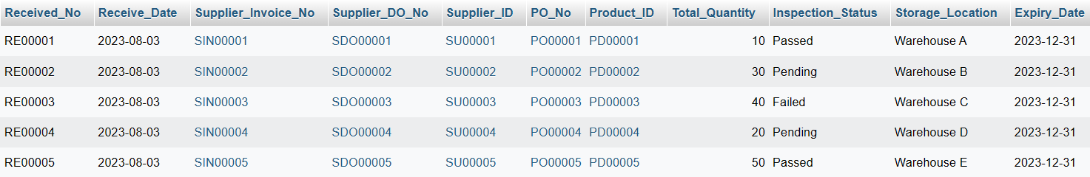

### **3.5.21 Table Stock Card**

UPDATE Stock_Card

SET Transaction_Date = '2023-08-04', Transaction_Type = 'In', Transaction_Description = 'Received from supplier'

WHERE Stock_Card_ID = 'ST00001';

UPDATE Stock_Card

SET Transaction_Date = '2023-08-05', Transaction_Type = 'Out', Transaction_Description = 'Sold to customer'

WHERE Stock_Card_ID = 'ST00002';

UPDATE Stock_Card

SET Transaction_Date = '2023-08-06', Transaction_Type = 'In', Transaction_Description = 'Received from supplier'

WHERE Stock_Card_ID = 'ST00003';

UPDATE Stock_Card

SET Transaction_Date = '2023-08-07', Transaction_Type = 'Out', Transaction_Description = 'Sold to customer'

WHERE Stock_Card_ID = 'ST00004';

UPDATE Stock_Card

SET Transaction_Date = '2023-08-08', Transaction_Type = 'In', Transaction_Description = 'Received from supplier'

WHERE Stock_Card_ID = 'ST00005';

***Output***

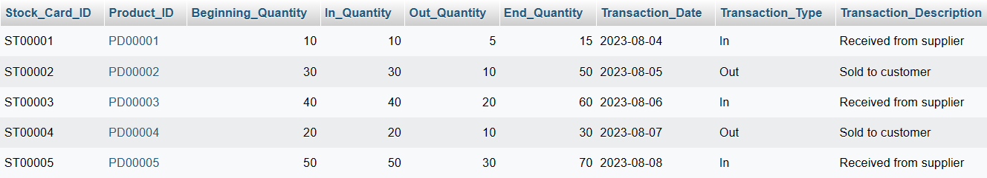

### **3.5.22 Table Customer Interest**

UPDATE Customer_Interest

SET Interest_Date = '2023-08-10', Interest_Source = 'Website', Comments = 'Customer liked the product features.'

WHERE Interest_ID = 'CI00001';

UPDATE Customer_Interest

SET Interest_Date = '2023-08-11', Interest_Source = 'In-Store Display', Comments = 'Customer expressed interest after seeing the product in-store.'

WHERE Interest_ID = 'CI00002';

UPDATE Customer_Interest

SET Interest_Date = '2023-08-12', Interest_Source = 'Social Media', Comments = 'Customer showed interest through a social media advertisement.'

WHERE Interest_ID = 'CI00003';

UPDATE Customer_Interest

SET Interest_Date = '2023-08-13', Interest_Source = 'Referral', Comments = 'Customer heard about the product from a friend.'

WHERE Interest_ID = 'CI00004';

UPDATE Customer_Interest

SET Interest_Date = '2023-08-14', Interest_Source = 'Email Campaign', Comments = 'Customer clicked on an email promotion.'

WHERE Interest_ID = 'CI00005';

***Output***

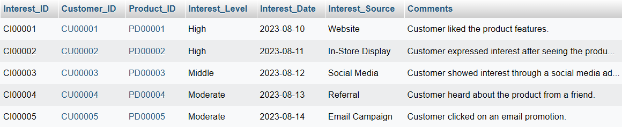

### **3.5.23 Table Customer Feedback**

UPDATE Customer_Feedback

SET Feedback_Type = 'General', Response_Text = 'Thank you for your feedback!', Response_Date = '2023-08-15'

WHERE Feedback_ID = 'FB00001';

UPDATE Customer_Feedback

SET Feedback_Type = 'Service', Response_Text = 'We appreciate your positive feedback!', Response_Date = '2023-08-16'

WHERE Feedback_ID = 'FB00002';

UPDATE Customer_Feedback

SET Feedback_Type = 'Pet', Response_Text = 'We''re glad you enjoyed our pets!', Response_Date = '2023-08-17'

WHERE Feedback_ID = 'FB00003';

UPDATE Customer_Feedback

SET Feedback_Type = 'Pet', Response_Text = 'Thank you for your kind words!', Response_Date = '2023-08-18'

WHERE Feedback_ID = 'FB00004';

UPDATE Customer_Feedback

SET Feedback_Type = 'Service', Response_Text = 'We''re thrilled to hear that! Thank you!', Response_Date = '2023-08-19'

WHERE Feedback_ID = 'FB00005';

***Output***

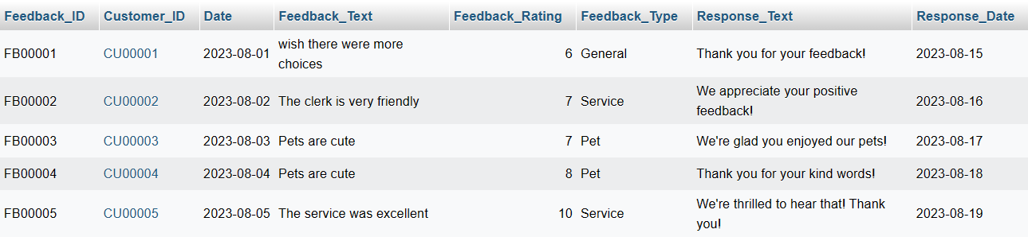

### **3.5.24 Table Employees**

UPDATE Employees

SET

Email = 'jayden@example.com',

Phone_Number = '123-456-7890',

Address = '123 Main St'

WHERE Employee_ID = 'EM00001';

UPDATE Employees

SET

Email = 'selina@example.com',

Phone_Number = '987-654-3210',

Address = '456 Oak St'

WHERE Employee_ID = 'EM00002';

UPDATE Employees

SET

Email = 'gabriel@example.com',

Phone_Number = '555-123-4567',

Address = '789 Pine St'

WHERE Employee_ID = 'EM00003';

UPDATE Employees

SET

Email = 'angel@example.com',

Phone_Number = '444-567-8901',

Address = '101 Cedar St'

WHERE Employee_ID = 'EM00004';

UPDATE Employees

SET

Email = 'beatrice@example.com',

Phone_Number = '222-333-4444',

Address = '202 Elm St'

WHERE Employee_ID = 'EM00005';

***Output***

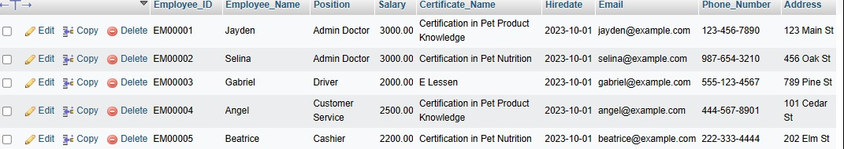

### **3.5.25 Table Employee Training**

UPDATE Employee_Training_Certification

SET

Trainer_Name = 'Updated Trainer 1',

Training_Duration = 6,

Training_Fee = 750.00

WHERE Training_ID = 'TR00001';

UPDATE Employee_Training_Certification

SET

Trainer_Name = 'Updated Trainer 2',

Training_Duration = 4,

Training_Fee = 600.00

WHERE Training_ID = 'TR00002';

UPDATE Employee_Training_Certification

SET

Trainer_Name = 'Updated Trainer 3',

Training_Duration = 8,

Training_Fee = 900.00

WHERE Training_ID = 'TR00003';

UPDATE Employee_Training_Certification

SET

Trainer_Name = 'Updated Trainer 4',

Training_Duration = 5,

Training_Fee = 700.00

WHERE Training_ID = 'TR00004';

UPDATE Employee_Training_Certification

SET

Trainer_Name = 'Updated Trainer 5',

Training_Duration = 3,

Training_Fee = 550.00

WHERE Training_ID = 'TR00005';

***Output***

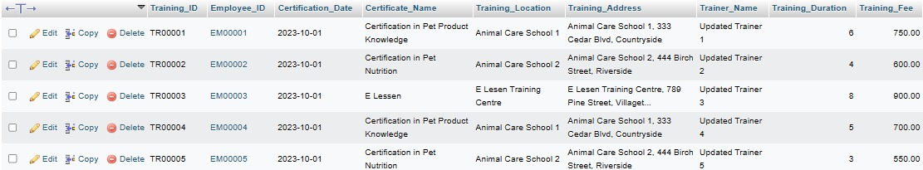

### **3.5.26 Table Pet Treatment Records**

UPDATE Pet_Treatment_Records

SET

Treatment_Type = 'Medical',

Treatment_Cost = 50.00,

Treatment_Status = 'Completed'

WHERE Treatment_Record_ID = 'PTR00001';

UPDATE Pet_Treatment_Records

SET

Treatment_Type = 'Dietary',

Treatment_Cost = 30.00,

Treatment_Status = 'Pending'

WHERE Treatment_Record_ID = 'PTR00002';

UPDATE Pet_Treatment_Records

SET

Treatment_Type = 'Nutritional',

Treatment_Cost = 40.00,

Treatment_Status = 'Completed'

WHERE Treatment_Record_ID = 'PTR00003';

UPDATE Pet_Treatment_Records

SET

Treatment_Type = 'Medical',

Treatment_Cost = 45.00,

Treatment_Status = 'InProgress'

WHERE Treatment_Record_ID = 'PTR00004';

UPDATE Pet_Treatment_Records

SET

Treatment_Type = 'Medical',

Treatment_Cost = 50.00,

Treatment_Status = 'Completed'

WHERE Treatment_Record_ID = 'PTR00005';

***Output***

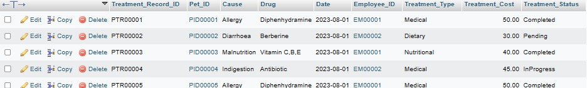

### **3.5.27 Table Vaccine Record**

UPDATE Vaccine_Record

SET

Vaccination_Clinic = 'ABC Veterinary Clinic',

Vaccination_Doctor = 'Dr. Smith',

Vaccination_Cost = 75.00

WHERE Vaccine_Record_ID = 'VR00001';

UPDATE Vaccine_Record

SET

Vaccination_Clinic = 'XYZ Pet Hospital',

Vaccination_Doctor = 'Dr. Johnson',

Vaccination_Cost = 90.00

WHERE Vaccine_Record_ID = 'VR00002';

UPDATE Vaccine_Record

SET

Vaccination_Clinic = 'PQR Animal Clinic',

Vaccination_Doctor = 'Dr. Anderson',

Vaccination_Cost = 80.00

WHERE Vaccine_Record_ID = 'VR00003';

UPDATE Vaccine_Record

SET

Vaccination_Clinic = 'LMN Vet Care',

Vaccination_Doctor = 'Dr. White',

Vaccination_Cost = 85.00

WHERE Vaccine_Record_ID = 'VR00004';

UPDATE Vaccine_Record

SET

Vaccination_Clinic = 'OPQ Pet Clinic',

Vaccination_Doctor = 'Dr. Brown',

Vaccination_Cost = 70.00

WHERE Vaccine_Record_ID = 'VR00005';

***Output***

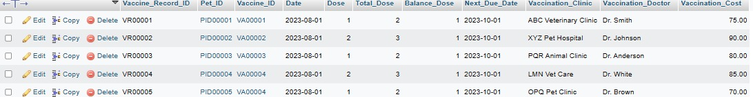

### **3.5.28 Table Shop Event**

UPDATE Shop_Event

SET

Organizer_Name = 'ABC Pet Store',

Contact_Email = 'abc@example.com',

Event_Description = 'Join us for an interactive workshop on pet care!'

WHERE Event_ID = 'EV00001';

UPDATE Shop_Event

SET

Organizer_Name = 'XYZ Pet Shop',

Contact_Email = 'xyz@example.com',

Event_Description = 'Celebrate our anniversary with exciting activities and offers!'

WHERE Event_ID = 'EV00002';

UPDATE Shop_Event

SET

Organizer_Name = 'PQR Animal Shelter',

Contact_Email = 'pqr@example.com',

Event_Description = 'Find your new furry friend at our pet adoption day!'

WHERE Event_ID = 'EV00003';

UPDATE Shop_Event

SET

Organizer_Name = 'LMN Vet Clinic',

Contact_Email = 'lmn@example.com',

Event_Description = 'Join us for a health check day and learn about pet wellness!'

WHERE Event_ID = 'EV00004';

UPDATE Shop_Event

SET

Organizer_Name = 'OPQ Pet Club',

Contact_Email = 'opq@example.com',

Event_Description = 'Socialize with fellow pet enthusiasts in this gathering!'

WHERE Event_ID = 'EV00005';

***Output***

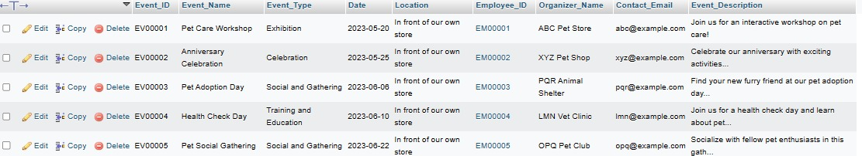

### **3.5.29 Table Sales History**

UPDATE Sales_History

SET

Discount = 5.00,

Customer_ID = 'CUST00001',

Payment_Method = 'Credit Card'

WHERE Sales_History_ID = 'SH00001';

UPDATE Sales_History

SET

Discount = 2.50,

Customer_ID = 'CUST00002',

Payment_Method = 'Cash'

WHERE Sales_History_ID = 'SH00002';

UPDATE Sales_History

SET

Discount = 10.00,

Customer_ID = 'CUST00003',

Payment_Method = 'PayPal'

WHERE Sales_History_ID = 'SH00003';

UPDATE Sales_History

SET

Discount = 15.00,

Customer_ID = 'CUST00004',

Payment_Method = 'Online Banking'

WHERE Sales_History_ID = 'SH00004';

UPDATE Sales_History

SET

Discount = 20.00,

Customer_ID = 'CUST00005',

Payment_Method = 'Cash'

WHERE Sales_History_ID = 'SH00005';

***Output***

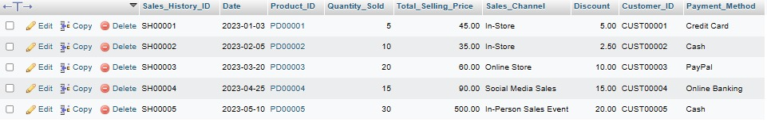

### **3.5.30 Table Payment History**

UPDATE Payment_History

SET

Invoice_Number = 'INV00001',

Payment_Description = 'Payment for Pet Products',

Employee_ID = 'EM00001'

WHERE PaymentHistory_ID = 'PH00001';

UPDATE Payment_History

SET

Invoice_Number = 'INV00002',

Payment_Description = 'Payment for Veterinary Services',

Employee_ID = 'EM00002'

WHERE PaymentHistory_ID = 'PH00002';

UPDATE Payment_History

SET

Invoice_Number = 'INV00003',

Payment_Description = 'Payment for Pet Accessories',

Employee_ID = 'EM00003'

WHERE PaymentHistory_ID = 'PH00003';

UPDATE Payment_History

SET

Invoice_Number = 'INV00004',

Payment_Description = 'Payment for Pet Health Check',

Employee_ID = 'EM00004'

WHERE PaymentHistory_ID = 'PH00004';

UPDATE Payment_History

SET

Invoice_Number = 'INV00005',

Payment_Description = 'Payment for Pet Grooming',

Employee_ID = 'EM00005'

WHERE PaymentHistory_ID = 'PH00005';

***Output***

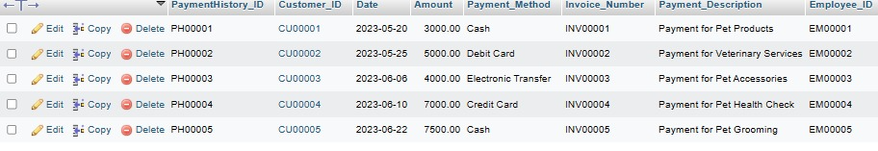

### **3.5.31 Table Monthly Net Report**

UPDATE Monthly_Net_Report

SET

Operating_Expenses = 1500.00,

Tax_Expense = 1000.00,

Net_Income = 2500.00

WHERE Monthly_Report_ID = 'MR00001';

UPDATE Monthly_Net_Report

SET

Operating_Expenses = 1200.00,

Tax_Expense = 800.00,

Net_Income = 2000.00

WHERE Monthly_Report_ID = 'MR00002';

UPDATE Monthly_Net_Report

SET

Operating_Expenses = 1300.00,

Tax_Expense = 900.00,

Net_Income = 2100.00

WHERE Monthly_Report_ID = 'MR00003';

UPDATE Monthly_Net_Report

SET

Operating_Expenses = 1800.00,

Tax_Expense = 1200.00,

Net_Income = 3200.00

WHERE Monthly_Report_ID = 'MR00004';

UPDATE Monthly_Net_Report

SET

Operating_Expenses = 2000.00,

Tax_Expense = 1500.00,

Net_Income = 4000.00

WHERE Monthly_Report_ID = 'MR00005';

***Output***

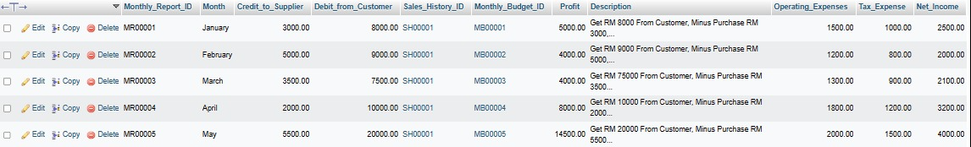

## **3.6. DROP**

### **3.6.1 Table Monthly Budget**

ALTER TABLE Monthly_Budget

DROP COLUMN Income,

DROP COLUMN Outcome,

DROP COLUMN Total_Outcome;

***Output***

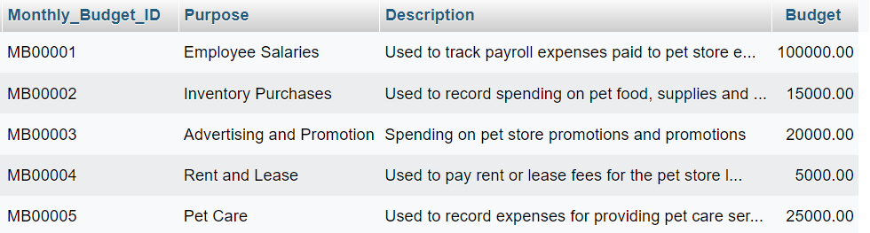

### **3.6.2 Table Supplier**

ALTER TABLE supplier

DROP COLUMN Contact_Person,

DROP COLUMN Address,

DROP COLUMN Balance_Owed;

***Output***

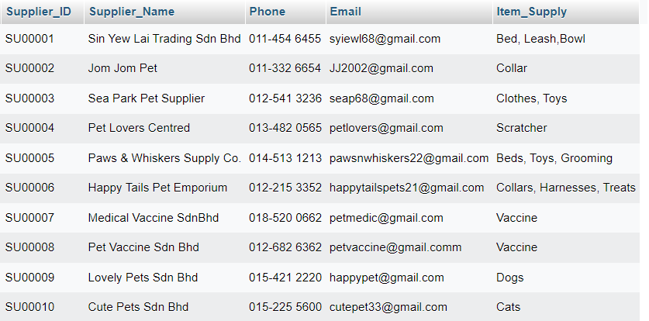

### **3.6.3 Table Pet Care Service**

ALTER TABLE pet_care_service

DROP COLUMN Location,

DROP COLUMN Available_Days,

DROP COLUMN Discount_Percentage;

***Output***

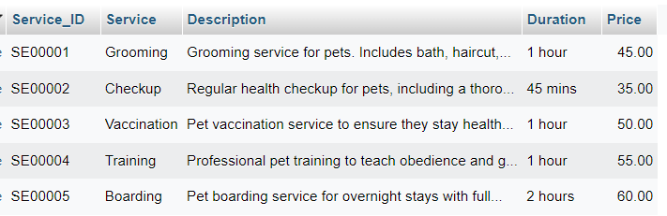

### **3.6.4 Table Pet Accessories**

ALTER TABLE Pet_Accessories

DROP COLUMN Size,

DROP COLUMN Stock_Quantity,

DROP COLUMN Discount_Percentage;

***Output***

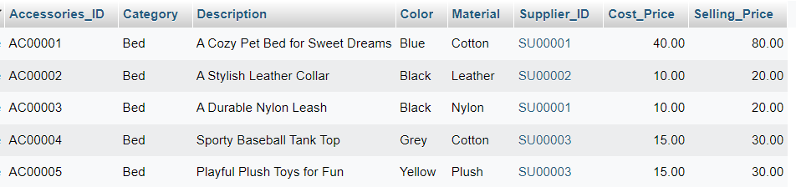

### **3.6.5 Table Pet Category**

ALTER TABLE pet_category

DROP COLUMN Age,

DROP COLUMN Weight,

DROP COLUMN Color;

***Output***

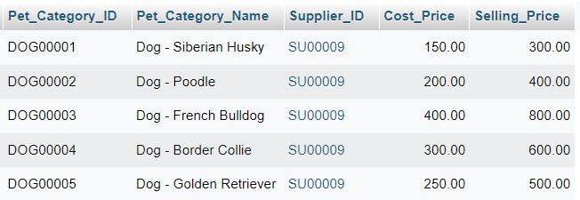

### **3.6.6 Table Vaccine**

ALTER TABLE vaccine

DROP COLUMN Expiry_Date,

DROP COLUMN Storage_Temperature,

DROP COLUMN Manufacturer;

***Output***

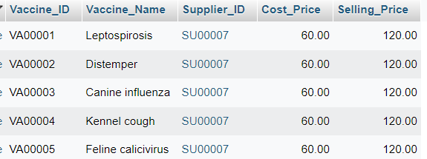

### **3.6.7 Table Inventory**

ALTER TABLE inventory

DROP COLUMN Purchase_Date;

DROP COLUMN Purchase_Cost;

DROP COLUMN Expiry_Date;

***Output***

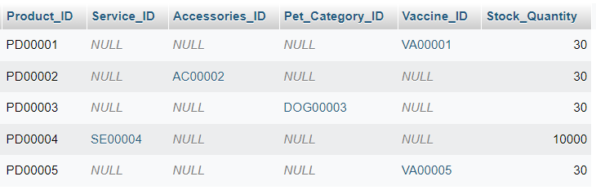

### **3.6.8 Table Customer**

ALTER TABLE Customer

DROP COLUMN Birthdate,

DROP COLUMN MembershipLevel,

DROP COLUMN RegistrationDate;

***Output***

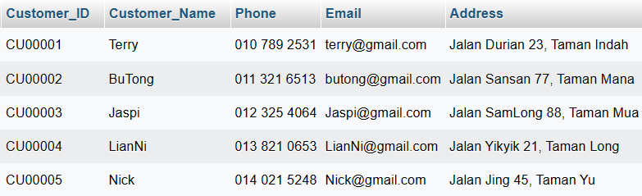

### **3.6.9 Table Customer Pet**

ALTER TABLE Customer_Pet

DROP COLUMN Vaccination_Status,

DROP COLUMN Last_Vaccination_Date,

DROP COLUMN Next_Vaccination_Date;

***Output***

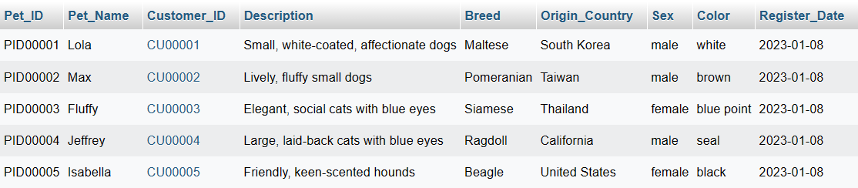

### **3.6.10 Table Adoption Record**

ALTER TABLE Adoption_Record

DROP COLUMN Adoption_Type,

DROP COLUMN Adoption_Fee,

DROP COLUMN Adoption_Status;

***Output***

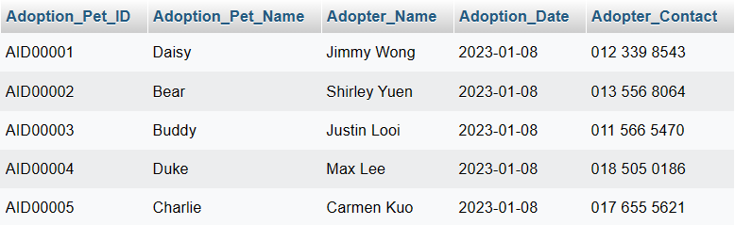

### **3.6.11 Table Lost And Found Record**

ALTER TABLE Lost_and_Found_Record

DROP COLUMN IsClaimed,

DROP COLUMN Claimer_Name,

DROP COLUMN Claimer_Contact;

***Output***

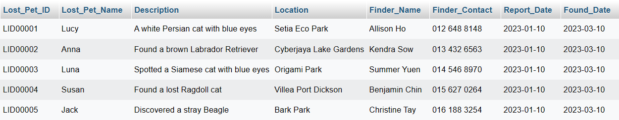

### **3.6.12 Table Pet Record**

ALTER TABLE Pet_Record

DROP COLUMN Vet_Appointment_Date,

DROP COLUMN Grooming_Appointment_Date,

DROP COLUMN Last_Feeding_Time;

***Output***

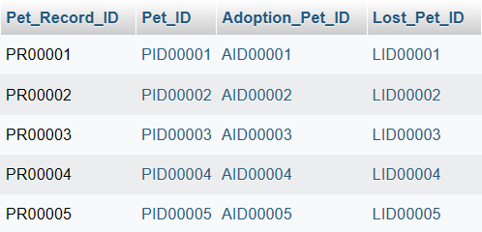

### **3.6.13 Table Membership**

ALTER TABLE Membership

DROP COLUMN Promo_Code,

DROP COLUMN Promo_Discount,

DROP COLUMN Promo_Expiry_Date;

***Output***

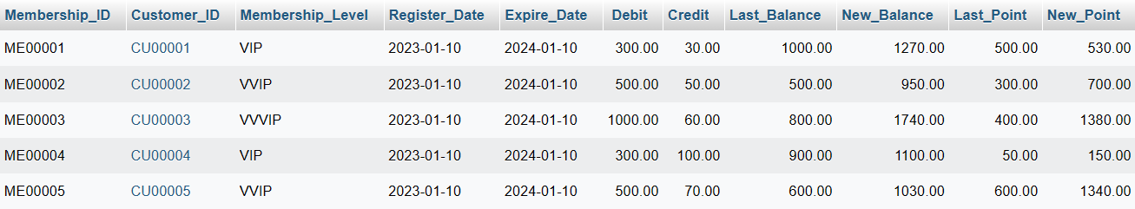

### **3.6.14 Table Pet Appointment Record**

ALTER TABLE Pet_Appointment_Record

DROP COLUMN Vet_Name,

DROP COLUMN Assistant_Name,

DROP COLUMN Additional_Notes;

***Output***

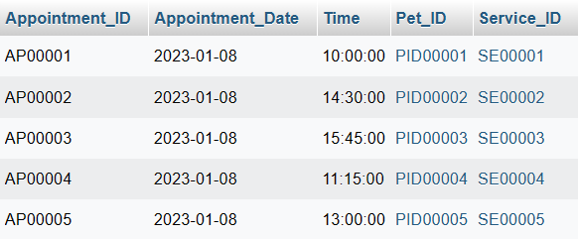

### **3.6.15 Table Purchase Order**

ALTER TABLE Purchase_Order

DROP COLUMN Delivery_Date,

DROP COLUMN Delivery_Address,

DROP COLUMN Delivery_Status;

***Output***

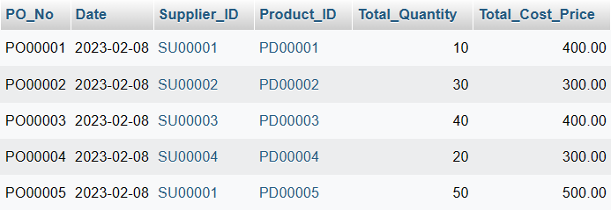

### **3.6.16 Table Customer Invoice**

ALTER TABLE Customer_Invoice

DROP COLUMN Payment_Method,

DROP COLUMN Payment_Status,

DROP COLUMN Due_Date;

***Output***

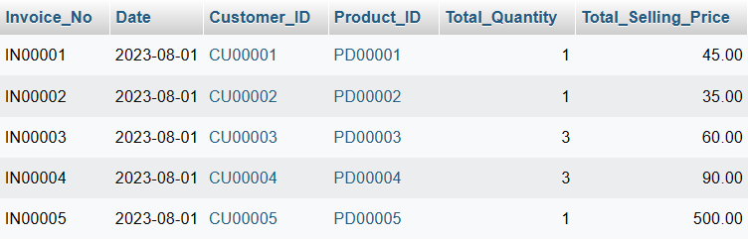

### **3.6.17 Table Customer DO**

ALTER TABLE Customer_DO

DROP COLUMN Delivery_Status,

DROP COLUMN Carrier_Name,

DROP COLUMN Tracking_Number;

***Output***

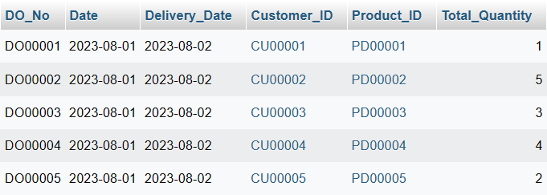

### **3.6.18 Table Supplier Invoice**

ALTER TABLE Supplier_Invoice

DROP COLUMN Payment_Method,

DROP COLUMN Payment_Status,

DROP COLUMN Due_Date;

***Output***

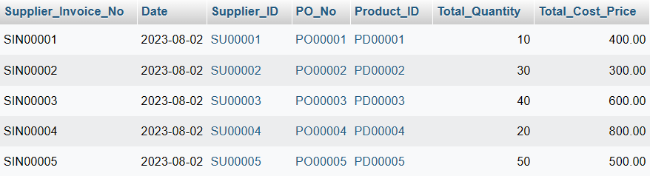

### **3.6.19 Table Supplier DO**

ALTER TABLE Supplier_DO

DROP COLUMN Delivery_Status,

DROP COLUMN Carrier_Name,

DROP COLUMN Tracking_Number;

***Output***

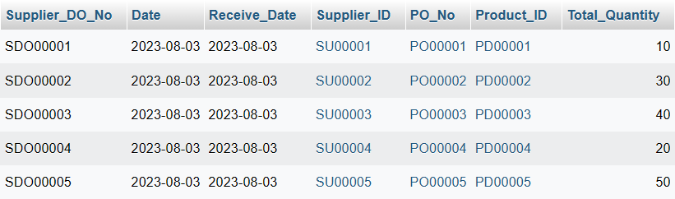

### **3.6.20 Table Stock Received**

ALTER TABLE Stock_Received

DROP COLUMN Inspection_Status,

DROP COLUMN Storage_Location,

DROP COLUMN Expiry_Date;

***Output***

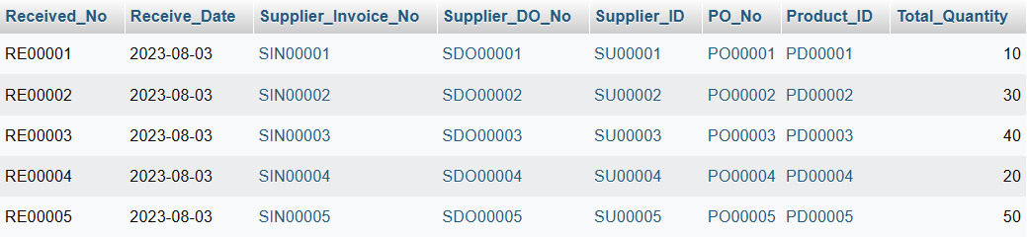

### **3.6.21 Table Stock Card**

ALTER TABLE Stock_Card

DROP COLUMN Transaction_Date,

DROP COLUMN Transaction_Type,

DROP COLUMN Transaction_Description;

***Output***

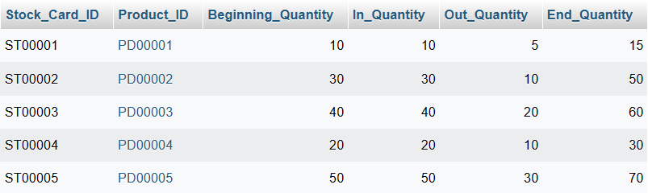

### **3.6.22 Table Customer Interest**

ALTER TABLE Customer_Interest

DROP COLUMN Interest_Date,

DROP COLUMN Interest_Source,

DROP COLUMN Comments;

***Output***

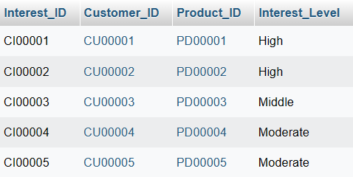

### **3.6.23 Table Customer Feedback**

ALTER TABLE Customer_Feedback

DROP COLUMN Feedback_Type,

DROP COLUMN Response_Text,

DROP COLUMN Response_Date;

***Output***

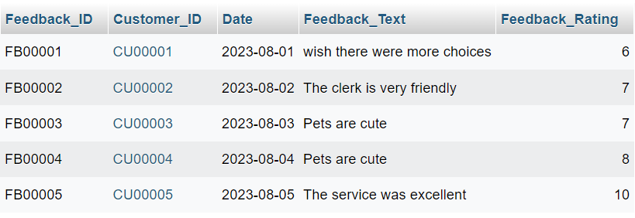

### **3.6.24 Table Employees**

ALTER TABLE Employees

DROP COLUMN Address,

DROP COLUMN Email,

DROP COLUMN Phone_Number;

***Output***

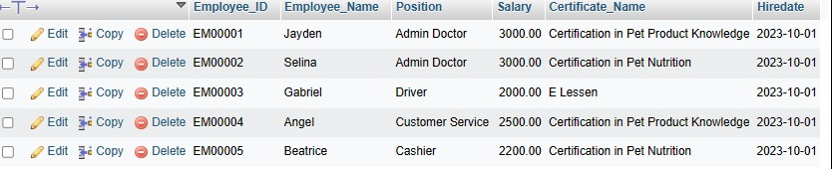

### **3.6.25 Table Employee Training**

ALTER TABLE Employee_Training_Certification

DROP COLUMN Trainer_Name;

DROP COLUMN Training_Duration;

DROP COLUMN Training_Fee;

***Output***



### **3.6.26 Table Pet Treatment Records**

ALTER TABLE Pet_Treatment_Records

DROP COLUMN Treatment_Type;

DROP COLUMN Treatment_Cost;

DROP COLUMN Treatment_Status;

***Output***

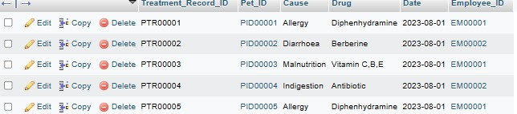

### **3.6.27 Table Vaccine Record**

ALTER TABLE Vaccine_Record

DROP COLUMN Vaccination_Clinic;

DROP COLUMN Vaccination_Doctor;

DROP COLUMN Vaccination_Cost;

***Output***

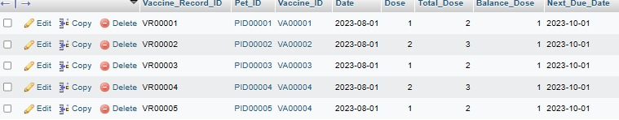

### **3.6.28 Table Shop Event**

ALTER TABLE Shop_Event

DROP COLUMN Organizer_Name;

DROP COLUMN Contact_Email;

DROP COLUMN Event_Description;

***Output***

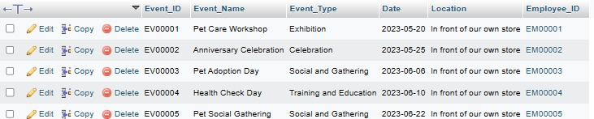

### **3.6.29 Table Sales History**

ALTER TABLE Sales_History

DROP COLUMN Discount;

DROP COLUMN Customer_ID;

DROP COLUMN Payment_Method;

***Output***

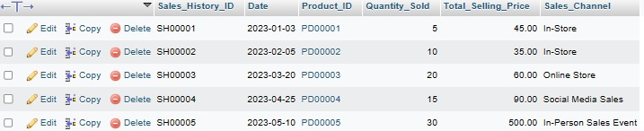

### **3.6.30 Table Payment History**

ALTER TABLE Payment_History

DROP COLUMN Invoice_Number;

DROP COLUMN Payment_Description;

DROP COLUMN Employee_ID;

***Output***

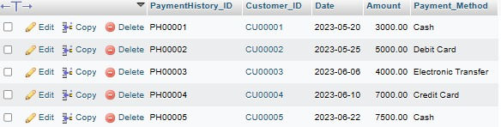

### **3.6.31 Table Monthly Net Report**

ALTER TABLE Monthly_Net_Report

DROP COLUMN Operating_Expenses;

DROP COLUMN Tax_Expense;

DROP COLUMN Net_Income;

***Output***

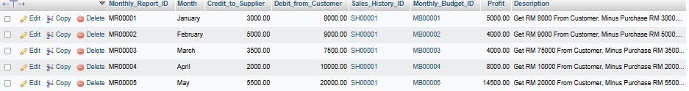

# **4. Queries**

## **4.1 Table Monthly Budget**

### **4.1.1 UNION**

SELECT Monthly_Budget_ID, Purpose FROM Monthly_Budget

UNION

SELECT Monthly_Budget_ID, Description FROM Monthly_Budget;

***Output***

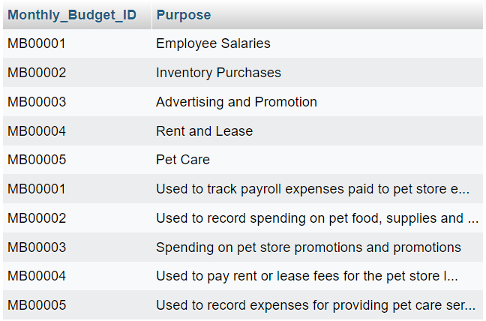

### **4.1.2 GROUP BY**

SELECT Purpose, SUM(Budget) AS TotalBudget

FROM Monthly_Budget

GROUP BY Purpose;

***Output***

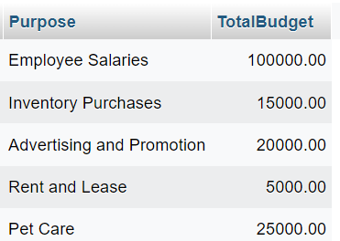

### **4.1.3 HAVING**

SELECT Purpose, SUM(Budget) AS TotalBudget

FROM Monthly_Budget

GROUP BY Purpose

HAVING TotalBudget > 20000;

***Output***

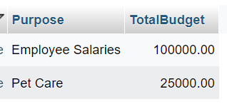

### **4.1.4 EXISTS**

***Output***

### **4.1.5 ANY, ALL**

SELECT *

FROM Monthly_Budget mb1

WHERE Budget > ANY (

SELECT Budget

FROM Monthly_Budget mb2

WHERE mb2.Monthly_Budget_ID <> mb1.Monthly_Budget_ID

);

***Output***

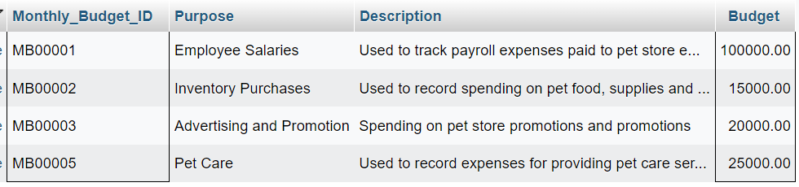

### **4.1.6 CASE**

SELECT Monthly_Budget_ID, Purpose, Description, Budget,

CASE WHEN Budget > (SELECT AVG(Budget) FROM Monthly_Budget) THEN 'Above Average' ELSE 'Below Average' END AS BudgetStatus

FROM Monthly_Budget;

***Output***

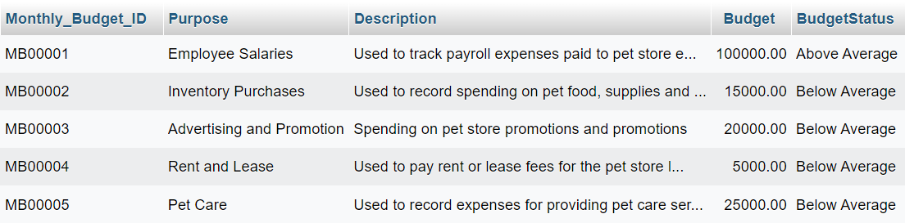

### **4.1.7 NULL FUNCTIONS**

SELECT Purpose, IFNULL(Description, 'Not Available') AS Description, Budget

FROM Monthly_Budget;

***Output***

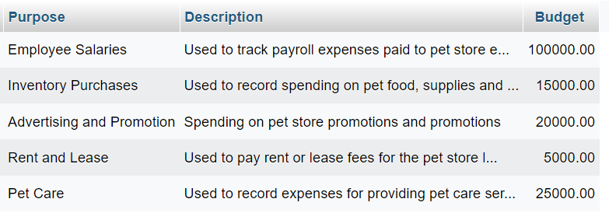

***Note: The 'Description' column does not contain null data, so 'Not Available' will not be shown.***

## **4.2 Table Supplier**

### **4.2.1 UNION**

SELECT Supplier_ID, Supplier_Name FROM Supplier WHERE Item_Supply LIKE '%Toys%'

UNION

SELECT Supplier_ID, Supplier_Name FROM Supplier WHERE Item_Supply LIKE '%Collar%';

***Output***

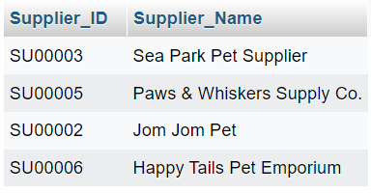

### **4.2.2 GROUP BY**

SELECT Supplier_ID, Supplier_Name, SUM(LENGTH(Email)) AS TotalPhoneDigits

FROM Supplier

GROUP BY Supplier_ID, Supplier_Name;

***Output***

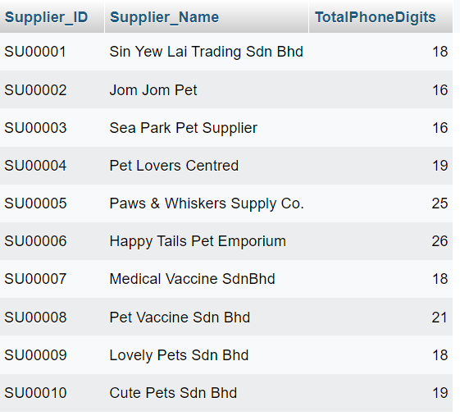

### **4.2.3 HAVING**

SELECT Supplier_ID, Supplier_Name, MAX(LENGTH(Email)) AS MaxEmailLength

FROM Supplier

GROUP BY Supplier_ID, Supplier_Name

HAVING MaxEmailLength > 20;

***Output***

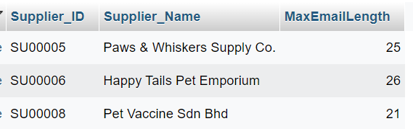

### **4.2.4 EXISTS**

SELECT Supplier_ID, Supplier_Name

FROM Supplier AS S

WHERE EXISTS (

SELECT *

FROM Supplier AS S2

WHERE S2.Supplier_ID = S.Supplier_ID

AND S2.Item_Supply = 'Vaccine'

);

***Output***

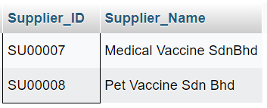

### **4.2.5 ANY, ALL**

SELECT Supplier_ID, Supplier_Name

FROM Supplier

WHERE Phone > ANY (SELECT Phone FROM Supplier WHERE Supplier_ID > 'SU00008');

***Output***

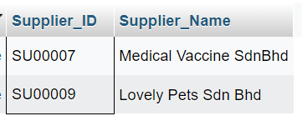

### **4.2.6 CASE**

SELECT Supplier_ID, Supplier_Name,

CASE

WHEN Item_Supply LIKE '%Toys%' THEN 'Pet Toys Supplier'

WHEN Item_Supply LIKE '%Vaccine%' THEN 'Medical Supplier'

ELSE 'General Pet Supplier'

END AS SupplierType

FROM Supplier;

***Output***

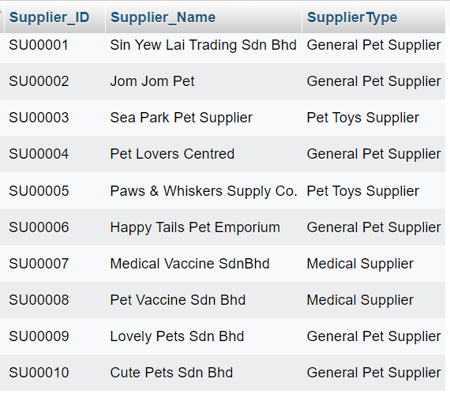

### **4.2.7 NULL FUNCTIONS**

SELECT Supplier_Name,

IFNULL(Email, 'Email Not Provided') AS SafeEmail

FROM Supplier;

***Output***

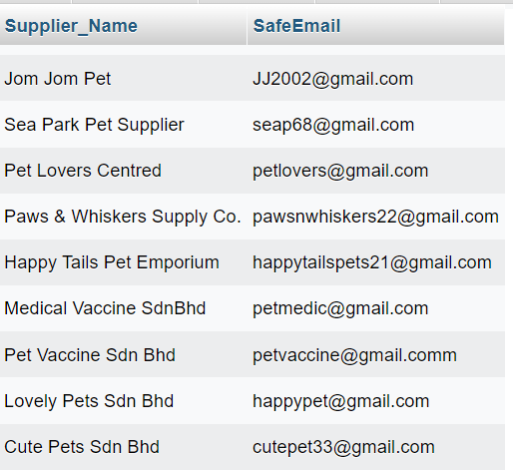

***\*Note: The 'Email' column does not contain null data, so 'Email Not Provided' will not be shown.***

## **4.3 Table Pet Care Service**

### **4.3.1 UNION**

SELECT Service_ID, Service FROM Pet_Care_Service WHERE Price > 40

UNION

SELECT Service_ID, Service FROM Pet_Care_Service WHERE Duration = '1 hour';

***Output***

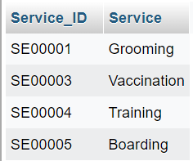

### **4.3.2 GROUP BY**

SELECT Duration, AVG(Price) AS AvgPrice

FROM Pet_Care_Service

GROUP BY Duration;

***Output***

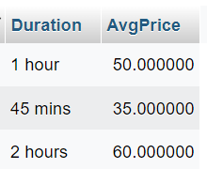

### **4.3.3 HAVING**

SELECT Duration, AVG(Price) AS AvgPrice

FROM Pet_Care_Service

GROUP BY Duration

HAVING AvgPrice > 50;

***Output***

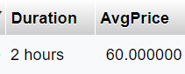

### **4.3.4 EXISTS**

SELECT Service_ID, Service

FROM Pet_Care_Service p1

WHERE EXISTS (SELECT * FROM Pet_Care_Service p2 WHERE p2.Duration = '1 hour' AND p1.Service_ID = p2.Service_ID);

***Output***

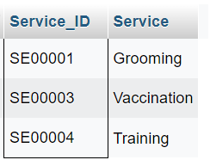

### **4.3.5 ANY, ALL**

SELECT Service_ID, Service

FROM Pet_Care_Service

WHERE Price > ANY (SELECT Price FROM Pet_Care_Service WHERE Duration <> '45 mins');

***Output***

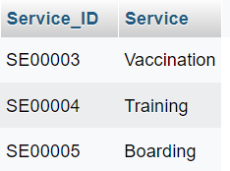

### **4.3.6 CASE**

SELECT Service_ID, Service,

CASE

WHEN Price < 40 THEN 'Low Price'

WHEN Price BETWEEN 40 AND 50 THEN 'Moderate Price'

ELSE 'High Price'

END AS PriceCategory

FROM Pet_Care_Service;

***Output***

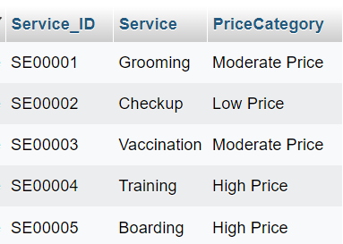

### **4.3.7 NULL FUNCTIONS**

SELECT Service_ID, Service, COALESCE(Duration, 'Not specified') AS Duration

FROM Pet_Care_Service;

***Output***

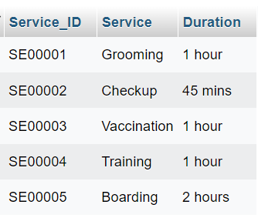

***\*Note: The 'Duration' column does not contain null data, so 'Not specified' will not be shown.***

## **4.4 Table Pet Accessories**

### **4.4.1 UNION with NULL FUNCTIONS**

SELECT

'Supplier' AS Source,

Supplier_ID,

Supplier_Name AS Name,

COALESCE(Phone, 'N/A') AS Phone,

COALESCE(Email, 'N/A') AS Email,

Item_Supply AS Product

FROM

Supplier

UNION

SELECT

'Pet_Accessories' AS Source,

Supplier_ID,

Category AS Name,

'N/A' AS Phone,

'N/A' AS Email,

Description AS Product

FROM

Pet_Accessories;

***Output***

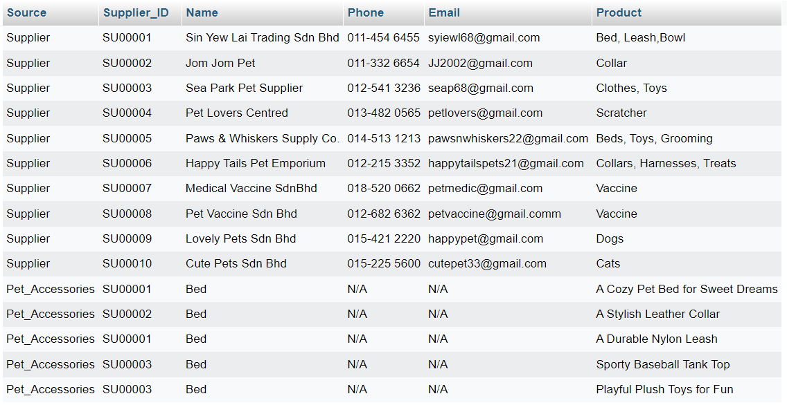

### **4.4.2 GROUP BY**

SELECT Material, SUM(Selling_Price) AS TotalSellingPrice

FROM Pet_Accessories

GROUP BY Material;

***Output***

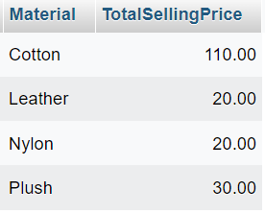

### **4.4.3 HAVING**

SELECT Supplier_ID, COUNT(*) AS Accessory_Count

FROM Pet_Accessories

GROUP BY Supplier_ID

HAVING Accessory_Count > 1;

***Output***

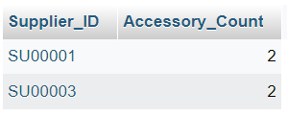

### **4.4.4 EXISTS**

SELECT *

FROM Supplier

WHERE EXISTS (

SELECT 1

FROM Pet_Accessories

WHERE Supplier.Supplier_ID = Pet_Accessories.Supplier_ID

);

***Output***

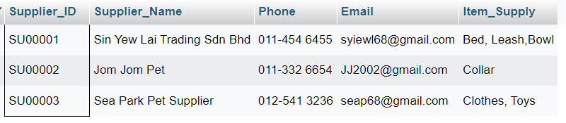

### **4.4.5 ANY, ALL**

SELECT Accessories_ID, Cost_Price

FROM Pet_Accessories

WHERE Cost_Price > ANY (SELECT Cost_Price FROM Pet_Accessories WHERE Material = 'Cotton');

***Output***

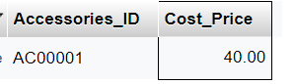

### **4.4.6 CASE**

SELECT Accessories_ID, Selling_Price,

CASE

WHEN Selling_Price >= 50 THEN 'Expensive'

WHEN Selling_Price >= 30 AND Selling_Price < 50 THEN 'Moderate'

ELSE 'Affordable'

END AS Price_Category

FROM Pet_Accessories;

***Output***

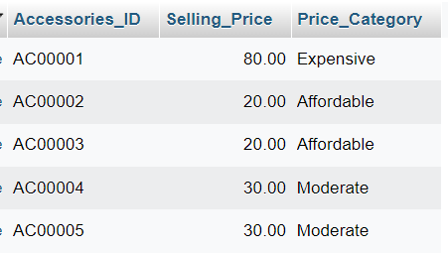

## **4.5 Table Pet Category**

### **4.5.1 UNION with NULL FUNCTIONS**

SELECT

Supplier_ID,

IFNULL(Supplier_Name, 'Not Available') AS Supplier_Name,

IFNULL(Phone, 'Not Available') AS Phone,

IFNULL(Email, 'Not Available') AS Email,

IFNULL(Item_Supply, 'Not Available') AS Item_Supply

FROM Supplier

UNION

SELECT

Pet_Category.Supplier_ID,

IFNULL(Pet_Category_Name, 'Not Available') AS Supplier_Name,

IFNULL(Cost_Price, 'Not Available') AS Phone,

IFNULL(Selling_Price, 'Not Available') AS Email,

'Not Available' AS Item_Supply

FROM Pet_Category;

***Output***

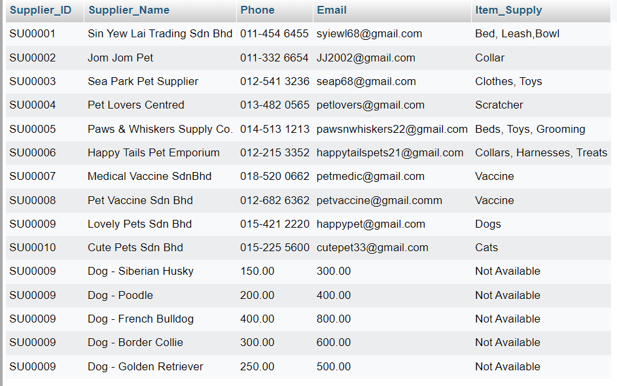

### **4.5.2 GROUP BY**

SELECT Pet_Category_ID,

Pet_Category_Name,

SUM(Cost_Price) AS Total_Cost,

AVG(Selling_Price) AS Avg_Selling_Price

FROM Pet_Category

GROUP BY Pet_Category_ID;

***Output***

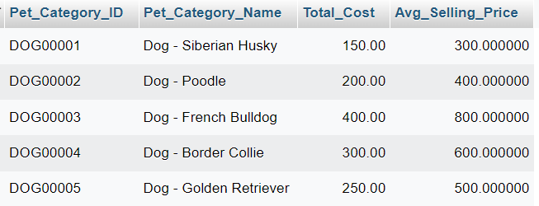

### **4.5.3 HAVING**

SELECT Pet_Category_ID,

Pet_Category_Name,

AVG(Selling_Price) AS Avg_Selling_Price

FROM Pet_Category

GROUP BY Pet_Category_ID

HAVING AVG(Selling_Price) > 600;

***Output***

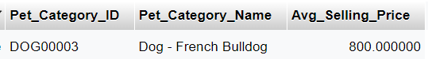

### **4.5.4 EXISTS**

SELECT Pet_Category_ID,

Selling_Price

FROM Pet_Category pc

WHERE EXISTS (

SELECT 1

FROM Supplier s

WHERE s.Supplier_ID = pc.Supplier_ID

);

***Output***

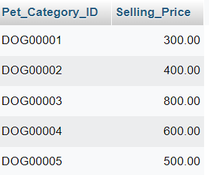

### **4.5.5 ANY, ALL**

SELECT Pet_Category_ID,

Pet_Category_Name

FROM Pet_Category

WHERE Selling_Price > ANY (

SELECT Cost_Price

FROM Pet_Category

);

***Output***

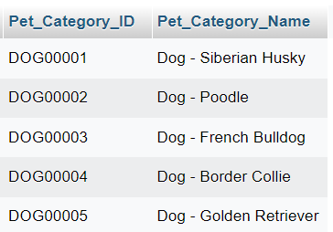

### **4.5.6 CASE**

SELECT Pet_Category_ID,

Pet_Category_Name,

Selling_Price,

CASE

WHEN Selling_Price < 400 THEN 'Low Price'

WHEN Selling_Price >= 400 AND Selling_Price < 700 THEN 'Medium Price'

ELSE 'High Price'

END AS Price_Category

FROM Pet_Category;

***Output***

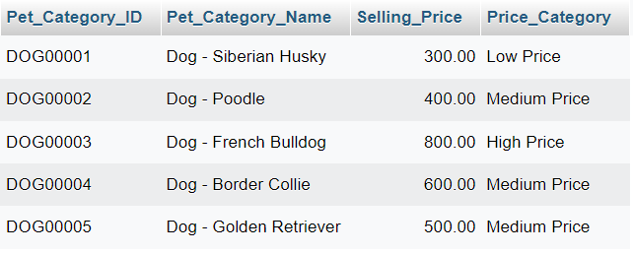

## **4.6 Table Vaccine**

### **4.6.1 UNION with NULL FUNCTIONS**

SELECT

Supplier_ID,

Supplier_Name,

IFNULL(Phone, 'Not Available') AS Phone,

IFNULL(Email, 'Not Available') AS Email,

IFNULL(Item_Supply, 'Not Available') AS Item_Supply

FROM Supplier

UNION

SELECT

Vaccine_ID AS Supplier_ID,

Vaccine_Name AS Supplier_Name,

COALESCE(Supplier.Phone, 'Not Available') AS Phone,

COALESCE(Supplier.Email, 'Not Available') AS Email,

'Not Available' AS Item_Supply

FROM Vaccine

JOIN Supplier ON Vaccine.Supplier_ID = Supplier.Supplier_ID;

***Output***

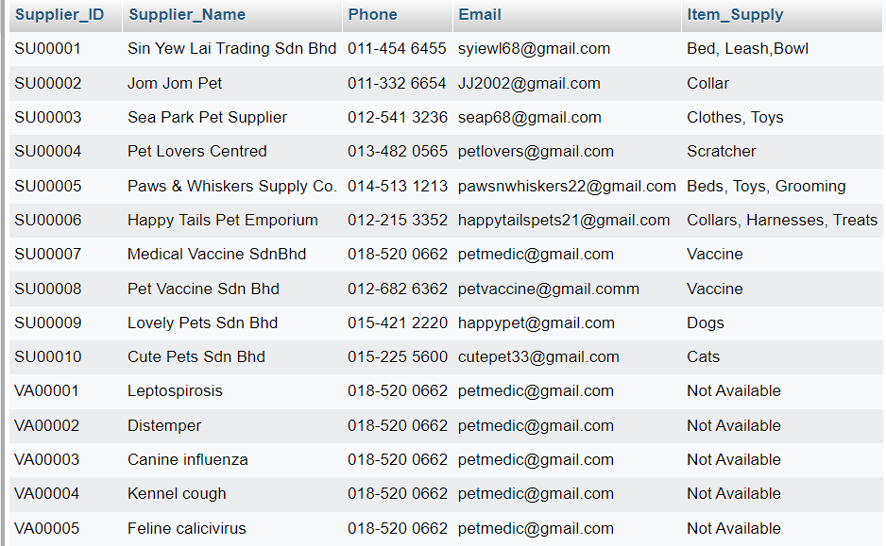

### **4.6.2 GROUP BY**

SELECT Vaccine_ID, Vaccine_Name, SUM(Cost_Price) AS Total_Cost, SUM(Selling_Price) AS Total_Selling_Price

FROM Vaccine

GROUP BY Vaccine_ID, Vaccine_Name;

***Output***

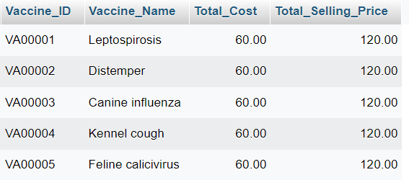

### **4.6.3 HAVING**

SELECT Supplier_ID, SUM(Selling_Price) AS Total_Selling_Price

FROM Vaccine

GROUP BY Supplier_ID

HAVING Total_Selling_Price > 300;

***Output***

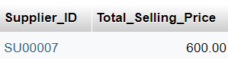

### **4.6.4 EXISTS**

SELECT Vaccine_ID, Vaccine_Name

FROM Vaccine V1

WHERE EXISTS (

SELECT 1

FROM Vaccine V2

WHERE V1.Supplier_ID = V2.Supplier_ID

AND V1.Vaccine_ID <> V2.Vaccine_ID

);

***Output***

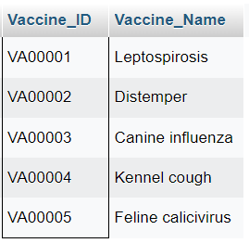

### **4.6.5 ANY, ALL**

SELECT Vaccine_ID, Vaccine_Name, Selling_Price

FROM Vaccine

WHERE Selling_Price > ANY (SELECT Cost_Price FROM Vaccine);

***Output***

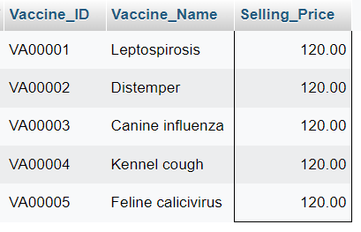

### **4.6.6 CASE**

SELECT Vaccine_ID, Vaccine_Name, Selling_Price,

CASE

WHEN Vaccine_Name LIKE '%1-dose%' THEN 'Single Dose'

WHEN Vaccine_Name LIKE '%2-dose%' THEN 'Two Dose'

WHEN Vaccine_Name LIKE '%3-dose%' THEN 'Three Dose'

ELSE 'Unknown'

END AS Dose_Category

FROM Vaccine;

***Output***

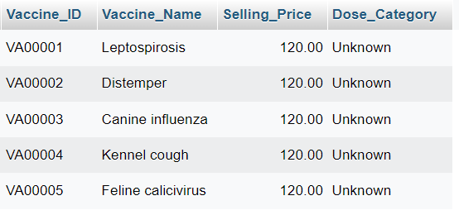

## **4.7 Table Inventory**

### **4.7.1 UNION**

SELECT Product_ID, Service_ID, Accessories_ID, Pet_Category_ID, Vaccine_ID, Stock_Quantity

FROM Inventory

WHERE Service_ID IS NOT NULL

UNION

SELECT Product_ID, Service_ID, Accessories_ID, Pet_Category_ID, Vaccine_ID, Stock_Quantity

FROM Inventory

WHERE Accessories_ID IS NOT NULL

UNION

SELECT Product_ID, Service_ID, Accessories_ID, Pet_Category_ID, Vaccine_ID, Stock_Quantity

FROM Inventory

WHERE Pet_Category_ID IS NOT NULL

UNION

SELECT Product_ID, Service_ID, Accessories_ID, Pet_Category_ID, Vaccine_ID, Stock_Quantity

FROM Inventory

WHERE Vaccine_ID IS NOT NULL;

***Output***

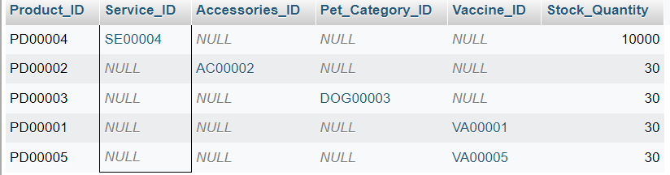

### **4.7.2 GROUP BY**

SELECT Pet_Category_ID, Vaccine_ID, SUM(Stock_Quantity) AS TotalStock

FROM Inventory

WHERE Pet_Category_ID IS NOT NULL OR Vaccine_ID IS NOT NULL

GROUP BY Pet_Category_ID, Vaccine_ID;

***Output***

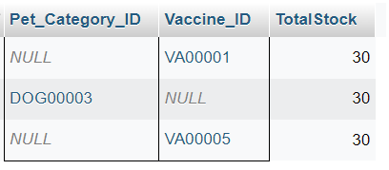

### **4.7.3 HAVING**

SELECT Product_ID, AVG(Stock_Quantity) AS AverageStock

FROM Inventory

WHERE Product_ID IS NOT NULL

GROUP BY Product_ID

HAVING AverageStock <= 30;

***Output***

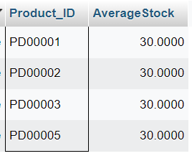

### **4.7.4 EXISTS**

SELECT Product_ID, Stock_Quantity

FROM Inventory

WHERE EXISTS (

SELECT 1

FROM Inventory

WHERE Stock_Quantity > 1000

AND Inventory.Product_ID = Inventory.Product_ID -- Make sure to correlate the subquery with the outer query

);

***Output***

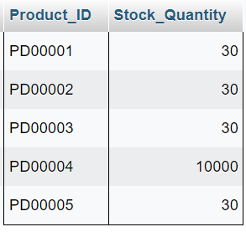

### **4.7.5 ANY, ALL**

SELECT Product_ID, Stock_Quantity

FROM Inventory

WHERE Stock_Quantity > ANY (

SELECT Stock_Quantity

FROM Inventory

WHERE Pet_Category_ID IS NOT NULL

);

***Output***

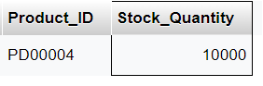

### **4.7.6 CASE**

SELECT Product_ID,

CASE

WHEN Stock_Quantity > 50 THEN 'High Stock'

WHEN Stock_Quantity <= 50 AND Stock_Quantity > 0 THEN 'Low Stock'

ELSE 'Out of Stock'

END AS Stock_Status

FROM Inventory

WHERE Stock_Quantity IS NOT NULL;

***Output***

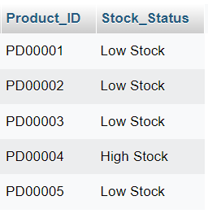

### **4.7.7 NULL FUNCTIONS**

SELECT Product_ID, COALESCE(Vaccine_ID, 'N/A') AS Vaccine_ID

FROM Inventory;

***Output***

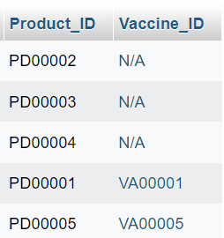

## **4.8 Table Customer**

### **4.8.1 SELECT & WHERE**

SELECT * FROM Customer WHERE Customer_Name = 'Terry';

***Output***

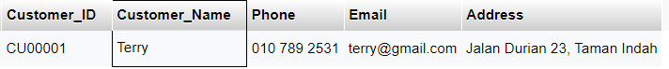

### **4.8.2 AND, OR, NOT**

SELECT * FROM Customer WHERE Customer_Name = 'Terry' AND Phone LIKE '010%';

***Output***



SELECT * FROM Customer WHERE Customer_Name = 'Terry' OR Customer_Name = 'BuTong';

***Output***

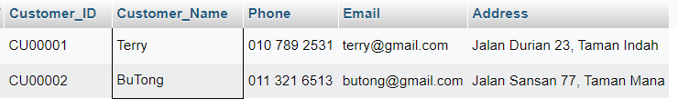

SELECT * FROM Customer WHERE NOT Email = 'terry@gmail.com';

***Output***

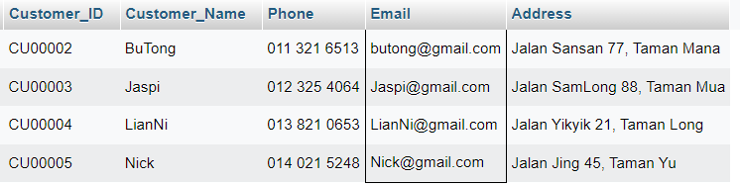

### **4.8.3 ORDER BY**

SELECT * FROM Customer ORDER BY Customer_Name ASC;

***Output***

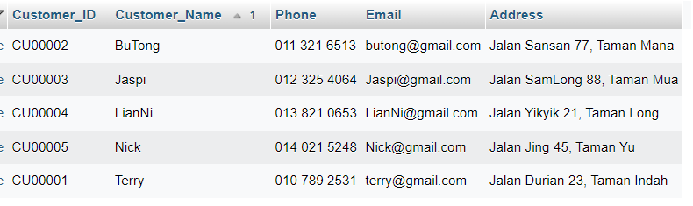

SELECT * FROM Customer ORDER BY Phone DESC;

***Output***

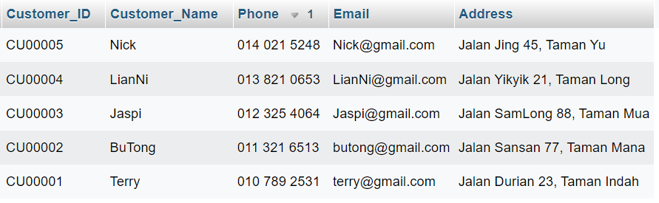

### **4.8.4 NULL & NOT NULL VALUES**

SELECT * FROM Customer WHERE Email IS NULL;

***Output***

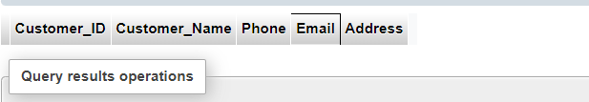

SELECT * FROM Customer WHERE Email IS NOT NULL;

***Output***

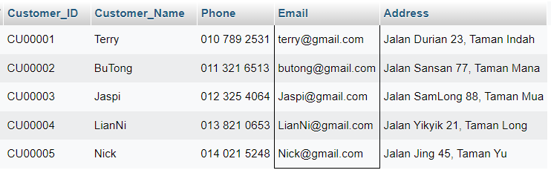

## **4.9 Table Customer Pet**

### **4.9.1 SELECT & WHERE**

SELECT * FROM Customer_Pet WHERE Breed = 'Beagle';

***Output***



### **4.9.2 AND, OR, NOT**

SELECT * FROM Customer_Pet WHERE Origin_Country = 'Taiwan' AND Sex = 'male';

***Output***



SELECT * FROM Customer_Pet WHERE Color = 'white' OR Color = 'brown';

***Output***

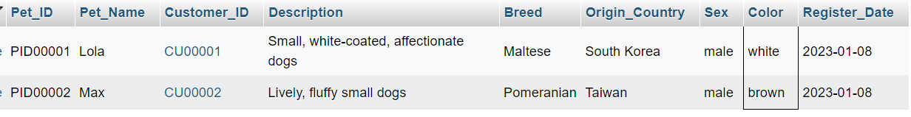

SELECT * FROM Customer_Pet WHERE NOT Breed = 'Siamese';

***Output***

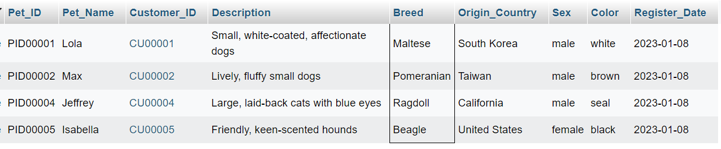

### **4.9.3 ORDER BY**

SELECT * FROM Customer_Pet ORDER BY Register_Date ASC;

***Output***

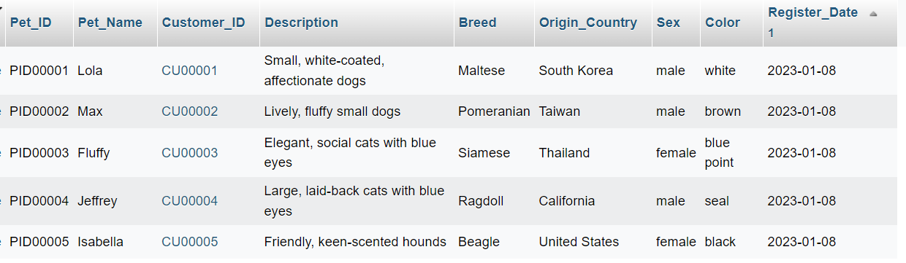

### **4.9.4 NULL & NOT NULL VALUES**

SELECT * FROM Customer_Pet WHERE Description IS NOT NULL;

***Output***

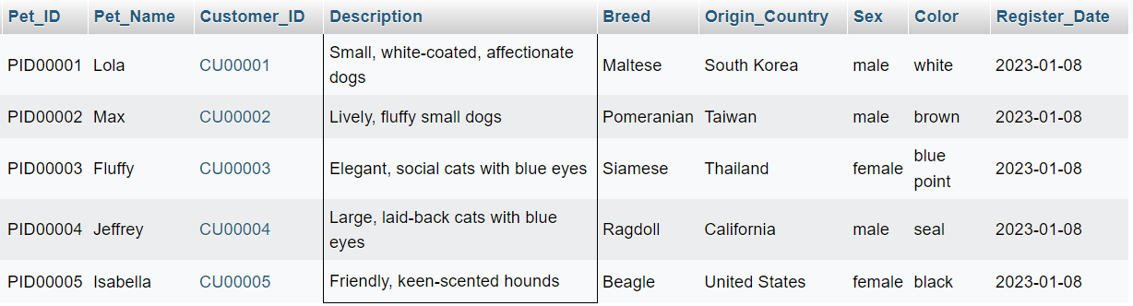

## **4.10 Table Adoption Record**

### **4.10.1 SELECT & WHERE**

SELECT * FROM Adoption_Record WHERE Adopter_Name = 'Shirley Yuen';

***Output***

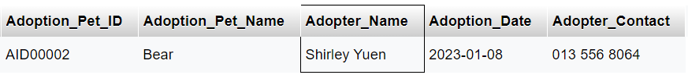

### **4.10.2 AND, OR, NOT**

SELECT * FROM Adoption_Record WHERE Adoption_Date = '2023-01-08' AND Adopter_Contact LIKE '01%';

***Output***

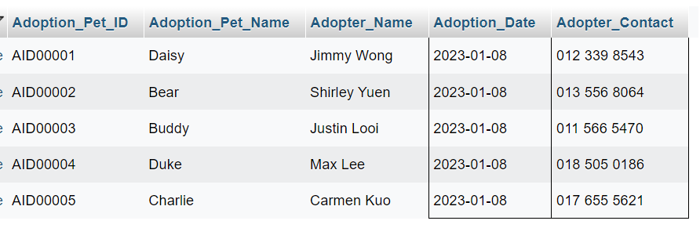

SELECT * FROM Adoption_Record WHERE Adopter_Name = 'Jimmy Wong' OR Adopter_Name = 'Max Lee';

***Output***

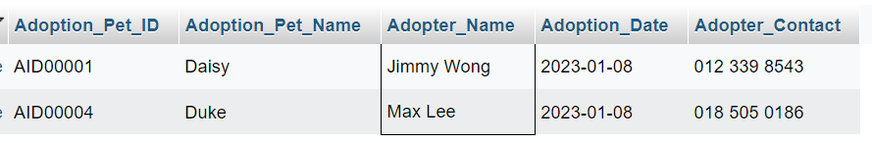

SELECT * FROM Adoption_Record WHERE NOT Adopter_Name = 'Justin Looi';

***Output***

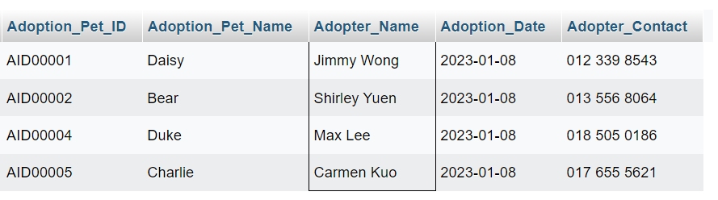

### **4.10.3 ORDER BY**

SELECT * FROM Adoption_Record ORDER BY Adoption_Date DESC;

***Output***

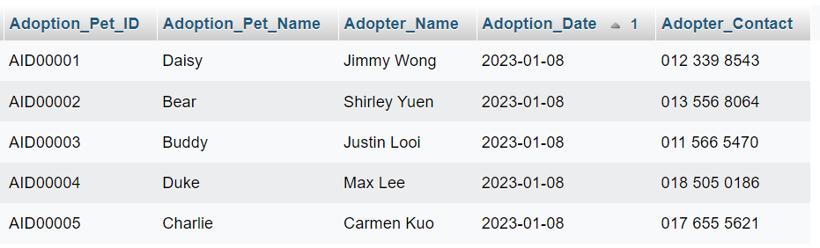

### **4.10.4 NULL & NOT NULL VALUES**

SELECT * FROM Adoption_Record WHERE Adoption_Pet_Name IS NOT NULL;

***Output***

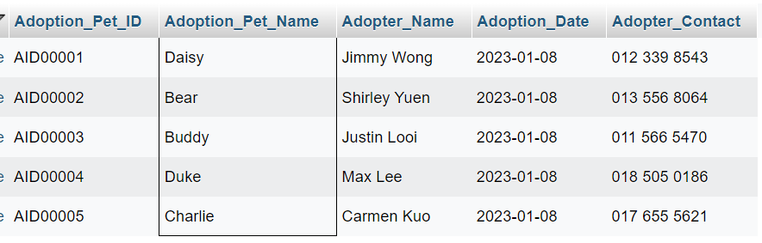

## **4.11 Table Lost And Found Record**

### **4.11.1 SELECT & WHERE**

SELECT * FROM Lost_and_Found_Record WHERE Location = 'Origami Park';

***Output***



### **4.11.2 AND, OR, NOT**

SELECT * FROM Lost_and_Found_Record WHERE Description LIKE '%cat%' AND Finder_Name = 'Allison Ho';

***Output***

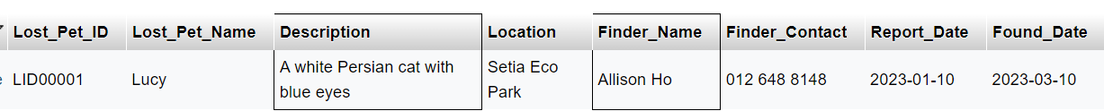

SELECT * FROM Lost_and_Found_Record WHERE Location = 'Bark Park' OR Location = 'Setia Eco Park';

***Output***

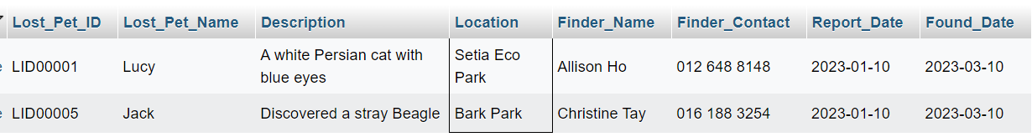

SELECT * FROM Lost_and_Found_Record WHERE NOT Finder_Name = 'Summer Yuen';

***Output***

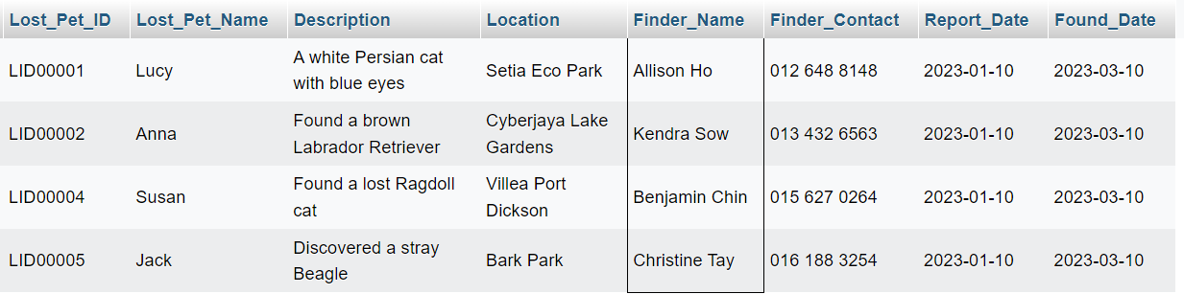

### **4.11.3 ORDER BY**

SELECT * FROM Lost_and_Found_Record ORDER BY Lost_Pet_Name ASC;

***Output***

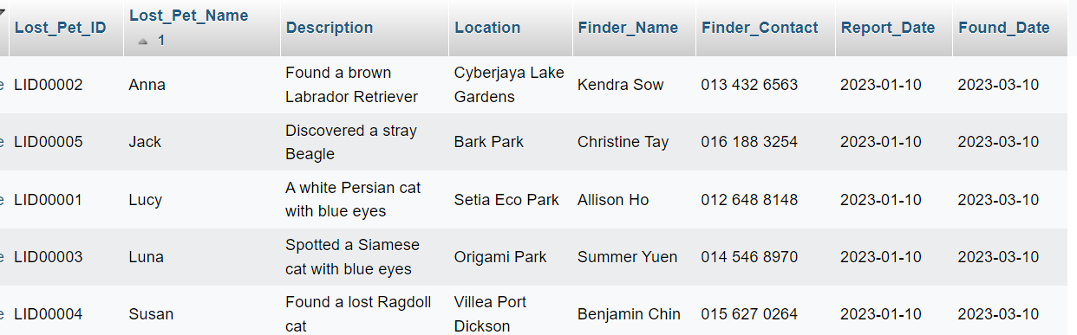

SELECT * FROM Lost_and_Found_Record ORDER BY Lost_Pet_Name DESC;

***Output***

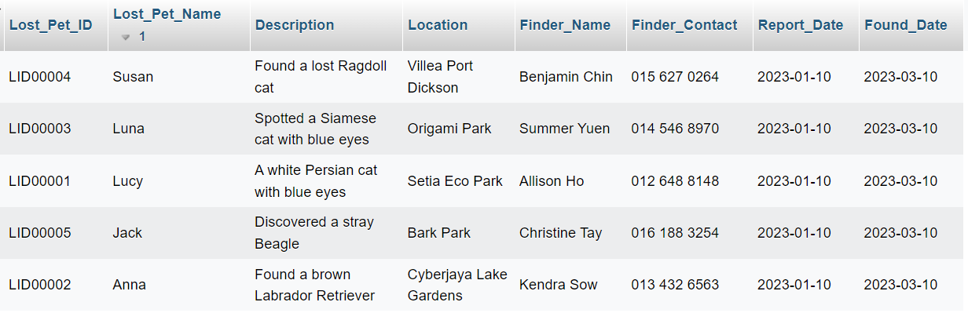

### **4.11.4 NULL & NOT NULL VALUES**

SELECT * FROM Lost_and_Found_Record WHERE Found_Date IS NOT NULL;

***Output***

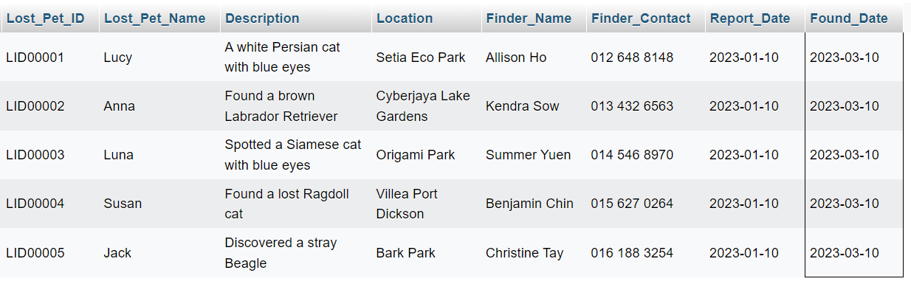

## **4.12 Table Pet Record**

### **4.12.1 SELECT & WHERE**

SELECT * FROM Pet_Record WHERE Pet_ID = 'PID00003';

***Output***

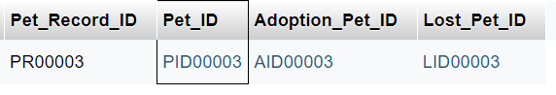

### **4.12.2 AND, OR, NOT**

SELECT * FROM Pet_Record WHERE Adoption_Pet_ID = 'AID00001' AND Lost_Pet_ID = 'LID00001';

***Output***

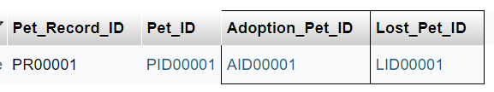

SELECT * FROM Pet_Record WHERE Adoption_Pet_ID = 'AID00002' OR Lost_Pet_ID = 'LID00002';

***Output***

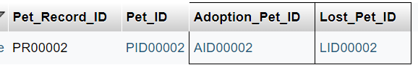

SELECT * FROM Pet_Record WHERE NOT Pet_ID = 'PID00004';

***Output***

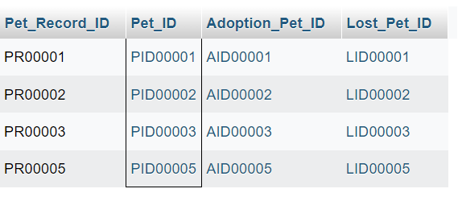

### **4.12.3 ORDER BY**

SELECT * FROM Pet_Record ORDER BY Pet_Record_ID ASC;

***Output***

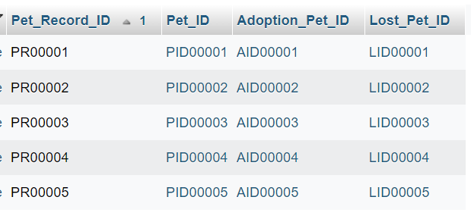

SELECT * FROM Pet_Record ORDER BY Pet_Record_ID DESC;

***Output***

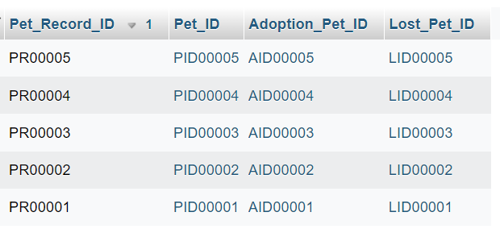

### **4.12.4 NULL & NOT NULL VALUES**

SELECT * FROM Pet_Record WHERE Adoption_Pet_ID IS NOT NULL;

***Output***

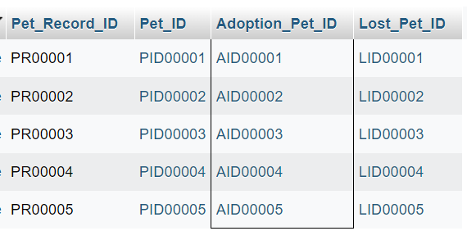

## **4.13 Table Membership**

### **4.13.1 SELECT & WHERE**

SELECT * FROM Membership WHERE Membership_Level = 'VVIP';

***Output***



### **4.13.2 AND, OR, NOT**

SELECT * FROM Membership WHERE Debit > 400 AND Credit > 40;

***Output***

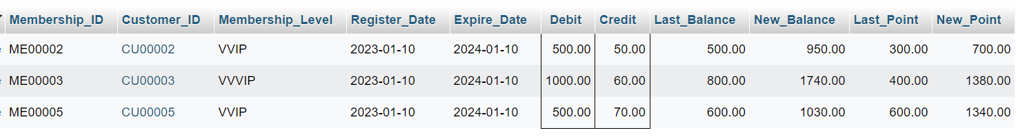

### **4.13.3 ORDER BY**

SELECT * FROM Membership ORDER BY Debit ASC;

***Output***

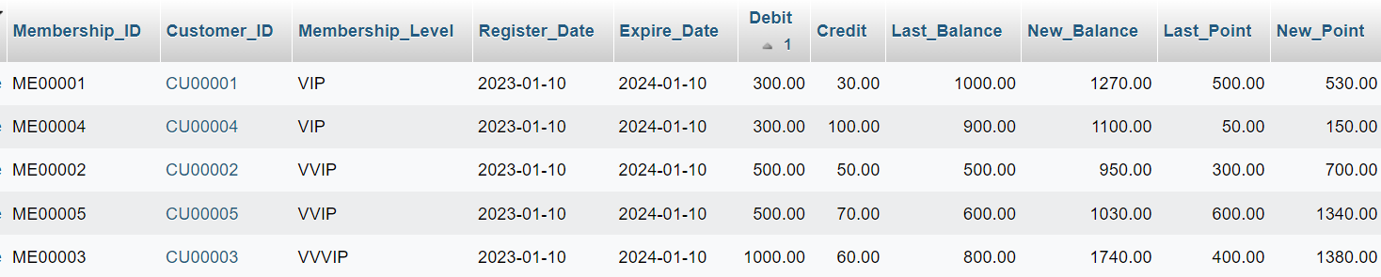

### **4.13.4 NULL & NOT NULL VALUES**

SELECT * FROM Membership WHERE Expire_Date IS NOT NULL;

***Output***

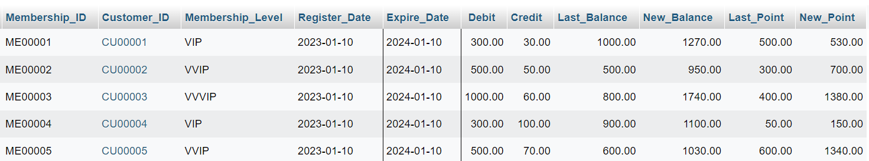

## **4.14 Table Pet Appointment Record**

### **4.14.1 SELECT & WHERE**

SELECT * FROM Pet_Appointment_Record WHERE Appointment_Date = '2023-01-08' AND Time >= '12:00:00';

***Output***

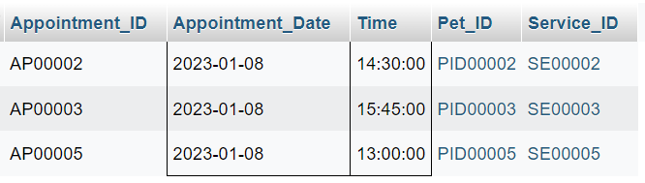

### **4.14.2 AND, OR, NOT**

SELECT * FROM Pet_Appointment_Record WHERE Appointment_Date = '2023-01-08' OR Appointment_ID = 'AP00001';

***Output***

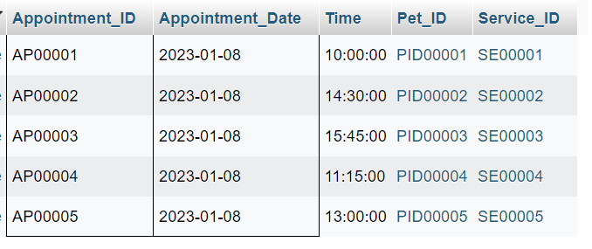

### **4.14.3 ORDER BY**

SELECT * FROM Pet_Appointment_Record ORDER BY Appointment_ID ASC, Time ASC;

***Output***

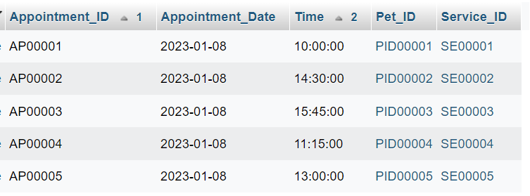

### **4.14.4 NULL & NOT NULL VALUES**

SELECT * FROM Pet_Appointment_Record WHERE Service_ID IS NOT NULL;

***Output***

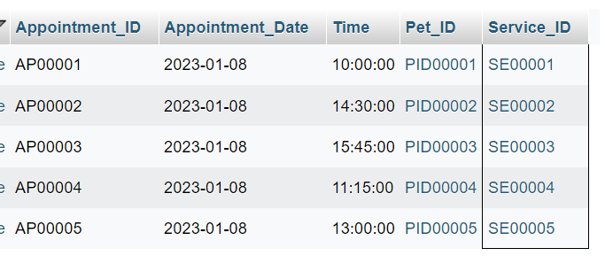

## **4.15 Table Purchase Order**

### **4.15.1 SELECT & WHERE**

SELECT * FROM Purchase_Order WHERE Total_Quantity > 30;

***Output***

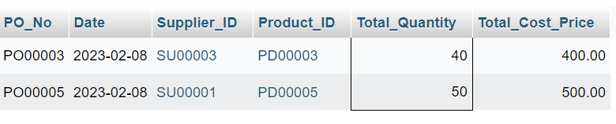

### **4.15.2 AND, OR, NOT**

SELECT * FROM Purchase_Order WHERE NOT Product_ID = 'PD00003';

***Output***

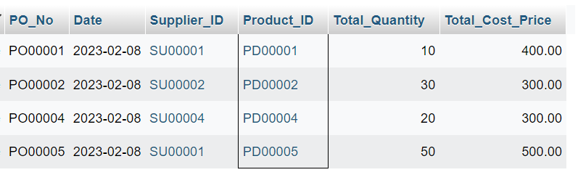

### **4.15.3 ORDER BY**

SELECT * FROM Purchase_Order ORDER BY Date ASC;

***Output***

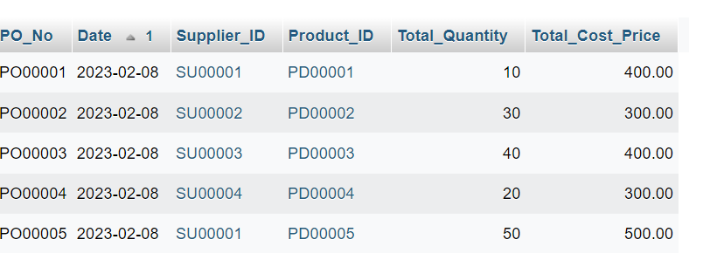

### **4.15.4 NULL & NOT NULL VALUES**

SELECT * FROM Purchase_Order WHERE Supplier_ID IS NOT NULL;

***Output***

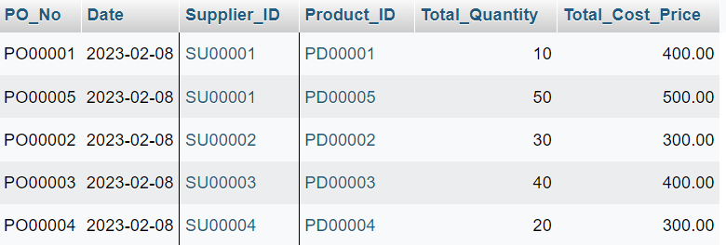

## **4.16 Table Customer Invoice**

### **4.16.1 ALIASES**

SELECT Invoice_No AS InvoiceNumber, Date AS InvoiceDate, Customer_ID AS CustomerID, Product_ID AS ProductID, Total_Quantity AS Quantity, Total_Selling_Price AS TotalPrice

FROM Customer_Invoice;

***Output***

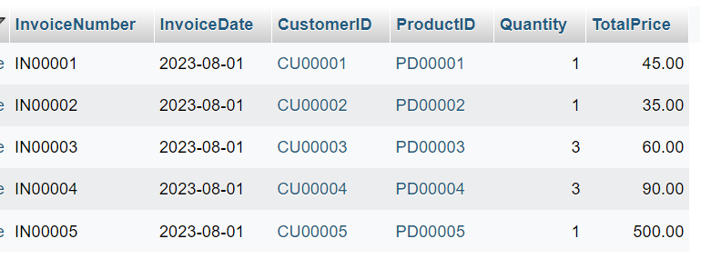

### **4.16.2 INNER JOIN**

SELECT Customer.Customer_ID, Customer.Customer_Name, Customer_Invoice.Invoice_No

FROM Customer

INNER JOIN Customer_Invoice ON Customer.Customer_ID = Customer_Invoice.Customer_ID;

***Output***

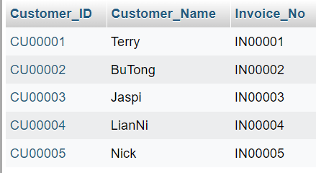

### **4.16.3 LEFT JOIN**

SELECT Customer.Customer_ID, Customer.Customer_Name, Customer_Invoice.Invoice_No

FROM Customer

LEFT JOIN Customer_Invoice ON Customer.Customer_ID = Customer_Invoice.Customer_ID;

***Output***

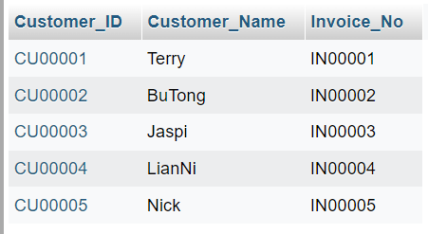

### **4.16.4 RIGHT JOIN**

SELECT Customer.Customer_ID, Customer.Customer_Name, Customer_Invoice.Invoice_No

FROM Customer

RIGHT JOIN Customer_Invoice ON Customer.Customer_ID = Customer_Invoice.Customer_ID;

***Output***

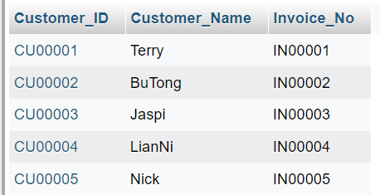

### **4.16.5 CROSS JOIN**

SELECT Customer.Customer_ID, Customer.Customer_Name, Customer_Invoice.Invoice_No

FROM Customer

CROSS JOIN Customer_Invoice;

***Output***

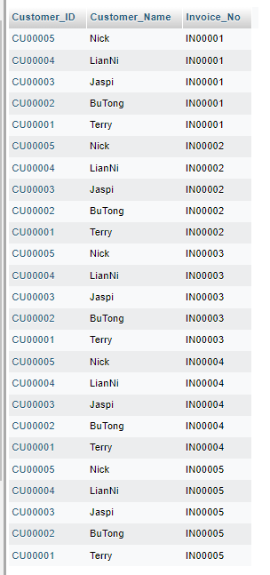

### **4.16.6 SELF JOIN**

SELECT a.Customer_ID AS Customer1, b.Customer_ID AS Customer2, a.Customer_Name AS Name1, b.Customer_Name AS Name2

FROM Customer a

JOIN Customer b ON a.Customer_ID < b.Customer_ID;

***Output***

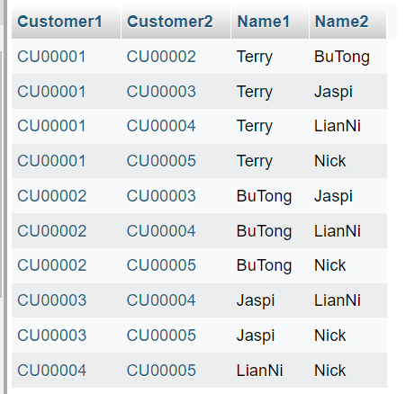

## **4.17 Table Customer DO**

### **4.17.1 ALIASES**

SELECT DO_No AS DeliveryOrderNo, Date AS OrderDate, Delivery_Date AS DeliveryDate, Customer_ID, Product_ID, Total_Quantity

FROM Customer_DO;

***Output***

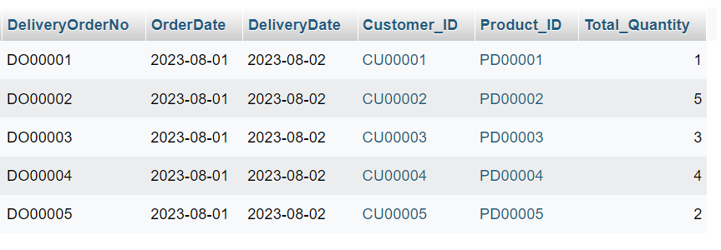

### **4.17.2 INNER JOIN**

SELECT Customer.Customer_ID, Customer.Customer_Name, Customer_Invoice.Invoice_No

FROM Customer

INNER JOIN Customer_Invoice ON Customer.Customer_ID = Customer_Invoice.Customer_ID;

***Output***

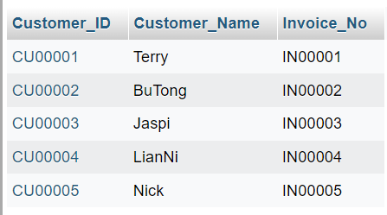

### **4.17.3 LEFT JOIN**

SELECT Customer.Customer_ID, Customer.Customer_Name, Customer_Invoice.Invoice_No

FROM Customer

LEFT JOIN Customer_Invoice ON Customer.Customer_ID = Customer_Invoice.Customer_ID;

***Output***

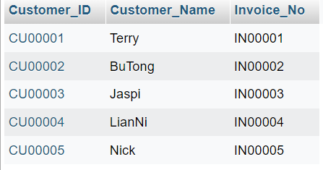

### **4.17.4 RIGHT JOIN**

SELECT Customer.Customer_ID, Customer.Customer_Name, Customer_Invoice.Invoice_No

FROM Customer

RIGHT JOIN Customer_Invoice ON Customer.Customer_ID = Customer_Invoice.Customer_ID;

***Output***

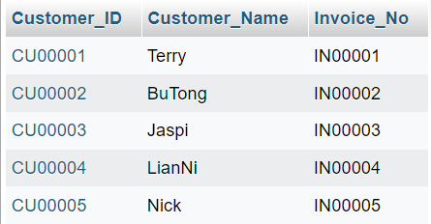

### **4.17.5 CROSS JOIN**

SELECT Customer.Customer_ID, Customer.Customer_Name, Customer_Invoice.Invoice_No

FROM Customer

CROSS JOIN Customer_Invoice;

***Output***

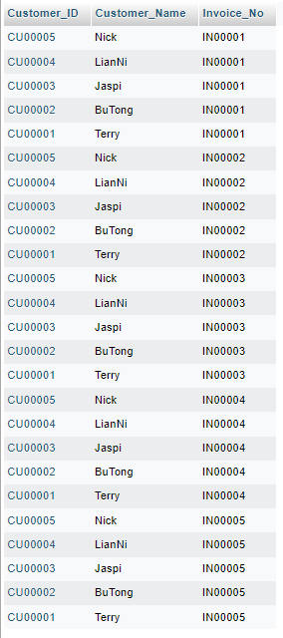

### **4.17.6 SELF JOIN**

SELECT a.Customer_ID AS Customer1, b.Customer_ID AS Customer2, a.Customer_Name AS Name1, b.Customer_Name AS Name2

FROM Customer a

JOIN Customer b ON a.Customer_ID < b.Customer_ID;

***Output***

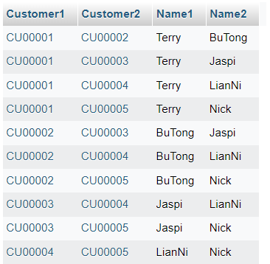

## **4.18 Table Supplier Invoice**

### **4.18.1 ALIASES**

SELECT Supplier_Invoice_No AS InvoiceNo, Date AS InvoiceDate, Supplier_ID AS SupplierID,

PO_No AS PurchaseOrderNo, Product_ID AS ProductID, Total_Quantity AS Quantity,

Total_Cost_Price AS CostPrice

FROM Supplier_Invoice;

***Output***

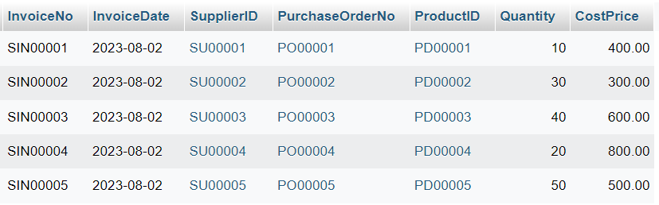

### **4.18.2 INNER JOIN**

SELECT Supplier.Supplier_ID, Supplier.Supplier_Name, Purchase_Order.PO_No

FROM Supplier

INNER JOIN Purchase_Order ON Supplier.Supplier_ID = Purchase_Order.Supplier_ID;

***Output***

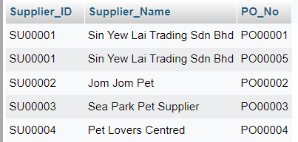

### **4.18.3 LEFT JOIN**

SELECT Supplier.Supplier_ID, Supplier.Supplier_Name, Purchase_Order.PO_No

FROM Supplier

LEFT JOIN Purchase_Order ON Supplier.Supplier_ID = Purchase_Order.Supplier_ID;

***Output***

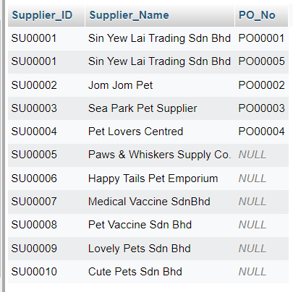

### **4.18.4 RIGHT JOIN**

SELECT Supplier.Supplier_ID, Supplier.Supplier_Name, Purchase_Order.PO_No

FROM Supplier

RIGHT JOIN Purchase_Order ON Supplier.Supplier_ID = Purchase_Order.Supplier_ID;

***Output***

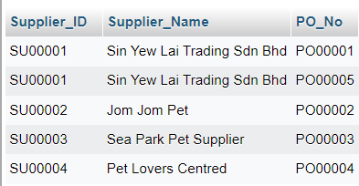

### **4.18.5 CROSS JOIN**

SELECT Supplier.Supplier_ID, Supplier.Supplier_Name, Purchase_Order.PO_No

FROM Supplier

CROSS JOIN Purchase_Order;

***Output***

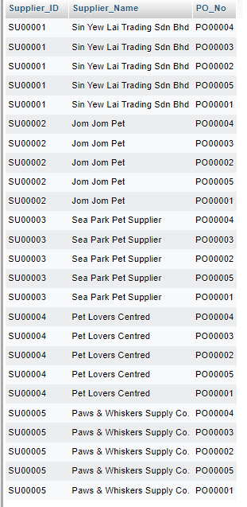

### **4.18.6 SELF JOIN**

SELECT a.Supplier_ID AS Supplier1, b.Supplier_ID AS Supplier2, a.Supplier_Name AS Name1, b.Supplier_Name AS Name2

FROM Supplier a

JOIN Supplier b ON a.Supplier_ID < b.Supplier_ID;

***Output***

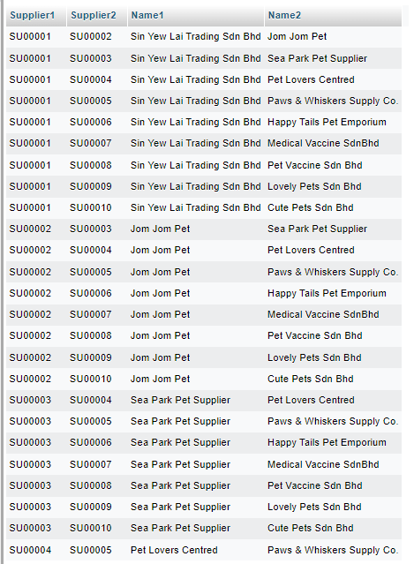

## **4.19 Table Supplier DO**

### **4.19.1 ALIASES**

SELECT Supplier_DO_No AS DO_No, Date AS DO_Date, Receive_Date AS ReceiveDate, Supplier_ID AS SupplierID,

PO_No AS PurchaseOrderNo, Product_ID AS ProductID, Total_Quantity AS Quantity

FROM Supplier_DO;

***Output***

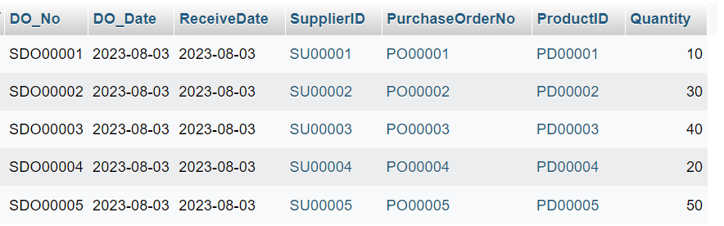

### **4.19.2 INNER JOIN**

SELECT Supplier.Supplier_ID, Supplier.Supplier_Name, Purchase_Order.PO_No

FROM Supplier

INNER JOIN Purchase_Order ON Supplier.Supplier_ID = Purchase_Order.Supplier_ID;

***Output***

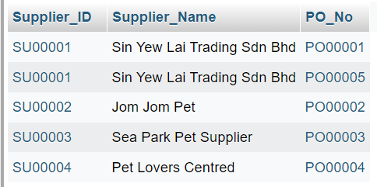

### **4.19.3 LEFT JOIN**

SELECT Supplier.Supplier_ID, Supplier.Supplier_Name, Purchase_Order.PO_No

FROM Supplier

LEFT JOIN Purchase_Order ON Supplier.Supplier_ID = Purchase_Order.Supplier_ID;

***Output***

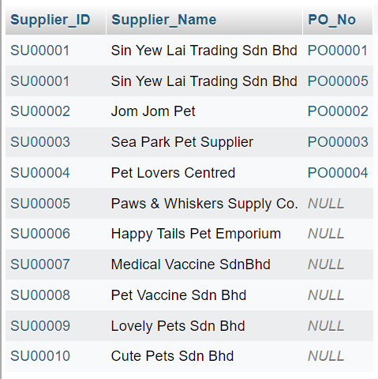

### **4.19.4 RIGHT JOIN**

SELECT Supplier.Supplier_ID, Supplier.Supplier_Name, Purchase_Order.PO_No

FROM Supplier

RIGHT JOIN Purchase_Order ON Supplier.Supplier_ID = Purchase_Order.Supplier_ID;

***Output***

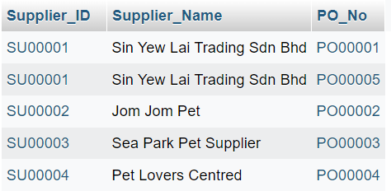

### **4.19.5 CROSS JOIN**

SELECT Supplier.Supplier_ID, Supplier.Supplier_Name, Purchase_Order.PO_No

FROM Supplier

CROSS JOIN Purchase_Order;

***Output***

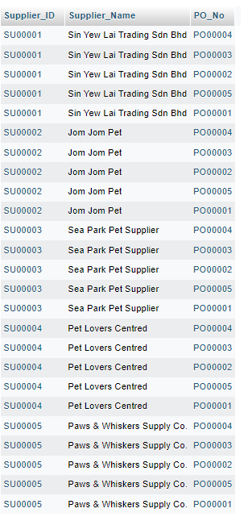

### **4.19.6 SELF JOIN**

SELECT A.Supplier_Name AS Supplier1, B.Supplier_Name AS Supplier2

FROM Supplier A

JOIN Supplier B ON A.Supplier_ID <> B.Supplier_ID;

***Output***

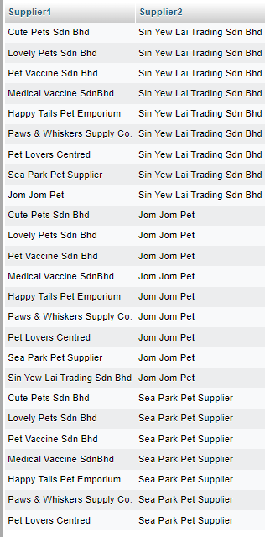

## **4.20 Table Stock Received**

### **4.20.1 ALIASES**

SELECT sr.Received_No, sr.Receive_Date, sr.Supplier_Invoice_No, sr.Supplier_DO_No, sr.Supplier_ID, sr.PO_No, sr.Product_ID, sr.Total_Quantity

FROM Stock_Received sr;

***Output***

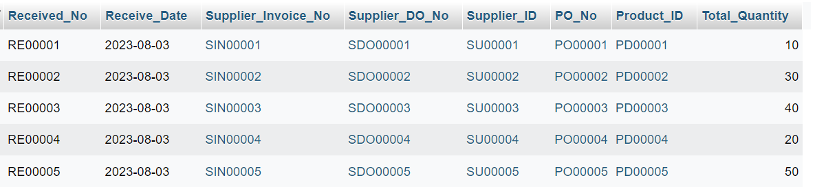

### **4.20.2 INNER JOIN**

SELECT Supplier.Supplier_ID, Supplier.Supplier_Name, Purchase_Order.PO_No

FROM Supplier

INNER JOIN Purchase_Order ON Supplier.Supplier_ID = Purchase_Order.Supplier_ID;

***Output***

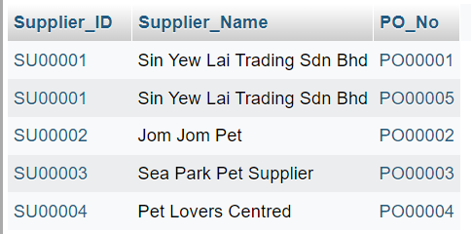

### **4.20.3 LEFT JOIN**

SELECT Supplier.Supplier_ID, Supplier.Supplier_Name, Purchase_Order.PO_No

FROM Supplier

LEFT JOIN Purchase_Order ON Supplier.Supplier_ID = Purchase_Order.Supplier_ID;

***Output***

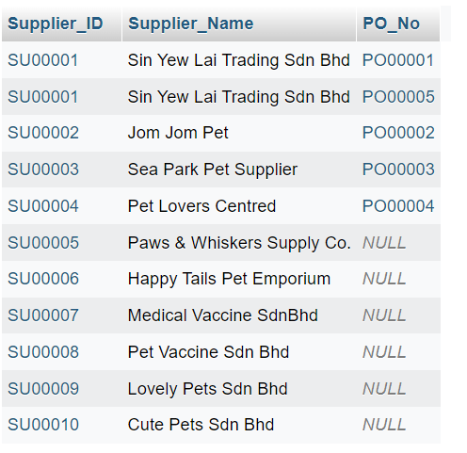

### **4.20.4 RIGHT JOIN**

SELECT Supplier.Supplier_ID, Supplier.Supplier_Name, Purchase_Order.PO_No

FROM Supplier

RIGHT JOIN Purchase_Order ON Supplier.Supplier_ID = Purchase_Order.Supplier_ID;

***Output***

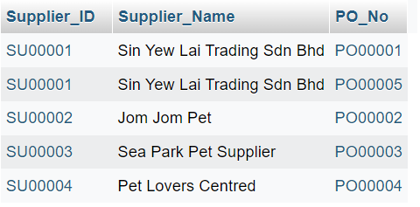

### **4.20.5 CROSS JOIN**

SELECT Supplier.Supplier_ID, Supplier.Supplier_Name, Purchase_Order.PO_No

FROM Supplier

CROSS JOIN Purchase_Order;

***Output***

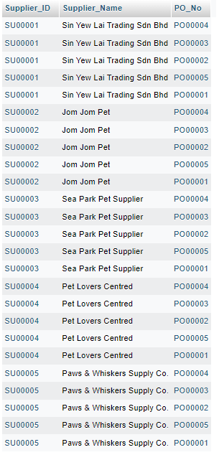

### **4.20.6 SELF JOIN**

SELECT s1.Supplier_ID AS Supplier1_ID, s1.Supplier_Name AS Supplier1_Name,

s2.Supplier_ID AS Supplier2_ID, s2.Supplier_Name AS Supplier2_Name

FROM Supplier s1

JOIN Supplier s2 ON s1.Item_Supply = s2.Item_Supply AND s1.Supplier_ID < s2.Supplier_ID;

***Output***

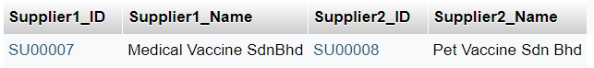

## **4.21 Table Stock Card**

### **4.21.1 ALIASES**

SELECT Stock_Card_ID AS Card_ID, Product_ID AS ID

FROM Stock_Card;

***Output***

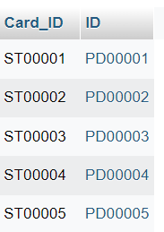

### **4.21.2 INNER JOIN**

SELECT Stock_Card.Stock_Card_ID, Inventory.Product_ID, Stock_Card.In_Quantity

FROM Stock_Card

INNER JOIN Inventory ON Stock_Card.Product_ID = Inventory.Product_ID;

***Output***

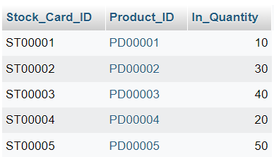

### **4.21.3 LEFT JOIN**

SELECT Inventory.Product_ID, Stock_Card.In_Quantity, Stock_Card.Out_Quantity

FROM Inventory

LEFT JOIN Stock_Card ON Inventory.Product_ID = Stock_Card.Product_ID;

***Output***

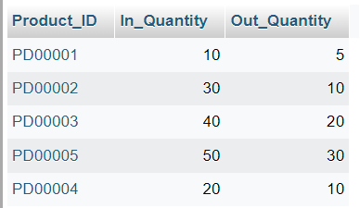

### **4.21.4 RIGHT JOIN**

SELECT Stock_Card.Stock_Card_ID, Inventory.Product_ID, Stock_Card.In_Quantity

FROM Stock_Card

RIGHT JOIN Inventory ON Stock_Card.Product_ID = Inventory.Product_ID;

***Output***

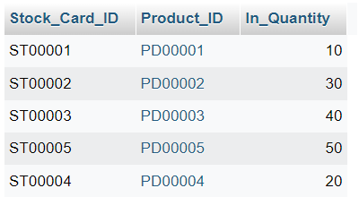

### **4.21.5 CROSS JOIN**

SELECT Inventory.Product_ID, Stock_Card.Stock_Card_ID

FROM Inventory

CROSS JOIN Stock_Card;

***Output***

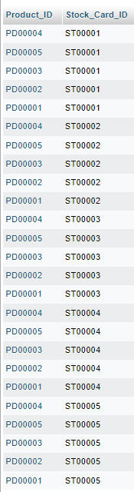

### **4.21.6 SELF JOIN**

SELECT

ic.Product_ID AS ProductID,

ic.Stock_Quantity AS StockQuantity,

sc.Beginning_Quantity AS BeginningQuantity,

sc.In_Quantity AS InQuantity,

sc.Out_Quantity AS OutQuantity,

sc.End_Quantity AS EndQuantity

FROM

Inventory ic

JOIN

Stock_Card sc ON ic.Product_ID = sc.Product_ID;

***Output***

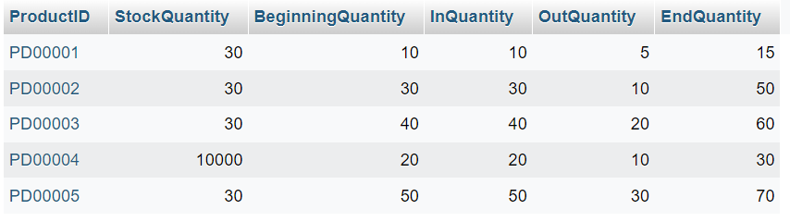

## **4.22 Table Customer Interest**

### **4.22.1 ALIASES**

SELECT Interest_ID AS ID, Customer_ID AS Customer, Product_ID AS Product, Interest_Level AS Level

FROM Customer_Interest;

***Output***

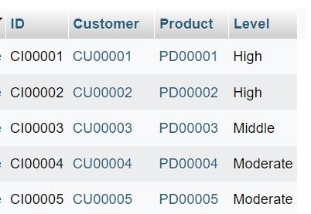

### **4.22.2 INNER JOIN**

SELECT Customer.Customer_ID, Customer.Customer_Name, Customer_Interest.Interest_Level

FROM Customer

INNER JOIN Customer_Interest ON Customer.Customer_ID = Customer_Interest.Customer_ID;

***Output***

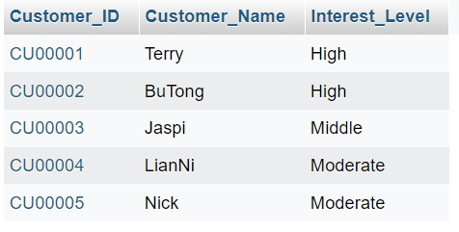

### **4.22.3 LEFT JOIN**

SELECT Customer.Customer_ID, Customer.Customer_Name, Customer_Interest.Interest_Level

FROM Customer

LEFT JOIN Customer_Interest ON Customer.Customer_ID = Customer_Interest.Customer_ID;

***Output***

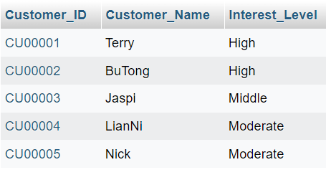

### **4.22.4 RIGHT JOIN**

SELECT Customer.Customer_ID, Customer.Customer_Name, Customer_Interest.Interest_Level

FROM Customer

RIGHT JOIN Customer_Interest ON Customer.Customer_ID = Customer_Interest.Customer_ID;

***Output***

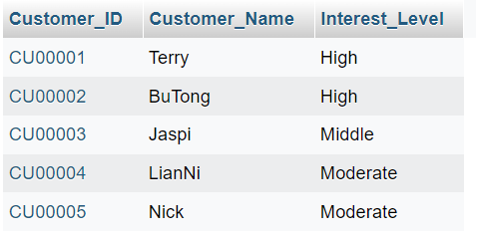

### **4.22.5 CROSS JOIN**

SELECT Customer.Customer_ID, Customer.Customer_Name, Inventory.Product_ID

FROM Customer

CROSS JOIN Inventory;

***Output***

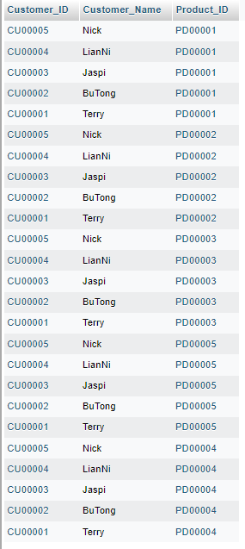

### **4.22.6 SELF JOIN**

SELECT

ci1.Customer_ID AS Customer1_ID,

c1.Customer_Name AS Customer1_Name,

ci1.Interest_Level AS Interest_Level,

ci2.Customer_ID AS Customer2_ID,

c2.Customer_Name AS Customer2_Name

FROM

Customer_Interest ci1

JOIN

Customer_Interest ci2 ON ci1.Interest_Level = ci2.Interest_Level

AND ci1.Customer_ID < ci2.Customer_ID

JOIN

Customer c1 ON ci1.Customer_ID = c1.Customer_ID

JOIN

Customer c2 ON ci2.Customer_ID = c2.Customer_ID;

***Output***

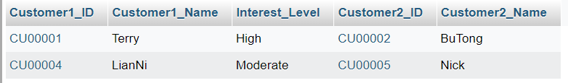

## **4.23 Table Customer Feedback**

### **4.23.1 ALIASES**

SELECT cf.Feedback_ID, cf.Customer_ID, cf.Date, cf.Feedback_Text, cf.Feedback_Rating

FROM Customer_Feedback cf;

***Output***

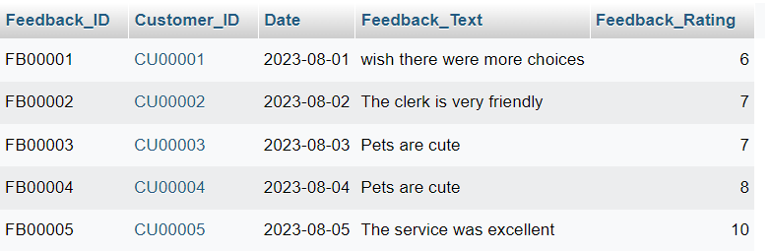

### **4.23.2 INNER JOIN**

SELECT Customer.Customer_ID, Customer.Customer_Name, Customer_Feedback.Feedback_Text

FROM Customer

INNER JOIN Customer_Feedback ON Customer.Customer_ID = Customer_Feedback.Customer_ID;

***Output***

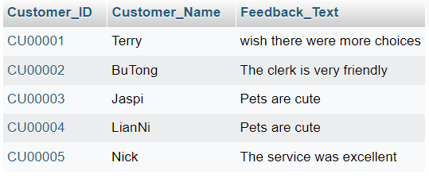

### **4.23.3 LEFT JOIN**

SELECT Customer.Customer_ID, Customer.Customer_Name, Customer_Feedback.Feedback_Text

FROM Customer

LEFT JOIN Customer_Feedback ON Customer.Customer_ID = Customer_Feedback.Customer_ID;

***Output***

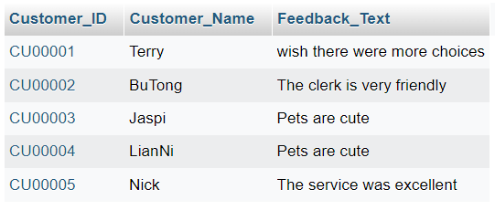

### **4.23.4 RIGHT JOIN**

SELECT Customer.Customer_ID, Customer.Customer_Name, Customer_Feedback.Feedback_Text

FROM Customer

RIGHT JOIN Customer_Feedback ON Customer.Customer_ID = Customer_Feedback.Customer_ID;

***Output***

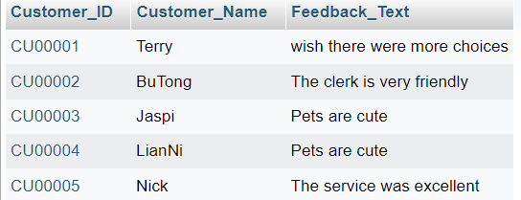

### **4.23.5 CROSS JOIN**

SELECT Customer.Customer_ID, Customer.Customer_Name, Customer_Feedback.Feedback_Text

FROM Customer

CROSS JOIN Customer_Feedback;

***Output***

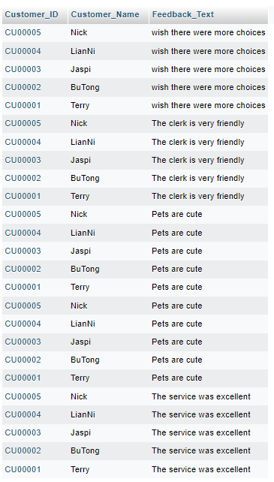

### **4.23.6 SELF JOIN**

SELECT c1.Customer_ID, c1.Customer_Name, c2.Feedback_Text

FROM Customer c1

INNER JOIN Customer_Feedback c2 ON c1.Customer_ID = c2.Customer_ID;

***Output***

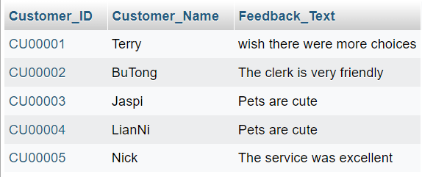

## **4.24 Table Employees**

### **4.24.1 MySQL Limit**

SELECT * FROM Employees

LIMIT 3;

***Output***

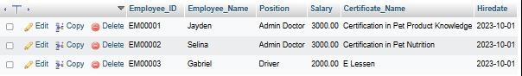

### **4.24.2 MySQL MIN and MAX**

SELECT MIN(Salary) AS Min_Salary, MAX(Salary) AS Max_Salary FROM Employees;

***Output***

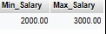

### **4.24.3 MySQL COUNT, AVG, SUM**

SELECT COUNT(Employee_ID) AS Employee_Count, AVG(Salary) AS Average_Salary, SUM(Salary) AS Total_Salary FROM Employees;

***Output***

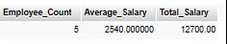

### **4.24.4 MySQL LIKE**

SELECT * FROM Employees

WHERE Position LIKE '%Doctor%';

***Output***

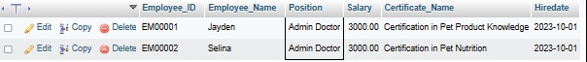

### **4.24.5 MySQL Wildcards**

SELECT * FROM Employees

WHERE Employee_Name LIKE 'B%';

***Output***



### **4.24.6 MySQL IN**

SELECT * FROM Employees

WHERE Employee_ID IN ('EM00001', 'EM00003', 'EM00005');

***Output***

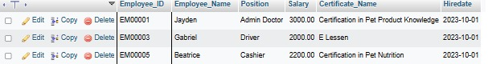

### **4.24.7 MySQL BETWEEN**

SELECT * FROM Employees

WHERE Hiredate BETWEEN '2023-09-01' AND '2023-12-31';

***Output***

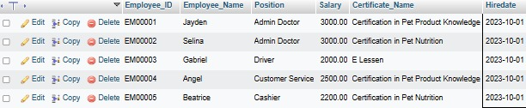

## **4.25 Table Employee Training**

### **4.25.1 MySQL LIMIT**

SELECT * FROM Employee_Training_Certification

LIMIT 3;

***Output***

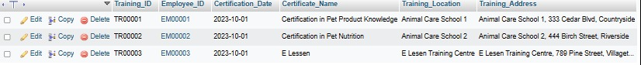

### **4.25.2 MySQL MIN and MAX**

SELECT MIN(Certification_Date) AS Earliest_Certification_Date, MAX(Certification_Date) AS Latest_Certification_Date FROM Employee_Training_Certification;

***Output***

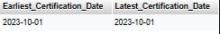

### **4.25.3 MySQL COUNT, AVG, SUM**

SELECT

COUNT(Training_ID) AS Training_Count,

AVG(Certification_Date) AS Average_Certification_Date,

SUM(Certification_Date) AS Total_Certification_Date

FROM Employee_Training_Certification;

***Output***

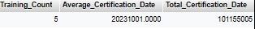

### **4.25.4 MySQL LIKE**

SELECT * FROM Employee_Training_Certification

WHERE Training_Location LIKE '%Animal%';

***Output***

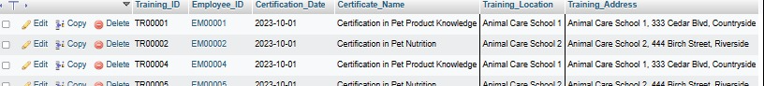

### **4.25.5 MySQL Wildcards**

SELECT * FROM Employee_Training_Certification

WHERE Certificate_Name LIKE '%Knowledge';

***Output***



### **4.25.6 MySQL IN**

SELECT * FROM Employee_Training_Certification

WHERE Employee_ID IN ('EM00001', 'EM00003', 'EM00005');

***Output***

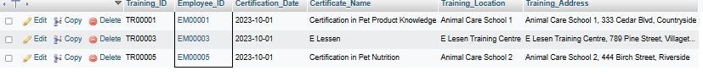

### **4.25.7 MySQL BETWEEN**

SELECT * FROM Employee_Training_Certification

WHERE Certification_Date BETWEEN '2023-09-01' AND '2023-12-31';

***Output***

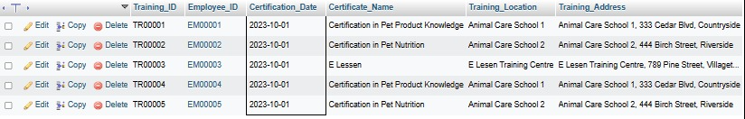

## **4.26 Table Pet Treatment Records**

### **4.26.1 MySQL LIMIT**

SELECT * FROM Pet_Treatment_Records

LIMIT 2;

***Output***

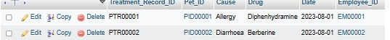

### **4.26.2 MySQL MIN and MAX**

SELECT MIN(Date) AS Earliest_Treatment_Date, MAX(Date) AS Latest_Treatment_Date FROM Pet_Treatment_Records;

***Output***

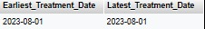

### **4.26.3 MySQL COUNT, AVG, SUM**

SELECT

COUNT(Treatment_Record_ID) AS Treatment_Count,

AVG(Date) AS Average_Treatment_Date,

SUM(Date) AS Total_Treatment_Date

FROM Pet_Treatment_Records;

***Output***

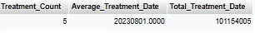

### **4.26.4 MySQL LIKE**

SELECT * FROM Pet_Treatment_Records

WHERE Cause LIKE '%Allergy%';

***Output***

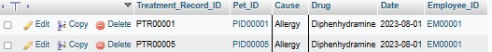

### **4.26.5 MySQL Wildcards**

SELECT * FROM Pet_Treatment_Records

WHERE Drug LIKE '%amine';

***Output***

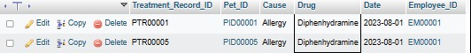

### **4.26.6 MySQL IN**

SELECT * FROM Pet_Treatment_Records

WHERE Pet_ID IN ('PID00001', 'PID00003', 'PID00005');

***Output***

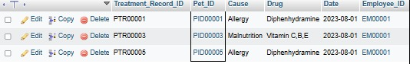

### **4.26.7 MySQL BETWEEN**

SELECT * FROM Pet_Treatment_Records

WHERE Date BETWEEN '2023-08-01' AND '2023-08-31';

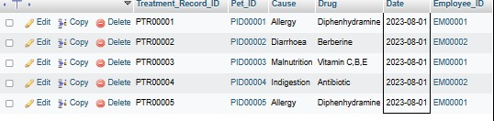

## **4.27 Table Vaccine Record**

### **4.27.1 MySQL LIMIT**

SELECT * FROM Vaccine_Record

LIMIT 3;

***Output***

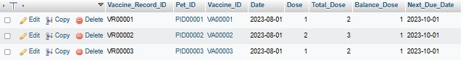

### **4.27.2 MySQL MIN and MAX**

SELECT MIN(Date) AS Earliest_Vaccination_Date, MAX(Date) AS Latest_Vaccination_Date FROM Vaccine_Record;

***Output***

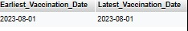

### **4.27.3 MySQL COUNT, AVG, SUM**

SELECT

COUNT(Vaccine_Record_ID) AS Vaccine_Count,

AVG(Dose) AS Average_Dose,

SUM(Dose) AS Total_Dose

FROM Vaccine_Record;

***Output***

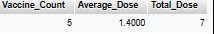

### **4.27.4 MySQL LIKE**

SELECT * FROM Vaccine_Record

WHERE Vaccine_ID LIKE '%VA%';

***Output***

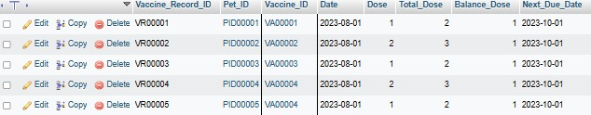

### **4.27.5 MySQL Wildcards**

SELECT * FROM Vaccine_Record

WHERE Next_Due_Date LIKE '%-10-01';

***Output***

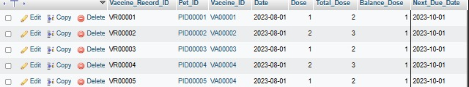

### **4.27.6 MySQL IN**

SELECT * FROM Vaccine_Record

WHERE Pet_ID IN ('PID00001', 'PID00003', 'PID00005');

***Output***

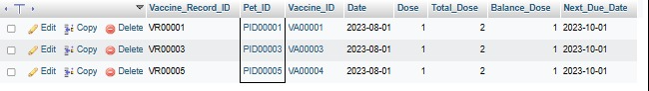

### **4.27.7 MySQL BETWEEN**

SELECT * FROM Vaccine_Record

WHERE Date BETWEEN '2023-08-01' AND '2023-08-31';

***Output***

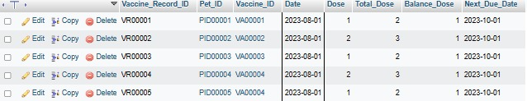

## **4.28 Table Shop Event**

### **4.28.1 MySQL LIMIT**

SELECT * FROM Shop_Event

LIMIT 2;

***Output***

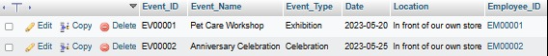

### **4.28.2 MySQL MIN and MAX**

SELECT MIN(Date) AS Earliest_Event_Date, MAX(Date) AS Latest_Event_Date FROM Shop_Event;

***Output***

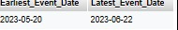

### **4.28.3 MySQL COUNT, AVG, SUM**

SELECT

COUNT(Event_ID) AS Event_Count,

AVG(Date) AS Average_Event_Date,

SUM(Date) AS Total_Event_Date

FROM Shop_Event;

***Output***

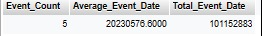

### **4.28.4 MySQL LIKE**

SELECT * FROM Shop_Event

WHERE Event_Name LIKE '%Pet%';

***Output***

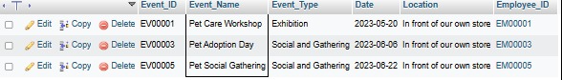

### **4.28.5 MySQL Wildcards**

SELECT * FROM Shop_Event

WHERE Location LIKE '%store';

***Output***

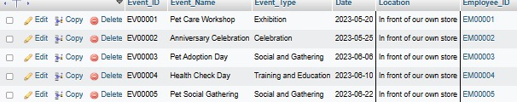

### **4.28.6 MySQL IN**

SELECT * FROM Shop_Event

WHERE Employee_ID IN ('EM00001', 'EM00003', 'EM00005');

***Output***

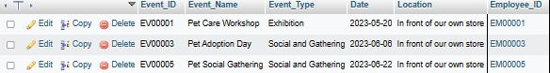

### **4.28.7 MySQL BETWEEN**

SELECT * FROM Shop_Event

WHERE Date BETWEEN '2023-06-01' AND '2023-06-30';

***Output***

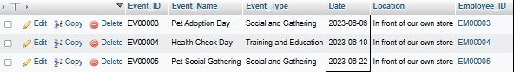

## **4.29 Table Sales History**

### **4.29.1 MySQL LIMIT**

SELECT * FROM Sales_History

LIMIT 3;

***Output***

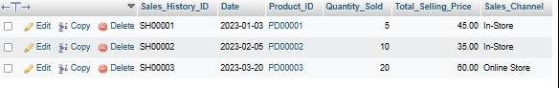

### **4.29.2 MySQL MIN and MAX**

SELECT MIN(Total_Selling_Price) AS Min_Price, MAX(Total_Selling_Price) AS Max_Price

FROM Sales_History;

***Output***

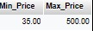

### **4.29.3 MySQL COUNT, AVG, SUM**

SELECT COUNT(*) AS Total_Records, AVG(Quantity_Sold) AS Avg_Quantity_Sold, SUM(Total_Selling_Price) AS Total_Sales

FROM Sales_History;

***Output***

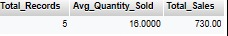

### **4.29.4 MySQL LIKE**

SELECT * FROM Sales_History

WHERE Sales_Channel LIKE '%Online%';

***Output***



### **4.29.5 MySQL Wildcards**

SELECT * FROM Sales_History

WHERE Product_ID LIKE 'PD00%';

***Output***

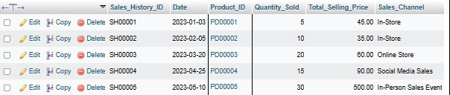

### **4.29.6 MySQL IN**

SELECT * FROM Sales_History

WHERE Sales_Channel IN ('In-Store', 'Online Store');

***Output***

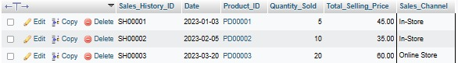

### **4.29.7 MySQL BETWEEN**

SELECT * FROM Sales_History

WHERE Quantity_Sold BETWEEN 10 AND 20;

***Output***

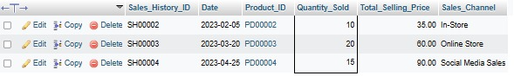

## **4.30 Table Payment History**

### **4.30.1 MySQL LIMIT**

SELECT * FROM Payment_History

LIMIT 2;

***Output***

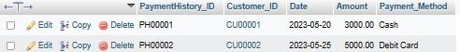

### **4.30.2 MySQL MIN and MAX**

SELECT MIN(Amount) AS Min_Amount, MAX(Amount) AS Max_Amount

FROM Payment_History;

***Output***

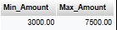

### **4.30.3 MySQL COUNT, AVG, SUM**

SELECT COUNT(*) AS Total_Records, AVG(Amount) AS Avg_Amount, SUM(Amount) AS Total_Amount

FROM Payment_History;

***Output***

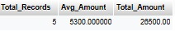

### **4.30.4 MySQL LIKE**

SELECT * FROM Payment_History

WHERE Payment_Method LIKE '%Card%';

***Output***

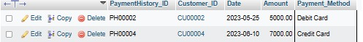

### **4.30.5 MySQL Wildcards**

SELECT * FROM Payment_History

WHERE Payment_Method LIKE 'C%';

***Output***

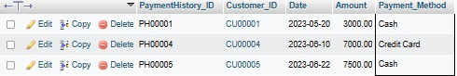

### **4.30.6 MySQL IN**

SELECT * FROM Payment_History

WHERE Payment_Method IN ('Cash', 'Credit Card');

***Output***

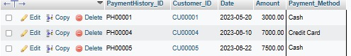

### **4.30.7 MySQL BETWEEN**

SELECT * FROM Payment_History

WHERE Amount BETWEEN 4000 AND 7000;

***Output***

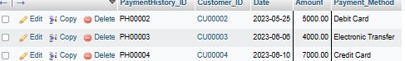

## **4.31 Table Monthly Net Report**

### **4.31.1 MySQL LIMIT**

SELECT * FROM Monthly_Net_Report

LIMIT 3;

***Output***



### **4.31.2 MySQL MIN and MAX**

SELECT MIN(Profit) AS Min_Profit, MAX(Profit) AS Max_Profit

FROM Monthly_Net_Report;

***Output***



### **4.31.3 MySQL COUNT, AVG, SUM**

SELECT COUNT(*) AS Total_Records, AVG(Profit) AS Avg_Profit, SUM(Profit) AS Total_Profit

FROM Monthly_Net_Report;

***Output***

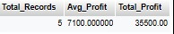

### **4.31.4 MySQL LIKE**

SELECT * FROM Monthly_Net_Report

WHERE Description LIKE '%Customer%';

***Output***

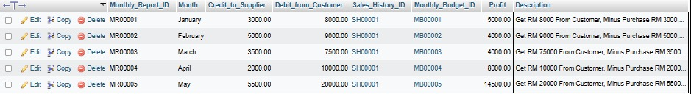

### **4.31.5 MySQL Wildcards**

SELECT * FROM Monthly_Net_Report

WHERE Month LIKE 'M%';

***Output***



### **4.31.6 MySQL IN**

SELECT * FROM Monthly_Net_Report

WHERE Monthly_Report_ID IN ('MR00001', 'MR00003', 'MR00005');

***Output***



### **4.31.7 MySQL BETWEEN**

SELECT * FROM Monthly_Net_Report

WHERE Profit BETWEEN 5000 AND 10000;

***Output***



# 

# **5. Normalization**

## **5.1 Table Monthly Budget**

1NF > (Monthly_Budget_ID, Purpose, Description, Budget)

## **5.2 Table Supplier**

0NF > (Supplier_ID, Supplier_Name, Phone, Email, Item_Supply)

1NF > (Supplier_ID, Supplier_Name, Phone, Email, Item_Supply)

***\*Note: While 0NF allows for multiple data in a row, 1NF only allows for one data in a row. However, the attributes remain unchanged between the two normalization levels.***

## **5.3 Table Pet Care Service**

1NF > (Service_ID, Service Description, Duration, Price)

## **5.4 Table Pet Accessories**

1NF > (Accessories_ID, Category, Description, Color, Material, Supplier_ID, Cost_Price, Selling_Price)

2NF > (Accessories_ID, Category, Description, Color, Material, Selling_Price)

2NF > (Supplier_ID, Cost_Price)

## **5.5 Table Pet Category**

1NF > (Pet_Category_ID, Pet_Category_Name, Supplier_ID, Cost_Price, Selling_Price)

2NF > (Pet_Category_ID, Pet_Category_Name, Selling_Price)

2NF > (Supplier_ID, Cost_Price)

## **5.6 Table Vaccine**

1NF > (Vaccine_ID, Vaccine_Name, Supplier_ID, Cost_Price, Selling_Price)

2NF > (Vaccine_ID, Vaccine_Name, Selling_Price)

2NF > (Supplier_ID, Cost_Price)

## **5.7 Table Inventory**

1NF > (Product_ID, Service_ID, Accessories_ID, Pet_Category_ID, Vaccine_ID, Stock_Quantity)

2NF > (Product_ID, Stock_Quantity)

2NF > (Service_ID, Stock_Quantity)

2NF > (Accessories_ID, Stock_Quantity)

2NF > (Pet_Category_ID, Stock_Quantity)

2NF > (Vaccine_ID, Stock_Quantity)

## **5.8 Table Customer**

1NF > (Customer_ID, Customer_Name, Phone, Email, Address)

2NF > (Customer_ID, Customer_Name)

## **5.9 Table Customer Pet**

1NF > (Pet_ID, Pet_Name, Customer_ID, Description, Breed, Origin_Country, Sex, Color, Register_Date)

2NF > (Pet_ID, Pet_Name, Description, Register_Date)

2NF > (Customer_ID, Pet_Name)

## **5.10 Table Adoption Record**

1NF > (Adoption_Pet_ID, Adoption_Pet_Name, Adopter_Name, Adoption_Date, Adopter_Contact)

2NF > (Adoption_Pet_ID, Adoption_Pet_Name)

2NF > (Adopter_Name, Adoption_Date, Adopter_Contact)

## **5.11 Table Lost And Found Record**

1NF > (Lost_Pet_ID, Lost_Pet_Name, Description, Location, Finder_Name, Finder_Contact, Report_Date, Found_Date)

2NF > (Lost_Pet_ID, Lost_Pet_Name, Description, Location)

2NF > (Finder_Name, Finder_Contact, Report_Date, Found_Date)

## **5.12 Table Pet Record**

1NF > (Pet_Record_ID, Pet_ID, Adoption_Pet_ID, Lost_Pet_ID)

2NF > (Pet_Record_ID, Pet_ID)

2NF > (Pet_Record_ID, Adoption_Pet_ID)

2NF > (Pet_Record_ID, Lost_Pet_ID)

## **5.13 Table Membership**

1NF > (Membership_ID, Customer_ID, Membership_Level, Register_Date, Expire_Date, Debit, Credit, Last_Balance, New_Balance, Last_Point, New_Point)

2NF > (Membership_ID,Membership_Level)

2NF > (Customer_ID, Register_Date, Expire_Date, Debit, Credit, Last_Balance, New_Balance, Last_Point, New_Point)

## **5.14 Table Pet Appointment Record**

1NF > (Appointment_ID, Appointment_Date, Time, Pet_ID, Service_ID)

2NF > (Pet_ID, Appointment_Date, Time)

2NF > (Service_ID, Appointment_Date, Time)

## **5.15 Table Purchase Order**

1NF > (PO_No, Date, Supplier_ID, Product_ID, Total_Quantity, Total_Cost_Price)

2NF > (PO_No, Date, Product_ID, Total_Quantity, Total_Cost_Price)

2NF > ( Supplier_ID, Product_ID, Total_Quantity, Total_Cost_Price)

3NF > (Product_ID, Total_Quantity, Total_Cost_Price)

## **5.16 Table Customer Invoice**

1NF > (Invoice_No, Date, Customer_ID, Product_ID, Total_Quantity, Total_Selling_Price)

2NF > (Customer_ID,Invoice_No,Date)

2NF > (Product_ID,Total_Quantity,Total_Selling_Price)

## **5.17 Table Customer DO**

1NF > (DO_No, Date, Delivery_Date, Customer_ID, Product_ID, Total_Quantity)

2NF > ( DO_No, Date, Delivery_Date)

2NF > ( Customer_ID, Product_ID, Total_Quantity)

3NF > (Product_ID, Total_Quantity)

## **5.18 Table Supplier Invoice**

1NF > (Supplier_Invoice_No, Date, Supplier_ID, PO_No, Product_ID, Total_Quantity, Total_Cost_Price)

2NF > (Supplier_Invoice_No, Date, PO_No, Total_Quantity, Total_Cost_Price)

2NF > ( Supplier_ID, PO_No, Total_Quantity, Total_Cost_Price)

3NF > ( Supplier_Invoice_No, Date, Total_Quantity, Total_Cost_Price)

3NF > ( PO_No, Total_Quantity, Total_Cost_Price)

## **5.19 Table Supplier DO**

1NF > (Supplier_DO_No, Date, Receive_Date, Supplier_ID, PO_No, Product_ID, Total_Quantity)

2NF > (Supplier_DO_No, Date, Receive_Date, Supplier_ID)

2NF > (Supplier_DO_No, PO_No, Product_ID, Total_Quantity)

3NF > (Supplier_DO_No, Date, Receive_Date, Supplier_ID)

3NF > (PO_No, Supplier_DO_No, Supplier_ID)

3NF > (PO_No , Product_ID , Total_Quantity)

## **5.20 Table Stock Received**

1NF > (Received_No, Receive_Date, Supplier_Invoice_No, Supplier_DO_No, Supplier_ID, PO_No, Product_ID, Total_Quantity)

2NF > (Received_No, Receive_Date, Supplier_Invoice_No, Supplier_DO_No, Total_Quantity)

2NF > (Received_No, Supplier_ID, PO_No, Product_ID)

3NF > (Supplier_ID, Total_Quantity)

3NF > Product_ID, Total_Quantity)

## **5.21 Table Stock Card**

1NF > (Stock_Card_ID, Product_ID, Beginning_Quantity, In_Quantity, Out_Quantity, End_Quantity)

2NF > (Stock_Card_ID, Product_ID, Beginning_Quantity, End_Quantity)

2NF > (Stock_Card_ID, In_Quantity, Out_Quantity)

## **5.22 Table Customer Interest**

1NF > (Interest_ID, Customer_ID, Product_ID, Interest_Level)

2NF > ((Interest_ID, Customer_ID,Interest_Level)

2NF > (Interest_ID, Product_ID, Interest_Leve)

2NF > (Interest_ID, Interest_Leve)

3NF > (Customer_ID,Interest_Level)

3NF > (Product_ID, Interest_Leve)

## **5.23 Table Customer Feedback**

1NF > (Feedback_ID, Customer_ID, Date, Feedback_Text, Feedback_Rating)

2NF > (Feedback_ID, Customer_ID, Date, Feedback_Text)

## **5.24 Table Employees**

1NF > (Employee_ID, Employee_Name, Position, Salary, Certificate_Name, Hiredate)

2NF > (Employee_ID, Employee_Name, Salary, Hiredate)

## **5.25 Table Employee Training**

1NF > (Training_ID, Employee_ID, Certification_Date, Certificate_Name, Training_Location, Training_Address)

2NF > (Employee_ID,Certification_Date,Certificate_Name)

2NF >(Training_ID,Training_Location,Training_Address)

## **5.26 Table Pet Treatment Records**

1NF > (Treatment_Record_ID, Pet_ID, Cause, Drug, Date, Employee_ID)

2NF > (Treatment_Record_ID, Pet_ID,Date)

## **5.27 Table Vaccine Record**

1NF > (Vaccine_Record_ID, Pet_ID, Vaccine_ID, Date, Dose, Total_Dose, Balance_Dose, Next_Due_Date)

2NF > (Vaccine_Record_ID,Dose, Vaccine_ID,Date, Next_Due_Date)

2NF > ( Pet_ID, Date, Dose, Total_Dose, Balance_Dose, Next_Due_Date)

## **5.28 Table Shop Event**

1NF > (Event_ID, Event_Name, Event_Type, Date, Location, Employee_ID)

2NF > (Event_ID, Date, Employee_ID,Event_Type)

2NF > (Employee_ID, Date)

## **5.29 Table Sales History**

1NF > (Sales_History_ID, Date, Product_ID, Quantity_Sold, Total_Selling_Price, Sales_Channel)

2NF > (Sales_History_ID, Date, Product_ID,Quantity_Sold, Total_Selling_Price)

## **5.30 Table Payment History**

1NF > (PaymentHistory_ID, Customer_ID, Date, Amount, Payment_Method)

2NF > (PaymentHistory_ID,Date, Amount, Payment_Method)

2NF > (Customer_ID, Date)

## **5.31 Table Monthly Net Report**

1NF > (Monthly_Report_ID, Month, Credit_to_Supplier, Debit_from_Customer, Sales_History_ID, Monthly_Budget_ID, Profit, Description)

2NF > (Monthly_Report_ID, Month, Credit_to_Supplier)

2NF > (Monthly_Report_ID, Month,Debit_from_Customer, Sales_History_ID, Monthly_Budget_ID, Profit)

# **6. References**

All information from:

W3Schools. (2021, September 22). Learn MySQL. W3Schools. Retrieved January 6, 2024, from <https://my-learning.w3schools.com/tutorial/mysql>